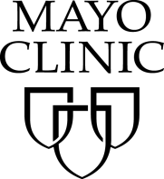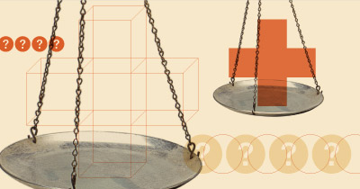

***Summer Undergraduate***

***Program in Biomedical***

***Ethics Research***

The Mayo Clinic Biomedical Ethics Program seeks applicants for its 2015 summer student program. This program is supported in part by a generous gift from Jim Vann and Lee Stanton Vann.

Each student will be placed with a faculty mentor to work on a particular research project for the summer. In addition, students will participate in a biomedical ethics summer curriculum, which includes educational sessions on bioethics research methods and lunch meetings with members of the program faculty. With appropriate permissions, students may be given the opportunity to shadow physicians or clinical ethics consultations.

Interested applicants should email the following materials to [bioethics@mayo.edu](mailto:bioethics@mayo.edu) by **Jan. 15, 2015.**

1. Cover letter describing your career goals and your interest in biomedical ethics research as it relates to your goals
2. Resume/CV that includes your major, relevant courses, honors, and experiences
3. Current, unofficial college transcript
4. Two letters of recommendation from research mentors or undergraduate teachers (addressed to Dr. Richard Sharp at [bioethics@mayo.edu](mailto:bioethics@mayo.edu)). *Letters can be sent either by the student or by the professor but must be received by the application deadline.*

Top applicants will be invited to participate in a brief phone conversation to discuss specific skills and areas of interest, in order to match the applicant with a mentor and research project.

Examples of research topics that might be explored include:

- Ethical issues in life-sustaining treatments and end-of-life care

- Research ethics

- Ethical issues in regenerative medicine and transplantation

- Allocation of health care resources

- Professionalism in medicine and science

- Ethical issues in genomics and individualized medicine

- Science and society

- Research related to clinical ethics consultation

Compensation will be set according to Mayo Clinic standard rates for students and will be finalized in 2015. Local student housing information will be sent to successful applicants.

For further information or specific questions contact Marguerite Robinson, Biomedical Ethics Program Manager, at 507-538-3402 or [robinson.marguerite@mayo.edu](mailto:robinson.marguerite@mayo.edu).