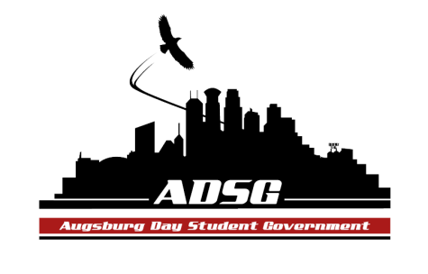
Augsburg Day Student Government Agenda
March 23, 2016
Marshall Room 6:00PM

Call to Order:
6:02PM
Roll Call: Pronouns; exciting thing you did over spring break.
Members present:
Duina Hernandez
Sheila Meh
Estephanie Romero-Rodriguez
Jesse Cervantes
Kevin Tran
B.K. Kormah
Lucy Sukar
Adirahman Ali
Julian Kritz
Sammy Coy
Nick Stewart-Bloch
Sammi Gyanfi
Maya Horton
Emmet Dysart
Jordan Parshall

Reies Romero
Mariam Fawzy
Zsolt Vinzce
Khadra Ibrahim
Elise Hinderliter

Members absent: Keisha Bernard, Mahamoud Abdi, Madison Wedan, Adirahman Ali
Advisors present: Michael Grewe
Guests present: Shawntera H.

- Share Puppy
Jordan Parshall Nick Stewart-Bloch
- Adoption of the Agenda
- Community Sharing:
  - Shawntera H. – Co-Founder of Civic Eagle
- What is Civic Eagle: An integrated platform that makes it easier for people to civically engage around the issues they care about and simultaneously equips civic leaders (municipalities and organizations) with the tools they need to be more effective.
- One can be engage by picking up the phone and downloading the app and providing any feedback that they have.

- Approval of Previous Minutes
  - 2-9-16 Approved! 6:29 PM
- Unfinished Business
- New Business
- Announcements
  - President:
Choosing the advisor committee for Leadership Awards:
- Meeting have to happened by next week
- Members interested:
Day at the Capital:
- April 6th (All day event) Two weeks from today-Wednesday
- Members interested: Jordan, Duina, BK, Reies

End of year celebration
-April 20th: Please RSVP ASAP!
Leadership Award
-5-7 PM April 5th: Encourage everyone to be there
Next Meeting
-President will be attending meeting
So make sure you are on time and dressed in your polos.

  - Vice President:
  - Finance Committee:
- KAUG Radio and Concert Promotion
Amount Requested: $16,500
Paying for performer, equipment, printing
We will debate and vote on it next week!

Commissioning Fund: $18,367
Chartering Fund: $10,105.27

  - Students Concerns Committee:
  - PR Committee:
  - Chartering Committee:
  - Commissioning Committee:
Society of Physic Students were not commissioned.
Tri-Beta Biological Honors Society were not commissioned either because they didn’t get 2/3 of votes.
  - Elections Committee:
Extended the deadline:
Time for more petition to come in- Meeting with potential president and vice president tomorrow
Debate between president and vice president: Wednesday, March 30th 4:30-5:30pm
  - Constitution Committee
  - Resolutions Committee
  - Environmental Action Committee
*This Friday: Putting in 24 bike units in Anderson, 12 in Mort, 8 in Urness.
Creating official officer job to go along with the plan
*Allyson Green: Proposing Community Garden behind Anderson: (More people wants to garden than there are spaces)
  - Community Service Committee

  - College Committees
    - Academic Affairs: Lucy S.
Latin Should be require: Now fit to fulfil language requirement
    - UC Diversity & Inclusion: Duina H.
    - Assessment: Julian K.
    - University Council:

  - Senators:
- Nick: SafePool: Augsburg standing in solidarity with them- There will be a meeting in OGC 200. One of their goal is to Increase minimum wage
- Julian: Next week from today, Augsburg was chosen to prescreen a movie with Morgan Freeman 7pm in Saturn.
  - Executive Board:
- Sammy: Day at the Capital; recruit people, 10 spots are open
*When: 9am-2pm.
*RSVP for leadership award by tomorrow. End of year celebration, *Smart is doing a clothing drive: please bring in clothe, tabling in Christensen Hall
- Sheila: KAUG: allocated
- Reies: Phife Dawg from the Tribe called Quest just died at age 45- huge loss in the hip hop community.
  - Advisors:
Michael:
*Make sure Mahamoud knows that you all have asset based on commissioning and chartering
*Two more meetings left- Make sure you read and analyze (any and all) messages from the Finance Committee
*Student leadership Committee: Make sure to meet and analyze the result for the Leadership Awards
- Adjournment.
Meeting was adjourned at 7:18Pm

