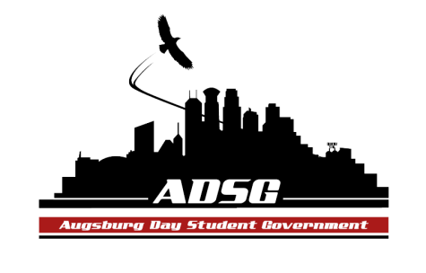
Augsburg Day Student Government Agenda
December 2, 2015
Marshall Room 6:00 PM
- Call to Order
Exec Board: Duina Hernandez, Reies Romero, Cuong Nguyen, Mariam Fawzy, Keisha Barnard, Shelia Meh, Madison Davis
Incumbant Senators: Julian Kritz, Kitanna Holland
Senators: Khadra Ibrahim, Aisha Barre, Jesse Cervantes, Kevin Tran, Mahamoud Abdi, Alexis Vue, Nicholas StwartBloch, Madison Wedan, Mohammed Safi, Grant Patterson, Tony Morales
Guest: Lucy Sukar, Bashiru Kormah (BK)
Advisors: Mike Grewe, Joanne Reeck
Not here: Alyson Rowe, Estephanie Romero-Rodriguez
- Roll Call
Name, pronoun, what are you doing for new years?
- Share Puppy

- Adoption of the Agenda
- Soapbox:
- Approval of Previous Minutes
  - 11-18-15, Madison D. sent them out.
- Unfinished Business
- New Business:
- Approval of Commissioned Student Organizations’ Officer Stipends
  - Duina: Motion to Pass
  - Vote For: all Opposed: 0 Abstained: 0
- Approval of Day Student Government Executive Board Stipends
  - Duina: Motion to Pass
  - Vote For: All Opposed: 0 Abstained: 0
- Approval of Day Student Body President and Vice President Stipends
  - Elise: Motion to Pass
  - Vote For: All Opposed: 0 Abstained: 0

- Announcements
  - President:
  - Vice President
  - Finance Committee:
Approved all Current Requests
All request need to be in by next Tuesday to get everything approved by the end of next weeks meeting!
  - Student Concerns Committee:
Met with Robert and Erickson to discuss ideas for getting rid of racism in sports
  - Senators
- Intramural Soccer
-if you aren’t playing at least come support everyone!
Community Sharing: Jen Jacobs
  - Executive Board
We are busing dishes in the commons before our meeting next week at 5:30!
  - Advisors
  - Adjournment at 7:20pm.

