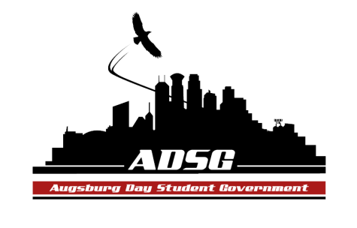
Augsburg Day Student Government Agenda
March 4, 2015
Marshall Room 6:00 PM
Exec Board Present: Adrian Lowe, Ahmed Mosallam, Elise Hinderliter, Brad St.Aubin, Vincent Henry, Banna Kidane, Reies Romero, Heath Anderson, Amber Nguyen
Senators Present (16/16): Lyle Nyberg, Nancy Lor, Nazih Safi, Abdirhman Dahir, April Johnson, Emily James, Ashley Parent, Habiib Hassan, Angela Hernandez, Marquell Moore, Julian Kritz, Cuong Nguyen, Cristian Baca-Perez, Nattacia Bailey, Liban Elmi, Daniel Polaschek
Advisors Present: Mike Grewe, Joanne Reeck
Guests Present: Kim Chism
- Call to Order
- Roll Call
  - name, pronoun, favorite restaurant in Minneapolis/St. Paul
- Share Puppy
  - Cuong->Vincent
- Adoption of the Agenda
- Soapbox
- Approval of Previous Minutes
- Unfinished Business
- New Business
  - Voting on Long-Term Project Fund Options
    - three options for students to choose from on elections:
      - charger stations
      - accessibility improvements (elevators, ramps, etc.)
      - subsidizing DPS escorts to allow for more hours
  - Voting on Surplus Fund Options
    - three options for students to choose from on elections:
      - beautification of campus
      - charger stations
      - student organization programming
  - Nazih - Motion to replace charger station option on Surplus Fund with a different option because it is under both Funds.
    - Vincent - Next runner up is painting walls.
    - Julian & Reies - Painting is redundant with beautification.
    - Vote For: 0 Against: 12 Abstain: 4
  - April - Motion to replace charger station option on Long Term Fund with a different option because it is under both Funds.
    - Vote For: 16 Against: 0 Abstain: 0
  - Vincent - Next runner up is upgrading Urness Lab. Motion to replace charger stations with upgrading Urness Lab.
    - Vote For: 16 Against: 0 Abstain: 0
- Announcements
  - President:
  - Vice President:
    - Approval of Appeals Committee Members
      - Appoint: Hai Thao, Tina Manje, Roman Khadka, Adrian Lowe, Muna Mohamed, Cody Cameron, Lia Jacobson, Wren Warpula, Anil Gherau
      - Vote For: 16 Against: 0 Abstain: 0
    - Dennis Stucke will come in soon to talk about the improvements to the lighting
    - Banna and Vincent are meeting with Beth to talk about designs for Student Lounge
  - Finance Committee:
    - Charter Fund: $0
    - Travel: $0
    - Commission: $820
  - Chartering and Commissioning Committee:
  - Students Concerns Committee:
    - 4:30-6:30 pm in Riverside Room on Friday to work on draft of report
    - going to Wellness Center next SCC meeting
  - PR Committee:
  - Elections Committee:
    - more tabling next week
    - petitions are due next Wednesday at 4:30pm to Student Gov. Office
  - Constitution Committee:
  - Community Service Committee:
  - Resolutions Committee:
    - working on process to follow up on resolutions
  - College Committees
    - Academic Affairs Committee
    - Assessment Committee
    - College Resource Committee
  - Senators:
    - Cuong - Auggie Olympics, April 18, is coming up and there is money prizes
    - Danny - Friday 10pm - Ultimate Frisbee
  - Executive Board:
    - Mike - Nominate people for the Augsburg Leadership Awards.
  - Advisers:
    - Kim - Need volunteers for Noble Peace Prize Forum, counts as Community Service commitment.
- Adjournment. 6:55pm

