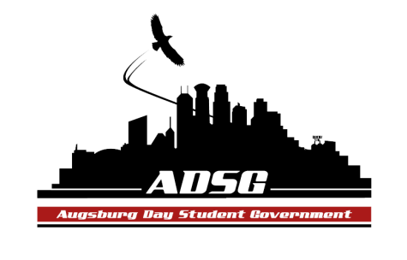
Augsburg Day Student Government Agenda
March 25, 2015
Marshall Room 6:00 PM
Exec Board Present: Elise Hinderliter, Brad St.Aubin, Vincent Henry,Reies Romero, Heath Anderson

Senators Present (9/16): Lyle Nyberg, Nancy Lor, Nazih Safi, Abdirhman Dahir, April Johnson, Emily James, Ashley Parent, Julian Kritz, Cuong Nguyen, Liban Elmi

Advisors Present: Mike Grewe

Guests Present: Nancy Guilbeault, Kim Chism, Amanda (VP of St. Paul College), Sarah Griesse, Anne Garvey

- Call to Order
  - Name, position, pronoun, favorite break memory
- Roll Call
- Share Puppy
  - Marquell
- Adoption of the Agenda
- Soapbox
  - Nancy Guilbeault – Center for Wellness and Counseling
    - Purpose of speaking to ADSG is to gain perspectives on improving CWC.
    - Work towards serving the diverse community
      - Bringing in specialists/making community partners
      - Have met with ASAA and CLUES
    - Increasing resources for prevention and outreach
      - Have a peer education program now (alcohol education)
      - Potentially screenings for mood (depression), healthy relationships, dietary
      - Stress reduction programs (meditation, tai chi, etc.)
    - Convocation ideas -> “resilience in the face of trauma”
Nazih – Could have speaker for CAO.
Nancy – It evolved away from that. We had that for 25 years.
Reies – Prevention: detect warning signs (possible workshop). Some stigma for going to CWC.
Nancy – That’s why we are working on having the meditation center. Also, want to work on having healthy snacks there.
Julian – Putting faces to the organization (willing testimonials) would help rebrand the CWC. Using Step Up in the prevention workshops would help->more effective from student to student.
Heath – Athletic demographic would benefit from a program specific to them. What can we learn from other college’s wellness centers?
Nancy – 40% of incoming freshman are athletes. Would like to have specific programs tailored to them. Many other centers have outreach and are around stress management.
Contact at guilbeau@augsburg.edu or 612-330-1169
- Approval of Previous Minutes
- Unfinished Business
- New Business
- Announcements
  - President:
  - Vice President:
    - Move to commit Carbon-Reduction Fee towards LED lights
      - For: 9 Against:0 Abstain: 0
    - All Exec and Committee Chairs need to write a report by April 8th.
    - Sexual assault awareness week soon. Meeting at 7 in Student Lounge tonight.
  - Finance Committee:
    - Chartered: $0
    - Commissioned: $820
    - Travel: $0
  - Chartering and Commissioning Committee:
  - Students Concerns Committee:
    - Have 6 pages of data in rough draft form. Final rough draft will be ready next student gov meeting. Presentation (invite heads of departments) is April 15th.
  - PR Committee:
  - Elections Committee:
    - Julian and Duina (Reies is running as VP) are running for President.
  - Constitution Committee:
    - Finance Policy Amendment – Move to remove Article 6 Section 6 Clause 5 a) about stipends.
      - Would put the decision in hands of Finance Committee for a year-to-year decision-making process.
Julian – It seems weird to remove this clause without replacing it with something.
Vincent – Before we didn’t have this, it was just the Finance Committee that would be doing this.
Mike – It removes this from the bylaws so that we can decide on a year-to-year basis but position equity would still remain the same.
      - For: 8 Against: 1 Abstain: 0
  - Community Service Committee:
  - Resolutions Committee:
  - College Committees
    - Academic Affairs Committee
    - Assessment Committee – Lyle emailed Amy Gort to come present to ADSG.
    - College Resource Committee
  - Senators:
Cuong – ASAC is recruiting new board members. Auggie Olympics and Spring Fling (Tues April 7th in the East Commons) coming up.
April – Backpack (any gently used bags) drive for Nicaragua.
  - Executive Board:
Reies – Augsburg Powwow this Saturday.
  - Advisers:
Mike – Coming up is approving stipends, next years budget, etc. -> keep up the momentum. April 1st is deadline to nominate someone for LGBTQIA scholarships.
- Adjournment. 6:55pm

