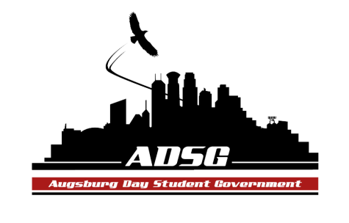
Augsburg Day Student Government Agenda
October 22, 2014
Marshall Room 6:10 PM
Members present: Christine Tang, Mohamed Safi, Winnie Godi, Ashley Parent, Emily James, Marissa Stewart, Thomas Kukowski, Cuong Nguyen, Cristian Baca-Perez, Daniel Medin, Julian Kritz, Danny Polaschek, Liban Elmi, Jabril Bonini, Elise Hinderliter, Amber Nguyen, Heath Anderson, Reies Romero, Banna Kidane, Vincent Henry, Michael LeRoy, Vision Bagonza, Adrian Lowe, Nancy Lor. (24)
Members absent: Hannah Thiry, Ahmed Musallam, Lyle Nyberg
Guests present: Chris Wallace, Priti Bhomik, Nattacia Bailey.
Advisors present: Joanne Reeck, Mike Grewe
- Call to Order 6:12 pm
- Roll Call
- Favorite part of the retreat
- Share Puppy
Mohamed SafiVision Bagonza
  - For work with the student government minutes. Congratulations!
- Adoption of the Agenda
- Soapbox
  - Chris Wallace – Orientation Leader Application
  - Currently recruiting for the student orientation leader position for the year 2015-2016
  - Very valuable leadership experience. Contact Chris and Sammy, the current SOC’s.
  - Attend the informational social in the student lounge, Thursday Nov 6th from 6:30-8 pm
- Approval of Previous Minutes
- Unfinished Business
- New Business
- Announcements
  - President:
  - Congratulations to Vision
  - Recognizes the PR committee for their work with the promotional video, as well as the student concerns committee for their work with the electronic survey.
  - Vice President:
  - Is considering the starting of a resolutions committee, so people can work on their committee.
  - There are only 4 unexcused absences that are allowed
  - Mike Grewe ordered polos, will be here next week.

  - Finance Committee:

Current budget:
Commissioning budget: $3,670
Travel fund:$86.24
Chartered groups meeting:$14,116.23

    - AASA – Pan-Asian Week
Finance committee is recommending a revised amount of $2,500 for Pan Asian Week.
Heath: Pointed out that Senator Mohamed sent a disrespectfully unwarranted email to the finance committee.

Vote: 14 for, 0 against, 2 abstained.
  - Students Concerns Committee:
  - Thanked Christine, Ashley and Liban for joining the Students concerns committee.
  - Is considering revamping their survey
Vision: Could you elaborate about the “board”?
figure of speech.
  - PR Committee:
  - Having interviews for the promo video
  - Good attendance, thank you!
  - Elections Committee:

  - Constitution Committee:

  - Will be going through by laws for clarity
  - Chartering and Commissioning Committee:
  - Community Service Committee:
  - Hannah and Elise are organizing the trick or Tr’Eat event
  - Meet at student lounge, 6 pm on October 31st
  - ASAC potentially wants to collaborate with ADSG.

  - Senators:
  - Thomas: Join ASAC for movie night next week
  - Cristian: Tomorrow, SRJ will be hosting a movie and discussion event “In Who’s Honor” in the East commons at 7pm
  - Jabril: Family Feud in student lounge, tomorrow
  - Nancy: Thank you for approving the grant
  - Daniel Medin: Tie and Scarf exchange in Anderson classroom, from 6 pm.
  - Executive Board:
  - Michael L: Strict attendance, you can miss for Augsburg related event or family emergencys.
    - Join KAUG and ASAC for a Creep Show
  - Vision: Good luck on your midterms.
  - Advisers:
- Mike: needs to talk to Heath about finance policy.
- Julian asked: How exactly do we get access to the student government key?
    - Everyone should fill in a form to request the key.
- Adjournment. 7:48pm

