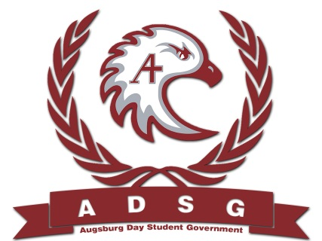
Augsburg Day Student Government Minutes
April 16, 2014
Marshall Room 6:00 PM
Day Student Government members present:

Executive board: Riley Hunter, Ibrahim Al-Hajiby, Lobar Tursunova, Ahmed Musallam, Brad St. Aubin, Amber Nguyen, Michael Fetting, Dua Saleh
Senate: Julia Laden, Lyle Nyberg, Nicole Krenz, Elise Hinderliter, Thomas Kukowski, Vincent Henry, Reies Romero, Hannah Thiry, Dan Medin, Michael LeRoy, Bram Oosterlee, Koal Williams, Amineh Safi, Cristian Baca, Tyler Ellefson, Vision Bagonza
Day Student Government members absent: Duina Hernandez, Nancy Lor, Mohamed Safi
Guests: Mike Grewe, Joanne Reeck-Irby, Banna Kidane, Kim, Jebrill

- Call to Order
- Roll Call – name – position – preferred pronoun?
- Share Puppy – Mike Amber
- Adoption of the Agenda
- Soapbox
- Approval of Previous Minutes
- Unfinished Business
- New Business
  - Government Transition
- Announcements
  - President: Banna Kidane: Swearing in the new senators
Next week – swearing in the new exec board
Scheduling our meetings, considering soar as well
  - Vice President: Vincent Henry
It will be great working with you all
  - Finance Committee:
  - Students Concerns Committee:
  - PR Committee:
  - Elections Committee:
  - Constitution Committee:
  - Chartering and Commissioning Committee:
  - Senators:
Cristian: thank you everyone for coming to the A-night and salsa night
Michael Leroy: congratulations to all for getting the leadership awards!
Ahmed: congratulation to Banna and Vincent and all the new senators!
Bram: thank you everyone for being strong throughout this whole year! We did a lot!
Ahmed: I second Bram, I am happy I was part of stud gov before graduating. Thank you.
  - Executive Board:
  - Advisers:
Mike: Congratulations everyone and thank you!
- Adjournment – 6:11pm

