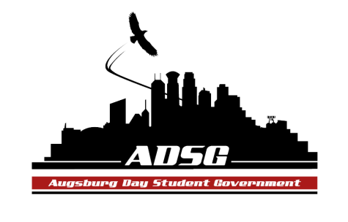
Augsburg Day Student Government Minutes
April 2, 2014
Marshall Room 6:00 PM
Day Student Government members present:

Executive board: Riley Hunter, Ibrahim Al-Hajiby, Lobar Tursunova, Ahmed Musallam, Brad St. Aubin, Duina Hernandez, Amber Nguyen, Michael Fetting
Senate: Julia Laden, Lyle Nyberg, Nicole Krenz, Elise Hinderliter, Thomas Kukowski, Vincent Henry, Reies Romero,Vision Bagonza, Hannah Thiry, Dan Medin, Michael LeRoy, Nancy Lor, Mohamed Safi, Tyler Ellefson, Bram Oosterlee, Koal Williams
Day Student Government members absent: Amineh Safi, Cristian Baca, Dua Saleh
Guests: Mai, Joanne Reeck-Irby

- Call to Order
- Roll Call – name, positions, preferred pronouns.
- Share Puppy – Riley Vincent
- Adoption of the Agenda
Nicole proposes to add point b under New Business
- Soapbox
Health Commons – outreach committee program – helping people that are marginalized in the community
Providing them with supplies that they don’t have access to
April 8th – bowl of rice event
- Approval of Previous Minutes
- Unfinished Business
- New Business
  - Voting on Budget and Stipend Proposals
Mike F moves to approve the equity stipends, the motions has been approved 16 in favor, 0 opposed, 0 abstained.
  - Voting on the Logo of ADSG
Everyone can vote
- 13 in favor
- 0
- 1
- 2
- 7
We can from now on change it up a little, improve it.
- Announcements
  - President:
Preparation for the day at the capitol was successful
If you still decide you want to go, please join us tomorrow morning
  - Vice President:
Zygoton this week, I will be presenting my research on Drones.
  - Finance Committee:
Please review the budget that we sent out
~$900 Chartered
~$2000 Commissioned
  - Students Concerns Committee:
April 16th DPS discussion panel at the Einstein
  - PR Committee: no updates
  - Elections Committee: no updates
  - Constitution Committee: no updates
  - Chartering and Commissioning Committee: no updates
  - Senators:
Hannah: campus clean-up morning, garbage bags, gloves, we will be cleaning up at 8am
Koal: tomorrow Ally training 7-9pm
Vincent: thank you, Riley, for the share puppy. Also African Art event in OGC tonight
Reies: save the kids movie night, next week, look out for flyers
  - Executive Board:
Brad: Buca Menu – circling the two selections you prefer from each course
Mike: Auggie’s Olympics are coming up, sponsored by ASAC
Duina: SRJ movie night, please join us! In Sateren from 7pm this Thursday!
Ahmed: you all are invited to the ISO Annual Banquet, check your emails for invitations!
  - Advisers: Leadership Awards next week! Please look formal.
- Adjournment – 6:47pm.

