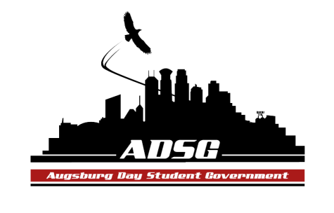
Augsburg Day Student Government Minutes
March 26, 2014
Marshall Room 6:00 PM
Day Student Government members present:

Executive board: Riley Hunter, Ibrahim Al-Hajiby, Lobar Tursunova, Ahmed Musallam, Dua Saleh

Senate: Julia Laden, Lyle Nyberg, Nicole Krenz, Elise Hinderliter, Thomas Kukowski, Vincent Henry, Reies Romero,Vision Bagonza, Hannah Thiry, Dan Medin, Michael LeRoy, Cristian Baca, Nancy Lor, Mohamed Safi, Tyler Ellefson

Day Student Government members absent: (ALL EXCUSED ABSENCES) Amineh Safi, Bram Oosterlee, Koal Williams, Brad St. Aubin, Duina Hernandez, Amber Nguyen, Michael Fetting,
Guests:
- Call to Order
- Roll Call – name, position, preferred pronoun?
- Share Puppy – Julia Laden Riley Hunter
- Adoption of the Agenda
- Soapbox
- Approval of Previous Minutes
- Unfinished Business
- New Business
- Announcements
  - President:
If you cannot make it to leadership awards please talk to Mike Grewe
  - Vice President:
    - Day at the Capitol – everyone must register, unless you have conflicts with class.
    - Training as well – everyone has to come as well, only 2 people signed up so far
    - HAPPY VIDEO – if you want to do it please sign up
    - LEADERSHIP AWARDS – please sign up
  - Finance Committee: no updates
  - Students Concerns Committee: no updates

  - PR Committee: submit your bio to Ahmed
Dua contacted A-mail about advertising the day at the capitol
  - Elections Committee: no updates
Who will announce the results of our elections to all the students?
  - Constitution Committee: no updates

  - Chartering and Commissioning Committee:
    - Augsburg Women in Computing – motion has been approved 14 in favor, 0 opposed, 0 abstained
    - Augsburg Percussion Collective - motion has been approved 14 in favor, 0 opposed, 0 abstained
    - Augsburg Women in Film - motion has been approved 14 in favor, 0 opposed, 0 abstained
    - Students for Interfaith Action - motion has been approved 14 in favor, 0 opposed, 0 abstained

Campus ministry and art club have been chartered.

- Senators:
Hannah: ASAC movie night tomorrow!!!
Lyle: movie 7pm. Gollie Art Medieval Society
Thomas: FROZEN movie
Vincent: April 16th – Jesse Cashman PANEL DISCUSSION 4-5:30pm at Einsteins. Also, Kim is holding the lighting tour, check your email!
We might have a shuttle bus service on campus (DPS)
PASU AFRICAN WEEK is next week for every day. Please join us!
Vision: Augsburg Health Commons – office is off campus and they are holding a drive to collect clothes and toiletries. Please contribute if you can
Reies: Save the Kids Radio is back on this Friday, Tune back in! we are also tabling at Pow Wow on this Saturday, we are also looking for volunteers for juvenile center, you have to be 21, see me for details
Cristian: SRJ workshop tomorrow in Old Main, Sin Nombre movie night in Sateren, ALAS salsa night on April 10th in the east commons.
- Executive Board:
Dua: Clothing drive in student lounge
Save the Kids at pow wow, listen to Reies Show please!
PASU African Week
Bi-weekly save the kids meeting next Wednesday!
Ahmed: ISO Elections at 5pm in the Augsburg Room, please come and hang out with us!
Ibrahim: Congratulations to Nicole for getting accepted at pepperdine
And Vision for getting the kemper scholarship!
- Advisers: none
- Adjournment – 6:34pm

