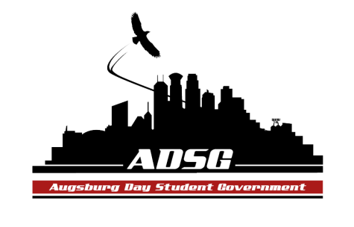
Augsburg Day Student Government Minutes
March 5th, 2014
Marshall Room 6:15 PM
Day Student Government members present:

Executive board: Riley Hunter, Ibrahim Al-Hajiby, Lobar Tursunova, Brad St. Aubin, Duina Hernandez, Amber Nguyen, Michael Fetting, Dua Saleh

Senate: Nancy Lor, Mohamed Safi, Julia Laden, Lyle Nyberg, Nicole Krenz, Elise Hinderliter, Thomas Kukowski, Vincent Henry, Koal Williams, Reies Romero,Vision Bagonza, Cristian Baca, Hannah Thiry, Dan Medin, Michael LeRoy, Amineh Safi, Bram Oosterlee, Tyler Ellefson

Day Student Government members absent: Ahmed Musallam
Guests: Michael Grewe, Banna Kidane, Amanda Scherer and Denis, Ann Garvey

- Call to Order
- Roll Call – name-position- preferred pronouns?
- Share Puppy – Cristian Duina
- Adoption of the Agenda
- Soapbox
  - Amanda Scherer (Grant Associate-Institutional Advancement: Day at the Capitol Update)
- April 3rd, very important to attend for the state grant program
- What will be at the training? It will happen in advance, packet of information, we did a video of what to expect and how to do it.
- Unfortunately there are no state grants provided for international students.
- Approval of Previous Minutes
- Unfinished Business
- New Business
- Announcements
  - President:
- Please speak up, it’s hard to hear some of you
- Brief exec check-in after this meeting
- If you are tabling, please distribute day at the capitol material

  - Vice President:
- Election campaign should not intervene with other activities that you are involved in
- Doing research in the Drones field, people of any faith can participate, hoping that it will be a larger campaign, join me on March 14th in the Augsburg Room at 6:30pm
  - Finance Committee:
- Chartered Fund - $5258
- Augsburg against gender violence grant request – guest speaker – Carlos Gomez - $2500 – Amber moves to approve the request, the motion has been approved 16 in favor, 2 opposed, 0 abstained
  - Students Concerns Committee:
- 95 Theses process is going amazing! Good exposure on campus, thank you to everyone who committed to this project.
- Friday at 2 pm we are all be nailing the thesis at the President’s door.
  - PR Committee:
- Billboard: showing our profiles, with pictures hopefully
- Tabling for day at the capitol
  - Elections Committee: - none
  - Constitution Committee: - none
  - Chartering and Commissioning Committee:
    - SISTERS FOR SUCCESS
- The motion is to charter this group, the motion has been approved 16 in favor, 0 opposed, 2 abstained
    - AUGSBURG COLLEGE WOMEN IN COMPUTING
- The motion is to charter this group,
- Lyle makes a motion to refer to the committee, Hannah seconded, the motion has been approved, 16 in favor, 0 opposed, 2 abstained

  - Senators:
- Reies – save the kids radio, women in hip-hop, and Riley, nice haircut!
- Cristian – thanks everyone who tuned in to the debate last night
- Michael – 8pm in Marshall room, appealing and hearing
- Ibrahim – our meeting next meeting will hopefully end at 7pm
- Lyle – Focus group went really well, it’s good that it’s mandatory
- Nancy – good luck to everyone who is running for the senate
- Cristian – SRJ workshop next Monday

  - Executive Board:
- Brad – each exec board member has to do a brief about their position ( 1-2pages)
- End of year celebration – some sort of restaurant? Email suggestions – some locations that we could use light rail
- Amber – movie night - Frozen – march 27th
- Duina – come to our Drag Show, this is a positive campaign, all members should stick to morals and ethics
- Dua - March 10th Save the Kids General Meeting in the Auggies Nest.
  - Advisers:
- Only 5 meetings left, can you believe that?
- Elections are on Monday thru Thursday
- ASAC is accepting applications for their new board
- Our meeting next week needs to be done by 7:15 pm
- Adjournment – 7:24pm

