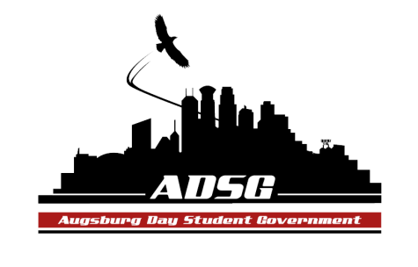
Augsburg Day Student Government Minutes
January 29, 2014
Marshall Room 6:00 PM
Day Student Government members present:

Executive board: Riley Hunter, Ibrahim Al-Hajiby, Lobar Tursunova, Ahmed Musallam, Brad St. Aubin, Dua Saleh, Duina Hernandez, Amber Nguyen, Michael Fetting
Senate: Nancy Lor, Mohamed Safi, Julia Laden, Lyle Nyberg, Nicole Krenz, Elise Hinderliter, Thomas Kukowski, Tyler Ellefson, Vincent Henry, Koal Williams, Reies Romero,Vision Bagonza, Cristian Baca, Hannah Thiry, Dan Medin, Bram Oosterlee
Day Student Government members absent: Michael Leroy, Amineh Safi
Guests:
- Call to Order
- Roll call – name, position, your favorite TV show?
- Share puppy - AmberAhmed
- Adoption of the Agenda
- Soapbox
- Approval of Previous Minutes – minutes have been adopted
- Unfinished Business
- New Business
- Announcements
  - President:- student involvement fair
  - Vice President:
    - Commissioning Process next week – no minor excuses (attendance and voting)
    - Mr. Underhill soapbox, Feb. 5th: (Wind Energy Fee progress, Environmental Stewardship Committee, Governance Task Force)
  - Finance Committee: - no grant requests
  - Students Concerns Committee:
- upcoming Monday meeting with Ann Garvey to share the survey results
  - PR Committee:
- taking pictures to update the social media
  - Elections Committee:
- emails have been sent to all the committees, look at the plan of upcoming elections
  - Constitution Committee:
- next week voting on part 2 of the constitutional changes
  - Chartering and Commissioning Committee: - none
  - Senators:
- Sunday: superbowl party in Anderson Hall by BOSS
        - PASU kickoff event
        - ISO General Meeting tomorrow 5pm in OGC 103
        - Save the Kids radio station 4-6pm on KAUG every Friday, hip-hop, r&b, social justice etc.
  - Executive Board:
-Committee chairs must email the updates to Ibrahim 24 hours prior to our meetings
- do not let any non-student gov members use our office! This is not appropriate.
- in the beginning of March there will be petitions available to be signed for the elections
- colorism panel discussion – sponsored by PASU – in the Marshall Room Feb 11 on Tuesday- please come join – everyone is welcome
- All-nighter this Saturday!!! At 8pm in Kennedy Center
- make sure you’re staffing during the office hours
- exec board check in meeting after this meeting
Advisers: not here
Adjournment: 6:30pm

