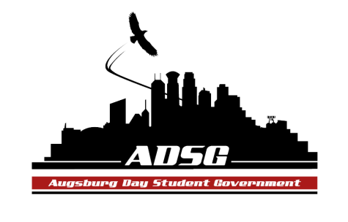
Augsburg Day Student Government Minutes
January 22, 2014
Marshall Room 6:00 PM
Day Student Government members present:

Executive board: Riley Hunter, Ibrahim Al-Hajiby, Lobar Tursunova, Ahmed Musallam, Brad St. Aubin, Dua Saleh, Duina Hernandez, Amber Nguyen, Michael Fetting
Senate: Nancy Lor, Mohamed Safi, Julia Laden, Lyle Nyberg, Nicole Krenz, Michael Leroy, Elise Hinderliter, Thomas Kukowski, Amineh Safi, Tyler Ellefson, Vincent Henry, Koal Williams, Reies Romero, Vision Bagonza, Cristian Baca, Hannah Thiri

Day Student Government members absent: Dan Medin (was late), Bram Oosterlee

Guests: Michael Grewe, Joanne Reeck-Irby,Anne Garvey, QSU,
- Call to Order
- Roll Call – Name, position, your favorite class this semester?
- Share Puppy – MikeAmber
- Adoption of the Agenda – adding new candidates to the soapbox
- Soapbox
- Austin Mishka as a candidate
- Hannah Thiri as a candidate
- Approval of Previous Minutes
- Unfinished Business
- New Business
- President Riley moves to appoint Hannah as a senior class senator, Amineh seconded, the motion has been approved 12 in favor, 1 opposed, 2 abstained.
- Hannah has been sworn in

- Announcements
  - President:
- Congratulations Hannah!
- Register for the CAO leadership institute! It is very informative, please come! Let Riley know if you cannot make it
  - Vice President:
- Register for the dinner with the board of regents
- Send Ibrahim committee email updates prior our general meetings
- If you cannot make it to the meeting, email 24 hours in advance, otherwise it is an unexcused absence.
  - Finance Committee:
- Chartered Fund: $~6,000, Commissioned Fund: $ ~6,000, Travel Fund: $0
- QSU Grant Request: $2000 – Drag Show (400 participants) – recommended is the same too, Amber moves to approve this request, the motion has been approved 16 in favor, 0 opposed,1 abstained
  - Students Concerns Committee:
- 95 thesis project
- Scheduled meetings with DPS and Anne Garvey
- Monday 2-3:30pm, Tue 10 – 11am meetings times

  - PR Committee:
- Meeting with Riley, contacting Yussuf to get pictures
  - Elections Committee: - none
  - Constitution Committee:
- Voting on Proposed Changes to the Constitution
- WEC college is transitioning, Michael Grewe has discussed them with the WEC students
- 2 categories of changes:
- First: changing the way it’s worded, grammar, etc.
now it will be AFA Student Advisory Council
- Second: major clarifications, requirements
meet with us biannually, AFA will now be a council, and ECHO will not be funded by the AFA
- 1st motion: Riley moves to approve all changes to the constitution regarding name, wording and grammar, by the consent of the senate with a stipulation that the name typo WEC be changed to AFA in section 2, clause 1; the motion has been approved 16 in favor, 0 opposed, 0 abstained.
- 2nd motion: Riley moves to approve all the remaining changes pending to the constitution, the motion has been approved 16 in favor, 0 opposed, 0 abstained.

  - Chartering and Commissioning Committee:
- Commissioning process overview
- The senate will be filling out the form for each organization on that day
- This process is starting in 2 weeks
- 25 potential student orgs
- Please take this process seriously, everyone will be voting in this process
- Some orgs are with sanctions, they will be looked at carefully
  - Senators:
- Congratulations to Hannah from Julia
  - Executive Board:
- Amber: all-nighter Feb 1st, please participate and volunteer
- Brad: new senators training tonight, committee chairs let Brad know attendance, sign up for office hours.
- Duina: sign up for the leadership institute
- Dua: she is part of racial justice based events within the community, partnering with PASU, trial session for mentoring programs with African-american people. If you know anyone who is interested, please let Dua know.
- Riley: we will invite Prof Underhill, he will talk about wind energy fee and sustainable investments

  - Advisers:
- Leadership institute registration is closing tonight
- Election committee should start meeting up, the elections are in March
- Joanne and Mike will be in Houston next week
- Adjournment: 7:10pm

