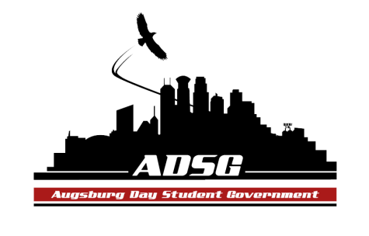
Augsburg Day Student Government Minutes
January 15, 2014
Marshall Room 6:00 PM
Day Student Government members present:

Executive board: Riley Hunter, Ibrahim Al-Hajiby, Lobar Tursunova, Ahmed Musallam, Brad St. Aubin, Dua Saleh, Duina Hernandez, Amber Nguyen,
Senate: Nancy Lor, Mohamed Safi, Julia Laden, Lyle Nyberg, Nicole Krenz, Michael Leroy, Elise Hinderliter, Thomas Kukowski, Bram Oosterlee, Amineh Safi, Tyler Ellefson, Vincent Henry, Koal Williams, Reies Romero, Dan Medin, Vision Bagonza, Cristian Baca

Day Student Government members absent: Michael Fetting

Guests: Michael Grewe, Lia Capaldini and Kaulise Lungstrom
- Call to Order
- Roll Call – name, position, favorite moment of the winter break?
- Share Puppy - Bram Mike
- Adoption of the Agenda
- Soapbox
  - Senate Candidates
  - ASAC – all-nighter – looking for volunteers
  - Kaulise –senior reception – chair position
- Approval of Previous Minutes
  - Adding WEC Student Government Members who attended to previous minutes: (Rob DeLoach, Nina Robinson, and Kimberly Chisholm).
- Unfinished Business
- New Business
  - Swearing-in Dua Saleh (PR Marketing and Promotions Officer)
  - Swearing in Cristian Baca (sophomore class senator )

  - Senior Planning Committee (Chair and Members)
Riley moves to appoint Kaulise as a chair, Michael seconds, the motion has been approved 12 in favor, 0 opposed, 0 abstained.
  - Voting on candidates
Riley moves to appoint Dan junior senator, Reies as senior senator, Koal as junior senator,Vision as sophomore senator by Secret ballot, Thomas seconds, 11 in favor, 1 opposed, 0 abstained.
The candidates have been sworn in by the President.
Congratulations!

- Announcements
  - President:
- meeting with the exec board after

  - Vice President:
- electronics are not permitted during the time of our meetings
- new senators connect with the head of staff for orientation and training

  - Finance Committee:
- Men’s Lacrosse Grant Request – asking for $2500 – Amber moves to approve this request, the motion has been approved 13 in favor, 3 opposed, 0 abstained.
- PASU Grant Request – asking for $1140 - Amber moves to approve this request, the motion has been approved 15 in favor, 0 opposed, 1 abstained

  - Students Concerns Committee:
- Members meeting
- Attend the SRJ leadership institute

  - PR Committee: none
  - Elections Committee: none

  - Constitution Committee:
- Stay after the meeting for some new business

  - Chartering and Commissioning Committee:
    - Augsburg Against Gender Violence
Michael moves to charter this group, the motion has been approved 15 in favor, 0 opposed, 1 abstained
  - Senators:
- Bram: Attend the PASU events !
- Michael: congratulations to all the new senators
- Reies: thank you and looking forward to working with all of you this semester

  - Executive Board:
- Brad: office hours – fill in the schedule, and new candidates see him after the meeting
  - Advisers:
- Leadership institute on Feb 1st – led by SRJ – exciting and amazing day! Please attend
- QSU Ally conference in Kansas

- Adjournment: 7:20 pm

