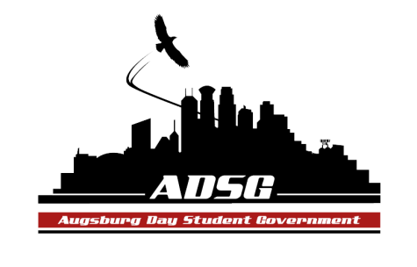
Augsburg Day Student Government Minutes
December 04, 2013
Marshall Room 6:00 PM
Day Student Government members present:

Executive board: Riley Hunter, Ibrahim Al-Hajiby, Lobar Tursunova, Ahmed Musallam, Yussuf Abdulle, Brad St. Aubin, Duina Hernandez, Amber Nguyen, Michael Fetting
Senate: Nancy Lor, Mohamed Safi, Julia Laden, Lyle Nyberg, Cuong Nguyen, Nicole Krenz, Maly Thao, Michael Leroy, Elise Hinderliter, Vincent Henry, Muna Ahmed, Thomas Kukowski, Bram Oosterlee, Amineh Safi, Tyler Ellefson

Day Student Government members absent: Kennedy Yang, Bee Vang

Guests: Michael Grewe, Joanne, Jill

- Call to Order
- Roll Call – name, position, what would you name your pet?
- Share Puppy – Riley Amber
- Adoption of the Agenda
- Soapbox
  - Jill Davenport: Central Support Services Manager
- Asking her questions about Aviand’s catering
- Michael moves to approve to extend the discussion for 5 more minutes, Nicole seconded, the motions has been approved 14 in favor, 1 abstained, 0 opposed
- Addressing the Food concerns on campus
- Riley – Marco concern
- Duina – time constrained, so many questions, what could we do better in such discussions?

  - DeVante Jackson: Junior Senator Position (affective Spring 2014)
Did not come…
- Approval of Previous Minutes
- Unfinished Business
- New Business
  - Voting on Student Organizations’ Stipends
- Bram, Muna and Vincent receive the stipends, can’t vote
- Vincent moved to divide the voting to all orgs vs ISO and PASU, the motion has been approved 12 in favor, 3 abstained,
- Michael moves to approve all the stipends excluding ISO and PASU, the motion has been approved 15 in favor, 0 opposed, 0 abstained
- Amineh moves to approve ISO and PASU stipends, Nazih seconded, 12 in favor, 3 abstained, 0 opposed

  - Voting on ADSG Executive Board Stipends (Chairperson Pro-Tempore -Bram)
- Tyler moves to approve the stipends for the executive board, Vincent seconded, the motion has been approved 14 in favor, 0 opposed, 0 abstained.

- Announcements
  - President: Thank you all for asking Jill questions
  - Vice President:
    - December 11th Meeting:
      - Joint meeting with WEC Student Government
      - Jesse Cashman: Director of Public Safety
      - Ann Garvey
  - Finance Committee:
- Campus ministry and ALAS approved grant requests
- AUG Chemistry Society – sweatshirts request – 60 people, recommended $900, Amber moves to approve their request, the motion has been approved 12 in favor, 2 abstained, 1 opposed.
- AASA Lunar Year – 300 people – recommended $3500 - Amber moves to approve their request, the motion has been approved 15 in favor, 0 abstained, 0 opposed.
  - Students Concerns Committee:
- Sorting and evaluating the surveys
- Tabling on Friday
- Riley – will the survey be helpful? Bram – of course it helps, the survey is much more detailed and focused.
- Amineh – the survey shows that we are willing to change something on campus, EVERYONE should fill out this survey
- Michael – where to find the survey? The first drawer in our office
- Nancy – for how long is the survey going for? Till the end of the semester perhaps
- Duina- the results will be showed to the students

  - PR Committee: none
  - Elections Committee: none
  - Constitution Committee: none
  - Chartering and Commissioning Committee:
- Commissioning process is coming up
  - Senators:
Amineh – do not take my questions personally
Nancy – thanks for all the hard work! And please come to the Lunar New Year (in February)
Muna – SRJ event right now, thanks everyone!
  - Executive Board:
Amber – thanks everyone for your attention
Yussuf – I’ve been missing meetings, I appreciate the time off, kids were sick, I decided to step down next semester
  - Advisers: none

- Adjournment.
7:12 pm

