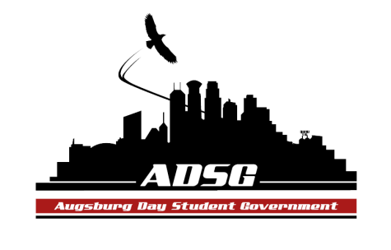
Augsburg Day Student Government Minutes
November 13, 2013
OGC 100 6:10 PM
Day Student Government members present: Riley Hunter, Ibrahim Al-Hajiby, Lobar Tursunova, Ahmed Musallam, Brad St. Aubin, Duina Hernandez, Amber Nguyen, Michael Fetting, Matthew Schirber, Bram Oosterlee, Amineh Safi, Cyle Jurvelin, Julia Laden, Cuong Nguyen, Maly Thao, Nicole Krenz, Michael Leroy, Bee Vang, Lyle Nyberg, Nancy Lor, Mohamed Safi, Thomas Kukowski, Vincent Henry, Tyler Ellefson

Day Student Government members absent: Yusuff Abdulle, Kennedy Yang

Guests: Michael Grewe, Joanne Reeck-Irby, Laura Roller, MSA members, Riahl O-Malley

- Call to Order
- Roll Call – Name, position, favorite ice cream flavor?
- Share Puppy – Mike Fetting Duina Hernandez
- Adoption of the Agenda
- Soapbox
  - Laura Roller: Day at the Capitol (April 3, 2014)
- Organized by the MN Private Colleges Council
- Students meet with their own state representatives (your home district)
- Starts at 9, talk about the experience, have lunch, transportation is taken care of
- New things: Prof Underhill made it as a requirement for his class, training sessions for students.
- ALL ADSG members are expected to attend this event
- Prize drawings – thank you for participants

  - Riahl O-Malley: CTUL
- Graduate student – volunteer for CTUL
- Target and genitors, there is wage theft etc.
- If you are passionate about the human rights, please join and support
  - Muslim student association
- THANK YOU
- EID event was very successful
- Your help means a lot to our organization
- Approval of Previous Minutes
- Unfinished Business
- New Business
- Announcements
  - President:
- Veto vote for the Delta request
- The finance committee recommended the lower price than asked initially
- Disproportionate distribution of money, thus
- Riley wants to vote down this request
  - Vice President:
- Campus light tour with Jesse (DPS) – ADSG members identify places that are dark, to ensure safety for all the students – this already happened - so in case if that happens again, Joanne will need students
- Chairs: even if you don’t have updates send an email to Ibrahim, 27 hours prior to the meeting
  - Finance Committee:
- Chartered: $11,960.89
- Commissioned: $13,097.63
- Travel fund: $2,848.00
- Unbounded - Math Jeopardy party request – in Hoversten chapel - $1250 – Amber moves to approve this grant request, the motion has been approved 15 in favor,1 abstained, 0 opposed
- PASU – Spring break trip to Chicago, asking $3600, recommended $1000, Amber moves to approve $1000, the motion has been approved 14 in favor, 2 abstained, 0 opposed
- Augsburg Chemistry Society – Augsburg Chemistry sweatshirts – asking $3000, recommended $0, the motion failed during the committee meeting.
  - Students Concerns Committee:
- Compilation, will possibly discuss it next meeting, tabling on Friday

  - PR Committee:
- The website is updated!
- Making a poster for students savings club
  - Elections Committee:
- Find recommendations for the empty seat in our senate!
  - Constitution Committee:
  - Chartering and Commissioning Committee:
- If you are a board member to apply for commissioning - let Michael know – meeting tomorrow
  - Senators:
- Vincent: thank you for granting the PASU request
- Bram: ISO event – tonight at 8pm – International hangout
  - Executive Board:
- Amber: Look at the budget that Ibrahim sends you in the email
- International Speed Dating tomorrow! Please come!
- Duina: SRJ discussion group in old main 105
- Mike: equity task force: meeting tomorrow!
- Matthew: discussions at Trinity church
- Riley: maybe collaborating with the WEC government

  - Advisers:
- Auggies Nest – new furniture!
- Everyone! – bring names to fill the empty vacancy

- Adjournment: 7:07 pm

