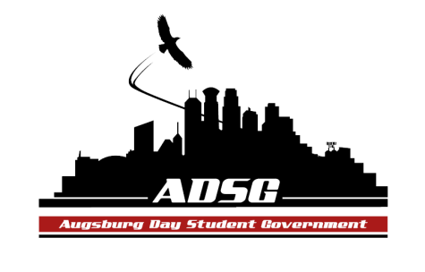
Augsburg Day Student Government Minutes
November 6, 2013
OGC 100 6:10 PM
Day Student Government members present: Riley Hunter, Ibrahim Al-Hajiby, Lobar Tursunova, Ahmed Musallam, Brad St. Aubin, Duina Hernandez, Amber Nguyen, Michael Fetting, Matthew Schirber, Bram Oosterlee, Amineh Safi, Cyle Jurvelin, Julia Laden, Cuong Nguyen, Maly Thao, Nicole Krenz, Michael Leroy, Bee Vang, Lyle Nyberg, Nancy Lor, Mohamed Safi, Thomas Kukowski, Vincent Henry, Tyler Ellefson

Day Student Government members absent: Yusuff Abdulle, Kennedy Yang,

Guests: Michael Grewe, Joanne Reeck-Irby
- Call to Order
- Roll Call – Name, position, what’s your favorite movie?
- Share Puppy Amineh Mike Fetting
- Adoption of the Agenda
- Soapbox
- Approval of Previous Minutes
- Unfinished Business
- New Business
- Announcements
  - President: - none
  - Vice President:
No meeting on the 27th

  - Finance Committee:

Grant request – QSU - $5,600 28 people to Kansas
Amber makes a motion to approve this Grant request, the motion has been approved 13 in favor, 0 opposed, 3 abstained.
Grant request – Omicron Delta – recommended $800 - original request $1530
- approx. 50 people
Amber makes a motion to approve this Grant request, the motion has failed 5 in favor, 9 opposed, 2 abstained.
Why not approved? – there are no benefits to the main Augsburg Community

  - Students Concerns Committee:
Working on compilation
Goals will be presented next week
915 thesis
Tabling again
From MSA – Aviand’s concern – meat mixed with beef and pork?
maybe make a food task force team, collect surveys and etc.
  - PR Committee:
Ahmed is designing posters
website will be done and ready in 2 days
  - Elections Committee:
Still looking for a Junior Class senator, Riley and Ibrahim will bring recommendations
  - Constitution Committee: none
  - Chartering and Commissioning Committee:
Gamers United – want to be chartered
EnviroPeace
Michael makes a motion to charter both of these organizations
Thomas moves to divide the question, Nicole seconds, the motion had been approved16 in favor, 0 opposed, 0 abstained
Michael makes a motion to charter Gamers United, the motion has been approved, 3 abstained, 12 in favor, 0 opposed
Michael makes a motion to charter EnviroPeace, Vincent seconds, the motion has been approved 1 abstained, 14 in favor, 0 opposed

  - Senators:
Cyle – Thank you, Duina for great work!!!
Bee – is there a way of getting info agenda prior to the meeting, so senators have more time to think about it and decide on
Ibrahim – make a deadline for the reports, send agendas on Tuesdays, and it will be sent out to all of us.
Nicole – thank you all for approving EnviroPeace
  - Executive Board:
Amber – Happy Birthday to Lobar
Mike – stipend equity task force! Amazing work! Meeting at 5:15pm tomorrow
Duina – thanks for approving the QSU grant request
Ahmed – International Education Week – 4day event – please come
Riley – everyone please come on time!
  - Advisers:
Joanne – we are getting all the new furniture in the Auggies Nest next Wednesday
Michael – OL application
Amber and Mike send an email informing chartered and travel budget
Ibrahim see Michael at the end

- Adjournment: 7:00pm

