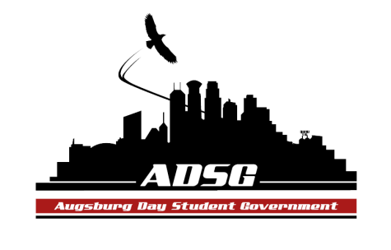
Augsburg Day Student Government Minutes
October 23, 2013
Marshall Room 6:10 PM
Day Student Government members present: Riley Hunter, Ibrahim Al-Hajiby, Lobar Tursunova, Ahmed Musallam, Brad St. Aubin, Yusuff Abdulle, Duina Hernandez, Amber Nguyen, Michael Fetting, Tyler Ellefson, Matthew Schirber, Bram Oosterlee, Amineh Safi, Cyle Jurvelin, Julia Laden, Cuong Nguyen, Maly Thao, Nicole Krenz, Michael Leroy, Bee Vang, Lyle Nyberg, Nancy Lor, Mohamed Safi, Thomas Kukowski

Day Student Government members absent: Kennedy Yang, Jacarri Roberson, Vincent Henry

Guests: Michael Grewe, Joanne Reeck-Irby

- Call to Order
- Roll Call – name-position-favortie color?
- Share Puppy – Kennedy Bee
- Adoption of the Agenda
- Soapbox
- Approval of Previous Minutes - (Bee added to the present members) minutes have been adopted
- Unfinished Business
- New Business
- Announcements
  - President:
  - Vice President:
- President Pribbenow visit to ADSG – be here! wear your polos!
There will be refreshments and socializing with the President
- Race relations at Augsburg College (Eli Grobel)
Survey created by this alum, connect with him! Need his input into the Student Concerns committee
  - Finance Committee:
- Dance team grant request has been tabled
- ISO grant request for the International Educational Week has been approved
- Making 2 amendments : the min of $25,000 from the commissioned fund will be lowered to $15,000
Amounts up to and equal to $10,000 need to be submitted 2 weeks in advance
Amounts over $10,000 need to be submitted 4 weeks in advance
These amendments are primarily made so that $10,000 from the commissioned funds can be transferred to the chartered fund
  - Students Concerns Committee:
- Successful tabling this week – THANK YOU EVERYONE
- General student concerns: food and Marco services
- What date for the next tabling?
  - PR Committee:
- Web meeting today, was very useful and insightful for Yussuf
- Fill out the Bio form!!! that Ahmed sent
- Taking pictures for the website next week
  - Elections Committee: - none
  - Constitution Committee: - none
  - Chartering and Commissioning Committee:
- Presenting the constitution of AMAC (Augsburg Manga and Anime Club) they want to be chartered.
- Michael moves to approve AMAC to be a chartered organization, the motion has been approved 13 in favor, 1 opposed, 0 abstained.
  - Senators:
- Idea: Making an online anonymous website for the students to submit their concerns
- THANKS Brad for the new polos!!!
  - Executive Board:
- Next Monday – Pumpkin carving contest, only 20 spots! 7-9pm
- THIS FRIDAY – MSA Eid at 7 pm. Please come!
- Riley meet with PR Committee
  - Advisers:
- Commissioning committee - Michael is coming to explain the process
- Finance committee - come up with a recommendation of student fee
- Create a stipend equity task force – make a recommendation
- Rev Mark speaks at the East commons on Tuesday – LGBT ally from Uganda
- Adjournment – 6:42 pm

