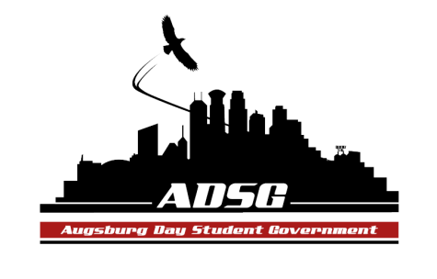
Augsburg Day Student Government Minutes
October 16, 2013
Marshall Room 6:10-8:00pm
Day Student Government members present: Riley Hunter, Ibrahim Al-Hajiby, Lobar Tursunova, Brad St. Aubin, Yusuff Abdulle, Duina Hernandez, Amber Nguyen, Michael Fetting, Tyler Ellefson, Matthew Schirber, Bram Oosterlee, Amineh Safi, Kennedy Yang, Vincent Henry, Cyle Jurvelin, Julia Laden, Cuong Nguyen, Maly Thao, Nicole Krenz, Michael Leroy, Bee Vang

Day Student Government members absent: Ahmed Musallam, Lyle Nyberg, Nancy Lor, Mohamed Safi, Jacarri Roberson, Thomas Kukowski,

Guests: MSA members

- Call to Order
- Roll Call – Name & Position
- Share Puppy – Duina Kennedy
- Adoption of the Agenda

- Soapbox
- MSA (Grant Request for Eid Event)
- They will have a religious speaker, talk about the importance of Eid celebration
- Bringing awareness to Islam as a whole

- Approval of Previous Minutes

- Unfinished Business
- MSA Grant Request of $11,669.11
- No decision made(no quorum) in the Finance committee, now it is up to the Senate
- Amber moves to approve the request, Michael Leroy seconds, the motion has been approved 11 in favor, 1 opposed, 1 abstained

- New Business - None

- Announcements
  - President-Riley Hunter:
  - Vice President-Ibrahim Al-Hajiby:
- President Pribbenow will visit our meeting October 30
- Reception for the first 30 minutes
- Thank you all for coming to the retreat! Review Robert’s Rules, challenge the process with reasons!
  - Finance Committee: - None
  - Students Concerns Committee:
- Tabling on Monday 10:30-2pm
- Starting a facebook page – anonymous concerns (more research needed) – some negatives and positives about this…
- Ahmed will create a website, thus a forum for student’s concerns
  - PR Committee:
- Working on pictures from the retreat, ECHO will be interested in publishing the experience of FLR 2013
- Setting up our first meeting- look out for an email from him
  - Elections Committee: - None
  - Constitution Committee: - None
  - Chartering and Commissioning Committee:
- Follow up with the 2 groups, hopefully the work will be done!
- Contacting groups if they want the Lacrosse equipment from our office
  - Senators:
- Cyle: come support the volleyball game tonight!
- Nicole: Enviropeace group starting
- Bram: tomorrow ISO General Meeting at 5:20pm
- Cuong: recruiting new OL’s, apply online, talk to him, deadline November 12

  - Executive Board:
- Brad: committee chairs! Send him an email of attendance list
- Riley: November 21st event, Homelessness
- Duina: ALLY training at 9:30pm in the fishbowl . Retreat on Sunday(LGBTQIA)

  - Advisers: not here

- Adjournment – 6:45 pm

