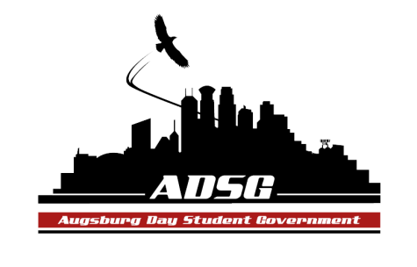
Augsburg Day Student Government Minutes
October 9, 2013
Marshall Room 6:10-8:00pm
Day Student Government members present: Riley Hunter, Ibrahim Al-Hajiby, Ahmed Musallam, Lobar Tursunova, Brad St. Aubin, Yusuff Abdulle, Duina Hernandez, Amber Nguyen, Michael Fetting, Tyler Ellefson, Matthew Schirber, Bram Oosterlee, Amineh Safi, Kennedy Yang, Vincent Henry, Cyle Jurvelin, Jacarri Roberson, Julia Laden, Nancy Lor, Mohamed Safi, Lyle Nyberg, Cuong Nguyen, Maly Thao, Nicole Krenz, Michael Leroy.

Day Student Government members absent: Bee Vang

Guests: Michael Grewe, AASA and ALAS members.

- Call to Order
- Roll Call – Name & Position
- Share Puppy – Brad Duina
- Adoption of the Agenda
- Vincent motions to add ALAS and AASA to the soapboax, motion has been approved.
- Soapbox
- Thomas Kukowski (Senior Senator Position)
- Sharing the FLR experience: An unforgettable experience for all the students who went, creating connection, becoming one family, thank you ADSG for the grant! Every penny was worth the experience.
- Approval of Previous Minutes
- Unfinished Business

- New Business
- Swearing-in appointed Senior Senator
Riley moves to appoint Thomas Kukowski as a Senior senator, the motion has been approved 14 in favor, 0 opposed, 1 abstained.

- Announcements
  - President-Riley Hunter:
- Retreat on Sunday!
  - Vice President-Ibrahim Al-Hajiby:
- in the Marshall Room from 12 to 6pm
  - Finance Committee:
- Grant request from Community Link – Halloween side block - $1430 – Amber moves to approve the request, the motion has been approved 15 in favor, 0 opposed, 0 abstained.
- Grant request from Augsburg Chemistry society – Halloween party - $1850 - Amber moves to approve the request, the motion has been approved 13 in favor, 0 opposed, 2 abstained.
  - Students Concerns Committee:
- Cyle has an idea of encouraging everyone to attend the meeting where you learn about gender issues, mandatory for DPS, to create a respectful environment on campus.
- Creating a subcommittee
  - PR Committee:
- Taking photographs at the retreat!
  - Elections Committee: - None
  - Constitution Committee: - None
  - Chartering and Commissioning Committee:
- 2 discussions tomorrow
- Beatbox group, Michael makes a motion to approve them as chartered organization , the motion has been approved 9 in favor, 2 opposed, 4 abstained.
  - Senators:
- Welcome to all the new members
- The FLR was a huge success for all the student groups!
- Every member has to sign up for 2 committees
- Anyone can join the student concerns committee
  - Executive Board:
- Thanks to Michael Leroy for organizing and cleaning the office
- Duina: QSU week, gender-neutral bathrooms for one day, taking pictures in a rainbow attire, please come and join, and support!
- Surplus of student activities fee: renovating the Auggie’s Nest, it will be a good space for group meetings!
- It is great that we are all supporting the gender-neutral language
  - Advisers:
- You all have a right to create your own (new) committee! (FYI)
- Michael Leroy – contact the president of Beatbox
- To all the new senators: Meet up one on one with Michael.
- Adjournment

