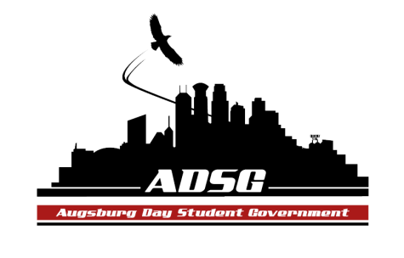
Augsburg Day Student Government Minutes
October 2, 2013
Marshall Room 6:10 PM
Day Student Government members present: Riley Hunter, Ibrahim Al-Hajiby, Ahmed Musallam, Lobar Tursunova, Brad St. Aubin, Duina Hernandez, Amber Nguyen, Michael Fetting, Bram Oosterlee, Vincent Henry, Matthew Schirber, Michael Leroy,Yusuff Abdulle, Maly Thao, Cuong Nguyen, Nicole Krenz, Cyle Jurvelin, Kennedy Yang, Bee Vang, Mohamed Safi, Amineh Safi, Lyle Nyberg, Nancy Lor, Julia Laden, Tyler Ellefson.

Day Student Government members absent: Erickson Saye

Guests: Michael Grewe, Joanne Reeck-Irby, Prof. Underhill, Patrick DuSchane, Kim(WEC Senate).

- Call to Order
- Roll Call - Name, Position, What clubs are you part of and Favorite thing about Augsburg?
- Share Puppy - Ibrahim Al-Hajiby Brad St.Aubin
- Adoption of the Agenda
- Soapbox
  - Prof. Underhill: Wind Energy fee
- Engage in campus progress – what can we do with the policy? And how to implement it?
- Met up with the local constructor who installs wind energy
- Cost = 2 million dollars to install
- Anyone who is interested, please join this new committee
- Community solar garden: serving just as a location
- Automatically our electricity annual bill will go down + LED lights

  - Patrick DuSchane: Mayoral Campaign Internships
- Candidates need help – recruiting new members
- 3 spots open right now – if you are interested in politics and law
- It’s a volunteering internship till November 5th
- Approval of Previous Minutes
- Unfinished Business
- New Business
  - Swearing-in of Senator-Elects
- Congratulations! And Welcome!
- Announcements
  - President:
- Appoint Tyler Ellefson as combatant senator
  - Vice President:
- Retreat Date: Sunday Oct. 13, 13 (12:00-6:00pm)
- Optional outing, Dinner at a nice place (dressed up)
- Name tags and position, send it to Brad
- You have to be a part of 2 committees
- Going through Parliamentary Procedure for Meetings
  - Finance Committee:
- Cheer Team (chartered org) - Amber moves to approve $200 per person ($1300 in total), the motion fails 5 in favor, 8 opposed, 2 abstained.
  - Students Concerns Committee:
- Welcome all the new senators!
- Please become a member and sign up
- SRJ – first workshop on Monday 4-6:30 pm open discussion
  - PR Committee:
- If you are interested, please sign up
- Introducing ADSG to the student body!(on the website)
  - Elections Committee:
- Candidate Recommendations
- Thank you Brad and Michael for all the hard work
- Still have open spots! Junior class senator
  - Constitution Committee:
- Meeting less frequently
  - Chartering and Commissioning Committee:
- Last week met up with EnviroPeace
- Tomorrow meeting with Beataugs (singers)

  - Senators:
- Cyle – gender neutral campus – be respectful!
  - Executive Board:
- Brad – absences! Your commitment is important. Wednesdays, committee meetings, office hours! Respond to emails as quick as possible! Email me a preferred name for your tag
- Michael – we have to email the cheer team why their grant request was denied…
Discussion: Against - how frequently will these outfits will be used? Is there a limit on how much they can request.
For – all the unused money will be returned to the budget
- Lyle motions to reconsider the grant request, the motion has been approved 10 in favor, 4 opposed, 1 abstained.

  - Advisers:
- Great job on the first meeting to the new senators
- Get a key from the office
- Meet up with Mike or Joanne to go over the details of your position
- This is not a high-school council, this is a formal official structure
- We are given rights, authority, power and responsibility – please take it seriously!
- Always be on time!
- There is an ALLY training next Tuesday 6-8pm

- Adjournment

