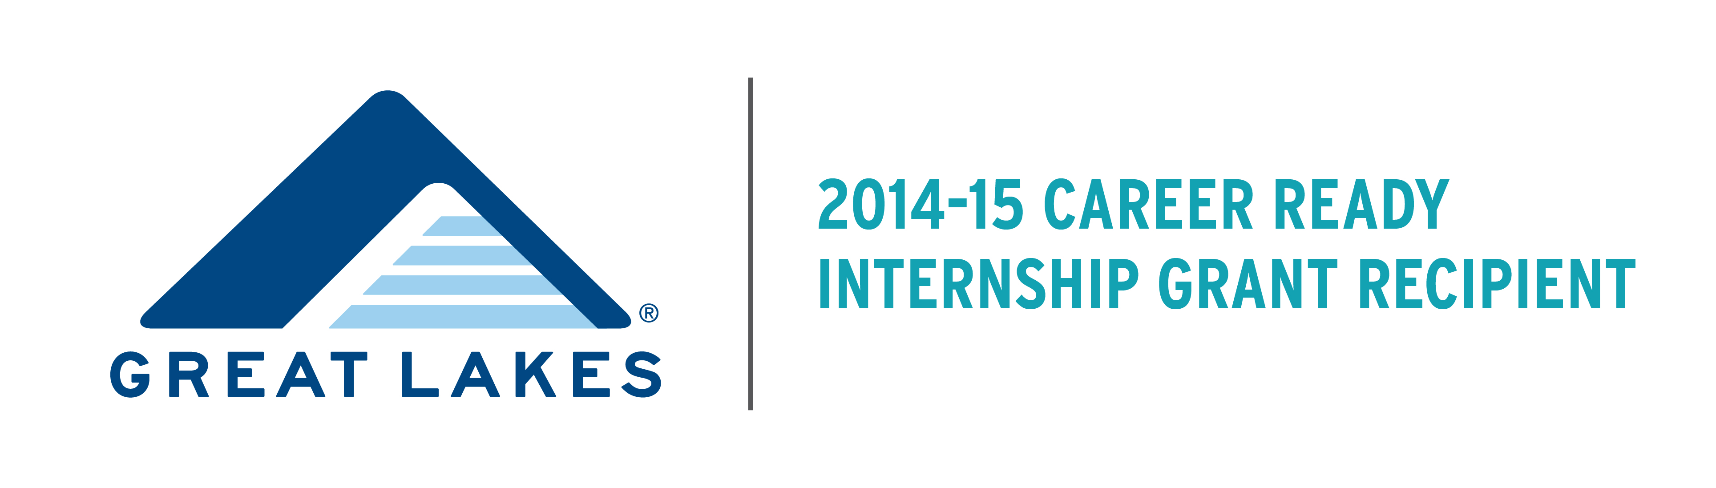STUDENT FAQ
What is the Great Lakes Career Ready Internship Grant?
The Great Lakes Career Ready Internship Grant was created in recognition that internships are both an important recruiting strategy and a key way for students to gain real-world, academically-connected career knowledge. Understanding that students who demonstrate financial need are often unable to pursue unpaid internships for financial reasons, the purpose of the Program is to create paid internship opportunities for these students, and to provide the support which will enable them to succeed within these opportunities.

How is the Great Lakes Career Ready Internship funded?
Augsburg College and several other colleges and universities in Minnesota were awarded a year-long Career Ready Internship Initiative grant from Great Lakes Higher Education Guaranty Corporation. Augsburg College received the grant in order to help foster student success through the creation of paid, meaningful career-related internships for juniors and seniors with demonstrated financial need for Fall 2014, Spring 2015 and Summer 2015. For more information on Great Lakes Higher Education Guaranty Corporation, please click here: http://www.mygreatlakes.org
Eligibility Requirements
Student Requirements:
1. Students must be at Junior or Senior status at time of the internship. Rising Juniors (2nd semester sophomores) are eligible for Summer 2015 internships only.
2. Students must be work study eligible as determined by the Free Application for Federal Student Aid (FAFSA).
3. Students must maintain Title IV Satisfactory Academic Progress. These requirements can be found at: here.
4. Under the stipulations of the grant maker, the following students are not eligible:
- International students
- Graduate students
- Students participating in student teaching and nursing practicums
- Students who have graduated.

Internship Requirements:
1. Internships during the academic year will be 12 hours per week for 16 weeks. Duration of summer internships will be 25-40 hours per week for 10-12 weeks.
2. Internships must be directly related to the student's major and provide the student with meaningful major-related work experience.
What internship opportunities are available through the grant?
Students may already have an internship site arranged OR obtain assistance finding an internship site through Career & Internship Services in the Strommen Center, The SABO center, or the STEM programs at Augsburg.
All available internships will be posted on AugPost. Use Employer keyword search “Great Lakes Grant”.
How do I apply for an internship through the Program?
You application involves TWO steps, applying for the grant itself AND applying for a specific internship.

1. Apply for the grant using the Augsburg College Human Resource Department work study system. The work study application will simply determine your eligibility for the Great Lakes grant.
  - Search for “Student: Great Lakes Grant Internship”.
  - Submit your resume through the online work study system
  - Answer the following questions on your application:
- Do you meet ALL of the eligibility criteria?
- How will this internship relate to your major?
- Do you have a site already arranged?
- Why is obtaining this grant and/or internship important to you?
- During what term would you like to do your internship? Spring 2015 or Summer 2015.
*You will receive a confirmation email upon completing the work study application.
2. Once approved through the work study system, apply directly to the organization hosting the internship using the AugPost system. *If you have already secured an internship site on your own, you will NOT need to complete this step in the process.
- Go to Augpost
- Login using your Augsburg email address and AugNet password
- Select “Internships/Jobs/Volunteer” under the “Augpost Internship/Jobs/Volunteer” tab
- Click on “Advanced Search” on the right-hand side of the page
- Choose “Internship-Paid” and “Internship-Unpaid” in the Position Type box
- Click “search”
- Click the “apply” button for internships that interest you and follow the application instructions for each position
What’s the deadline to apply?
Priority consideration will be given to students who apply FOR THE GRANT by November 15th. However, due to student interest, the deadline to apply has been extended to December 27th. Students who apply after the priority deadline cannot be guaranteed grant funding.

How do I get selected for the internship?
Augsburg staff will determine your eligibility for the grant and employers will select interns for their organization. Employer processes and requirements vary, but most internship sites will be selecting students through a combination of evaluating applications and conducting interviews.

When do I begin my internship?
Internships will take place during Spring 2015 or Summer 2015 semesters. Exact start dates will be determined by the intern and the organization.

How much will I be paid?
The average pay is $10 per hour (with a range of $10-$13 an hour). Students will be paid by Augsburg College, rather than directly by the employer. Some employers may choose to contribute additional hourly pay to the intern salary.
Can I do an internship for credit?
Yes. Students can choose an internship for credit or not-for-credit. Students choosing to do the internship for credit must follow the Augsburg requirements for doing so. Students choosing to do a Great Lakes funded internship not-for-credit will be required to follow the Augsburg Experience requirements. Details for each requirement can be found on the Strommen website.

Whom can I contact with additional questions?
Please email: greatlakesgrant@augsburg.edu

612-330-1148

