

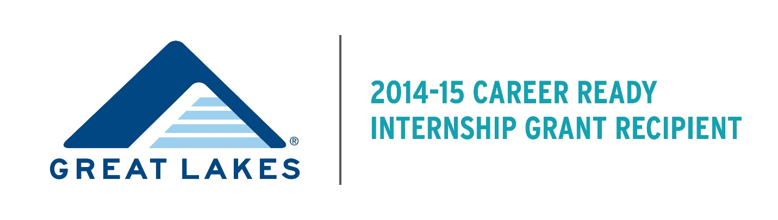

**EMPLOYER FAQs**

**What is the purpose of the Great Lakes Career Ready Internship Grant?**

The Great Lakes Career Ready Internship Grant was created in recognition that internships are both an important recruiting strategy and a key way for students to gain real-world, academically-connected career knowledge. Understanding that students who demonstrate financial need are often unable to pursue internships for financial reasons, the purpose of the Career Ready Internship Program is to create funded internship opportunities for these students and enable them to succeed in these opportunities. This Program is funded by a grant from the Great Lakes Higher Education Guaranty Corporation. This program funds internships for Spring 2015 and Summer 2015.

**What does this program do for my organization?**

As a participant in the Great Lakes Career Ready Internship Grant, your organization would be able to convert an existing, unpaid internship into a paid internship and/or to create a new, paid internship for an Augsburg student with financial need.  This would make your internship more accessible and attractive to students. Your organization would also gain greater visibility among Augsburg faculty, staff and students as a participant in the program.  Lastly, you may be able to add interns to your organization in an area that previously had no such opportunities.

**What are my responsibilities if my organization is selected?**

* Provide meaningful projects to your Augsburg intern with no more than 20% of their time dedicated to administrative tasks (filing, etc.).
* Provide supervision, including meeting on a regular basis to discuss responsibilities and progress/performance.
* Track student hours and respond to Augsburg College requests to confirm hours worked.
* Adhere to the Fair Labor Standards act (<http://www.dol.gov/whd/flsa/>).
* Complete all evaluation materials sent to you by Augsburg College.  This will include an evaluation at the end of the internship.
* Schedule willing, attend Augsburg’s year-end intern and employer reception.
* Pay any applicable FICA costs (7.67% of wages earned) when invoiced by Augsburg College. (summer internships only).   
             **Average cost to organization for summer interns (June-August)**                 20 hours a week x 12 weeks @ $10 hour =  approximately $185   
                40 hours a week x 12 weeks @ $10 hour =  approximately $370

**Can I apply to convert or create more than one internship?**

Yes, organizations are not limited in the number of applications they submit to create a paid internship or convert previously unpaid internships into paid internships. Organizations should submit a separate application for each internship they hope to convert or create.

**What guidance is available for organizations interested in creating new internships?**

Guidelines provided by the [National Association of Colleges and Employers](https://www.naceweb.org/internships/index.aspx) and the [Minnesota Association For Experiential Learning (MAFEL)](http://www.macalester.edu/mafel/resource.htm) provide many resources that can help your organization develop and/or improve your internship opportunities.  Both organizations provide guidance on best practices as well as tools that can help you ensure your internship is successful for your organization and the student.  In addition, Augsburg staff are available to answer questions, provide guidance, and share insight regarding your internship.

**Can I hire more than one student with the same internship title/description?**

We do not anticipate being able to fund multiple students in the same internship at any one internship site.  However, we are open to discussing this with organizations and will make a decision based on student interest and employer need.

**What does the EMPLOYER selection process look like?**

* Employers will complete and submit an online application by November 15, 2014.  The application can be accessed [here](http://augsburg.az1.qualtrics.com/SE/?SID=SV_0dlcNJhAg2E6F6t). Employers that apply after this priority deadline will be considered on a case-by-case basis.
* A committee made of faculty and staff from Augsburg College will select employers to create new internships/convert existing unpaid internships to paid internships.  *The committee will prioritize employers that have applied by the application deadline but may also consider additional employers on a rolling basis throughout the year.
* If your organization is selected, Augsburg College will post your internship, market the opportunity to students, and assist you in finding qualified candidates.  *Your organization will be responsible for selecting and interviewing internship candidates.
* Once your organization selects an intern and begins the internship, Augsburg and your organization will work together to monitor hours and complete the employer requirements mentioned above.

**Will I receive funding to disburse to the student? How will students be paid?**

Student interns will be paid by Augsburg College.  Employers will be responsible for FICA expenses for summer internships (Augsburg will pay FICA and invoice those organizations at the end of the summer).

**How much will students be paid?**

Internship salaries may vary, however, most internships will be paid at a rate of $10.00/hour.  If internships warrant a higher hourly rate, this will be considered by the Augsburg committee.  *Augsburg respectfully asks employers to contribute 25% of the internship hourly rate, if this is feasible for the organization.

**Is this funding renewable?**

The Great Lakes Career Ready Internship Grant is funded through a one-year grant from the Great Lakes Higher Education Guaranty Corporation. At this time, internship funding is available for 2014-2015 only.

**Can I offer full-time internships to students?**

The Program provides funding for 16-week, 12 hour/week internships for spring 2015 and 12-week, 25-40 hour/week internships for summer 2015.

**Can I apply to create or convert an internship that takes place outside the Minneapolis area?**

Yes, we encourage employers outside the Minneapolis area to apply to create or convert their internships, particularly for the summer 2015 timeframe. We particularly encourage alumni in cities outside Minneapolis to consider applying to create or convert internships.

**Can I apply to create or convert an internship that takes place outside the U.S.?**

No, internships must take place in the United States.

**Which students are eligible to participate in this program?**

To be eligible for a grant-funded internship, the student must have junior or senior year status, have completed the FAFSA covering the internship period, be maintaining [Satisfactory Academic Progress](http://inside.augsburg.edu/studentaffairs/studentguide/satisfactory-academic-process/) as defined by Augsburg College, and demonstrate financial need.

**Who will make the final hiring decisions?**

Augsburg College students who meet eligibility requirements will be invited to apply for internship opportunities created through and funded by the Great Lakes Career Ready Internship Grant. Augsburg staff will screen students for eligibility, but these students will apply directly to participating employers. Employers will select the students they want to hire as interns.

**What if I am able to have my internship created/funded and can’t find a good fit among the applicant pool?**

In cases where a match cannot be found between the participating employer and the applicant pool, we will discuss the situation with the employer. Potential solutions include reopening the application process to seek more applicants and seeking alternate employers to participate. Employers who cannot find a good fit among the applicant pool may be unable to participate formally in the program.

**Whom can I contact with additional questions?**

**Email:** greatlakesgrant@augsburg.edu

**Keith Munson**, Director of the Strommen Center for Meaningful Work  
612-330-1474

**Sandy Tilton,** Strommen Center for Meaningful Work, Great Lakes Grant Coordinator  
612-330-1472