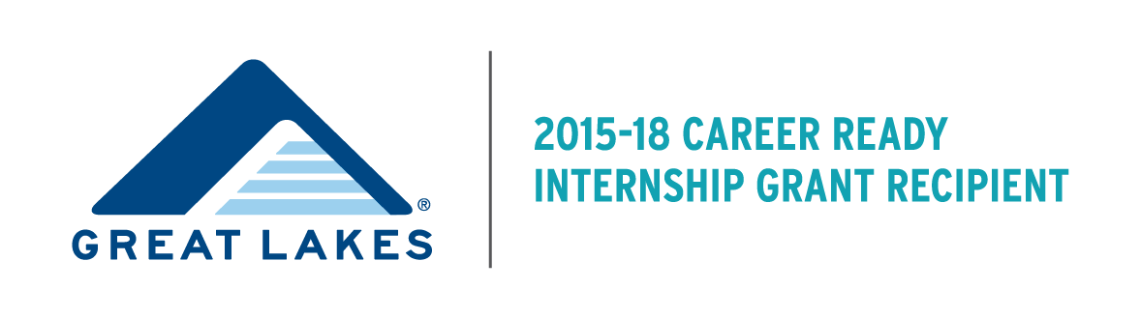STUDENT FAQ
What is the Great Lakes Career Ready Internship Grant?
The Great Lakes Career Ready Internship Grant was created in recognition that internships are both an important recruiting strategy and a key way for students to gain real-world, academically-connected career knowledge. Understanding that students who demonstrate financial need are often unable to pursue unpaid internships for financial reasons, the purpose of the program is to create paid internship opportunities for these students, and to provide the support which will enable them to succeed within these opportunities.

How is the Great Lakes Career Ready Internship funded?
Augsburg College was awarded a three Career Ready Internship grant from Great Lakes Higher Education Guaranty Corporation. Augsburg College received the grant in order to help foster student success through the creation of paid, meaningful career-related internships for juniors and seniors with demonstrated financial need. The grant will span three years, from Spring semester 2016 through Spring semester 2018. For more information on Great Lakes Higher Education Guaranty Corporation, please click here: http://www.mygreatlakes.org
Eligibility Requirements
Student Requirements:
1. Students must be at Junior or Senior status at time of the internship.
2. Students must be work study eligible as determined by the Free Application for Federal Student Aid (FAFSA).
3. Students must maintain Title IV Satisfactory Academic Progress. These requirements can be found at: here.
4. Under the stipulations of the grant maker, the following students are not eligible:
- DACA or undocumented students
- International students
- Graduate students
- Students participating in student teaching and nursing practicums
- Students who have graduated.

Internship Requirements:
1. Internships during the academic year will include up to 12 hours per week for 16 weeks for a total of 192 hours. Hours awarded for summer internships may vary. Certain research and STEM positions may be awarded up to 24 hours per week for 12 weeks (total of 288 hours). All other Summer internships will be awarded a maximum of 194 hours total (16 hours per week for 12 weeks)

2. Internships must be directly related to the student's major and provide the student with meaningful major-related work experience.
What internship opportunities are available through the grant?
Students may already have an internship site arranged OR obtain assistance finding an internship site through Career & Internship Services in the Strommen Center, The SABO center, or the STEM programs at Augsburg.
How do I apply for an internship through the Program?
You application involves TWO steps: 1) applying for the grant itself AND 2) applying for a specific internship.
Complete details on how to apply are listed in the Student FAQ below.
1. Apply for the grant using the Augsburg College Human Resource Department work study system.
- Log into Inside Augsburg (AugNet)
- Go to On-Campus Student Jobs (left side of screen, middle of page)
- Click on Student under the industry/function field
- Click on Find Jobs
- Search for Student: Great Lakes Grant Application
2. Apply directly to intern organizations using AugPost.
- Go to Augpost
- Click on the box ” Augsburg Student Login”
- Login using your Augsburg email address and AugNet password (If you are already logged into Inside Augsburg, you will be directed to AugPost without logging in)
- Select “Internships/Jobs/Volunteer” under the “AugPost Internship/Jobs/Volunteer” tab in the upper toolbar
- Click on “Advanced Search” on the right-hand side of the page
- Choose “Internship-Paid” and “Internship-Unpaid” in the Position Type box
- Click “search”
- Click the “apply” button for internships that interest you and follow the application instructions for each position
- To see organizations who have pre-approved internships already posted on AugPost, simply use Employer keyword search “Great Lakes Grant”.
*If you have already secured an internship site on your own, you will NOT need to complete step 2 in the process. You are required to notify us by emailing greatlakesgrant@augsburg.edu that you have secured an internship. At that point, the site will need to complete the employer application and receive approval from the Strommen Center.
**You must receive confirmation from the Strommen Center and completed all hiring forms prior to receiving grant funding.
What’s the deadline to apply?
Student acceptance into the Great Lakes program will be granted on a rolling basis until all funding has been used. It is in your best interest to apply early in the semester to verify your eligibility for the program and begin the registration process.

How do I get selected for the internship?
Augsburg staff will determine your eligibility for the grant and employers will select interns for their organization. Employer processes and requirements vary, but most internship sites will be selecting students through a combination of evaluating applications and conducting interviews.

When do I begin my internship?
Internships will take place Spring semester 2016, 2017, and 2018; Summer semester 2016 and 2017; and Fall 2016 and 2018. Exact start dates will be determined by the intern and the organization.

How much will I be paid?
The average pay is $10 per hour (with a range of $10-$13 an hour). Students will be paid by Augsburg College, rather than directly by the employer. Some employers may choose to contribute additional hourly pay to the intern salary.
Can I do an internship for credit?
Yes. Students can choose an internship for credit or not-for-credit. Students choosing to do the internship for credit must follow the Augsburg requirements for doing so. Students choosing to do a Great Lakes funded internship not-for-credit will be required to follow the Augsburg Experience requirements. Details for each requirement can be found on the Strommen website. Students are required to do either do the internship for credit or not-for-credit.

Whom can I contact with additional questions?
Please reach out to Keith Munson, Director, Strommen Career and Internship Center at munsonk@augsburg.edu with any questions.

