## **How do I electronically sign my document using SignNow?**

1. Click the green “Open Document” button in the email you received.



1. A pop up box will appear indicating you have been invited to fill out and sign the document in 2 places. Click the “Get Started” button to begin.

Picture of the Get Started button users will click on to begin the e-signature process.

1. Review the document and click on the orange “Start” button or directly on the Signature Field to sign.

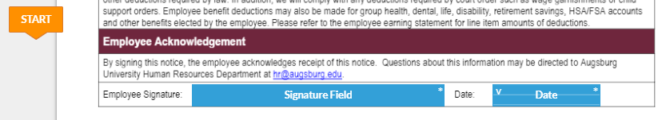

1. A pop up box will appear for you to create your signature. You may either type, draw, or upload your preferred signature.

1. Click on the Type, Draw, or Upload tab at the top of the pop up box to add your preferred type of signature. Any are acceptable.

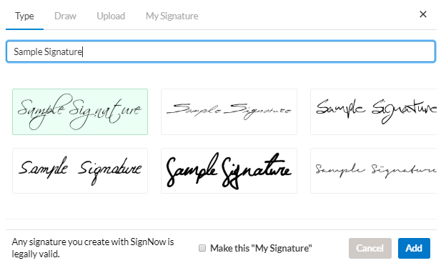

1. Click the “Add” button to add your signature to the document
2. Click the “Date” field. A calendar will appear and default to today’s date.
3. Click the green “Done” button at the top of the screen to finalize the signing process.



1. After signing, you will be given the option to download your document. You will also automatically receive a PDF copy of your document via email, so this step is optional.