Instructions for Free Text Invoicing – Trial Invoice and Final Invoicing

- Signon to Agresso Client
- Trial Invoice (This will allow you to view the invoice to ensure accuracy)
  - Agresso Financials/Accounts Receivable/Free Text Invoicing
  - Click on the plus next to Trial Invoice(FI07)
    - The Customer Group is hard coded so pick the variant “CGE Semester Cust Group Trial Invoice” or “CGE Short Term Cust Group Trial Invoice” whichever your customer was, SAVE then look for report under Reports it is FI07
    - Semester:
      - 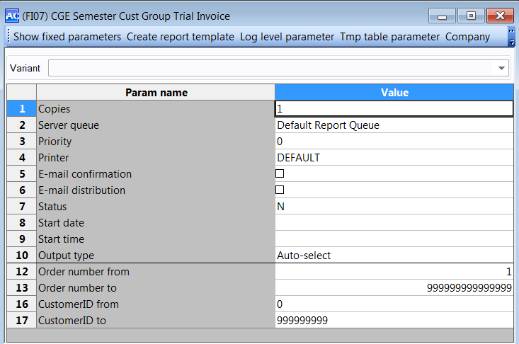
    - Custom Program Tailored:
      - 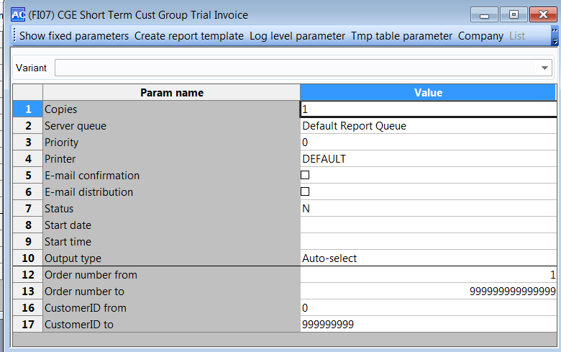
    - On the Reports and Server Processes by Order Date look for FI07 job
      - 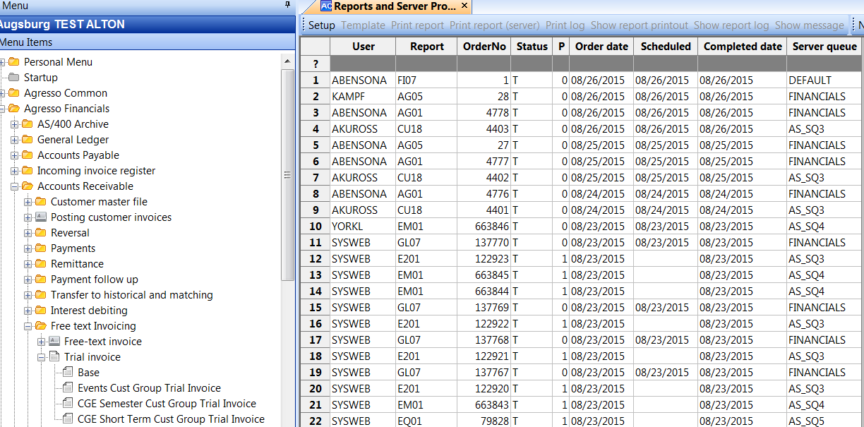
        - Status T is when it is done
        - Double click on the line and you will get two report options
        - 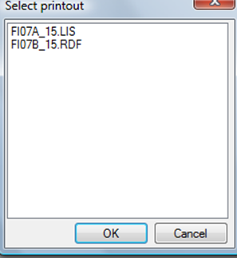

        - You will get two reports, the FI07B.rdfis below(ex of Semester and Tailored)
        - 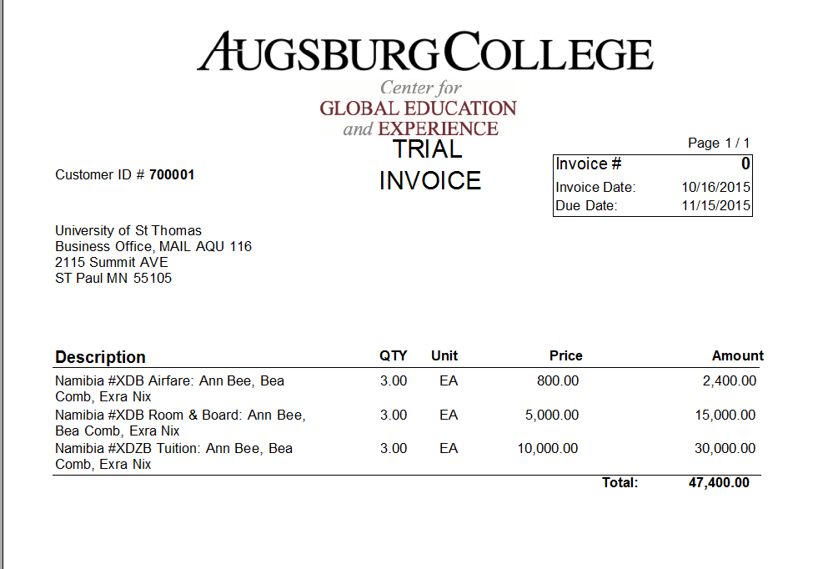
        - 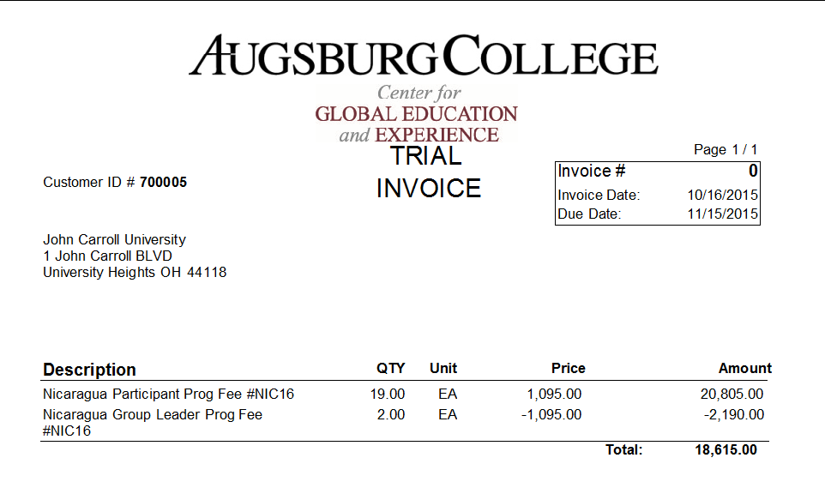
        - Check report FI07B for accuracy you will notice that there is NO INVOICE NUMBER assigned yet because this is a TRIAL

      - To CORRECT something you will go to INVOICE AND REQUISITION APPROVAL
        - Financials\Accounts Receivable\Free Text Invoicing\Invoice and Requisition Approval
          - Enter your CUSTID and it will bring up all for that customer
          - 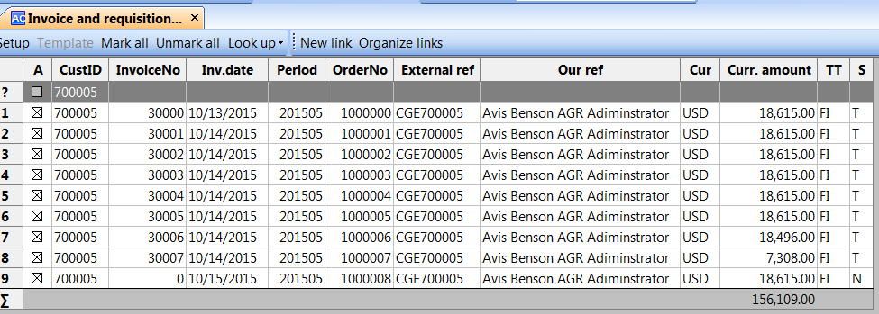
          - You cannot change any that have an invoiceno assigned
          - Double click on the line that has zero in the invoice no and it takes you right back into entry
          - 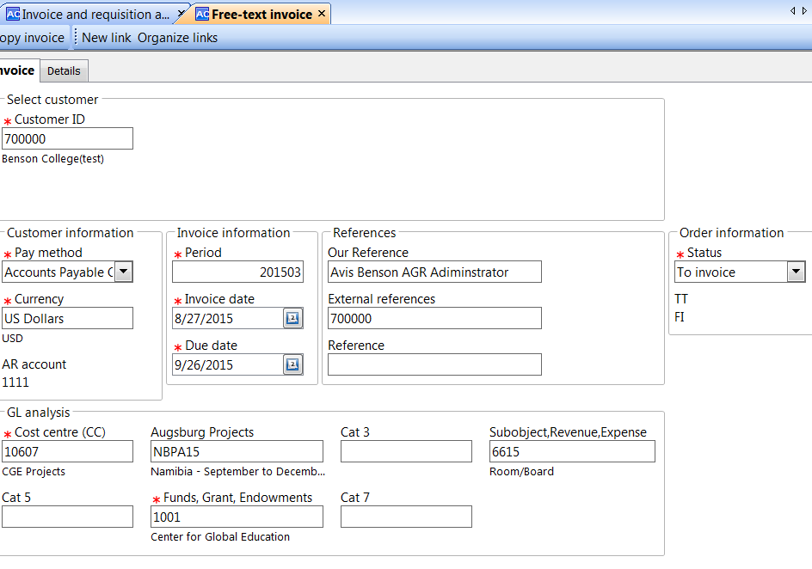
          - Correct and SAVE
        - 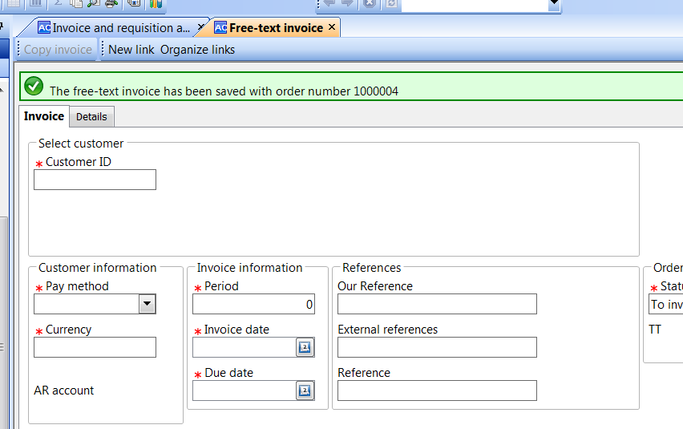
      - You can also get there by going to Free-Text Invoice and Binoculars opens up the ORDERNO field and follow process above for correction
        - 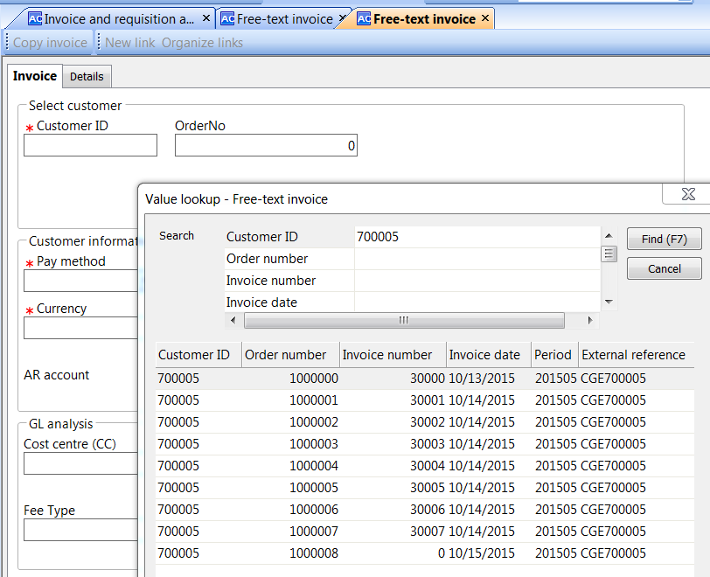

- If all info correct, Run the” Invoicing “step(Reports FI01, GL07)
  - Agresso Financials/Accounts Receivable/Free Text Invoicing/Invoicing
    - From the drop down pick the “CGE Short Term Invoice and Post to GL” or “CGE Semester Invoice and Post to GL” variant, again whichever your customer falls under
      - Semester EX:
        - 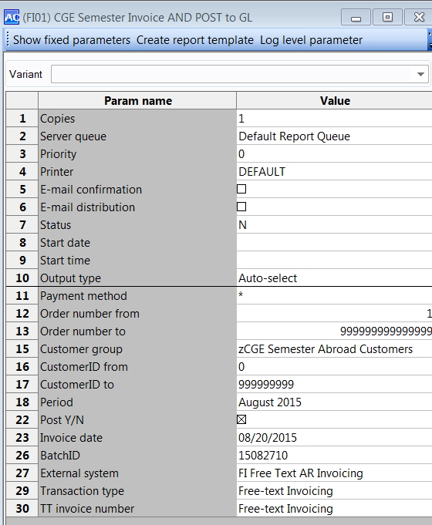
      - Custom Program Tailored EX:
        - 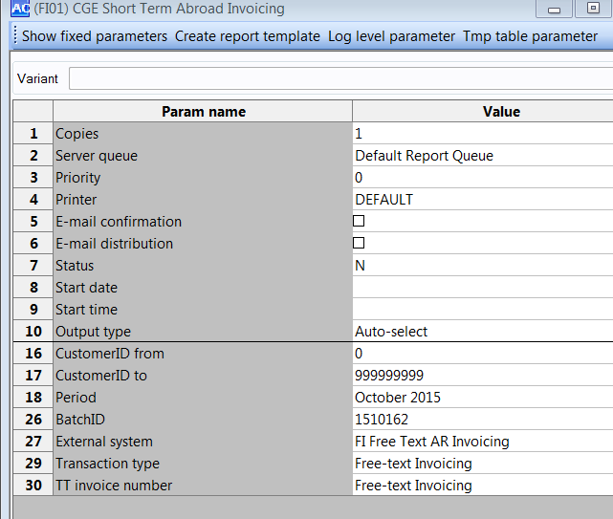
    - You must check or enter(trying to hard code)
      - Period
      - Invoice date
      - External system – FI Free Text Invoicing(you will have to pick till I get hard coding to work)
      - Transaction Type – Free Text Invoicing(you will have to pick till I get hard coding to work)
      - TT invoice number – Free Text Invoicing
    - SAVE or F12(this creates your invoice and posts to the GL) Remember the order number
      - 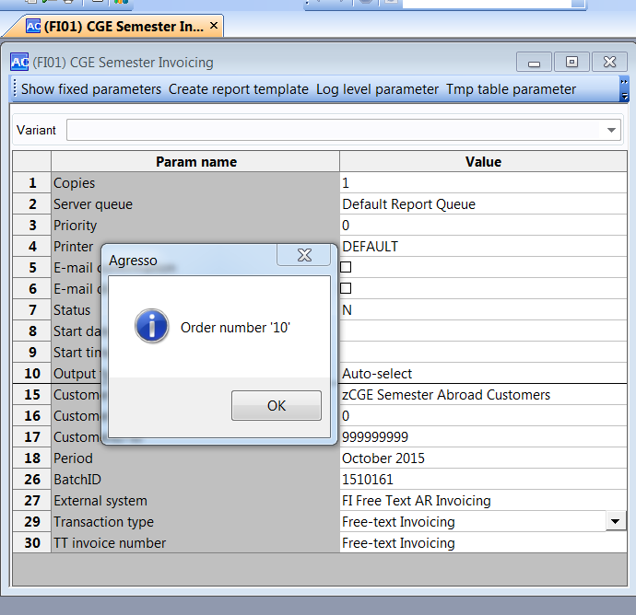
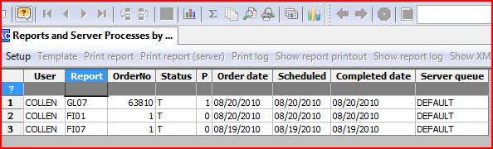
    - Creates FI01 and GL07(direct update to GL) reportsClick on the button REPORT LOG (a piece of paper with a magnifying glass)
    - Both your FI01 and GL07 should be there and wait till they are both at T
      - CHECK the GL07 that the Report says
          - STATEMENT BATCH INPUT
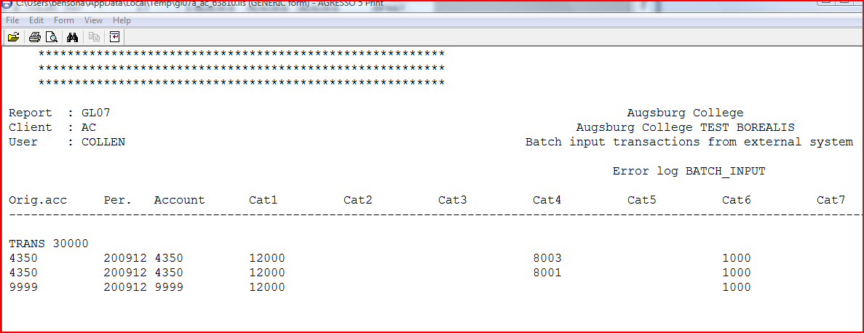
          - 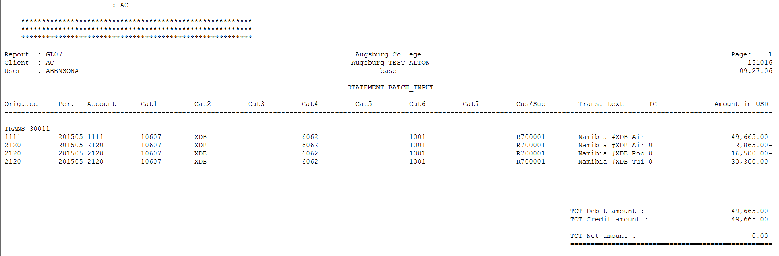
          - NOT ERROR etc in the header
            - If so call AVIS x1261
      - To look at the reports double click on the row of FI01, then double clidk on FI01B.rdf
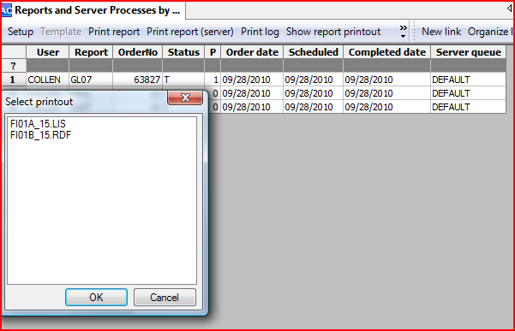

    - When it is a good load to the GL you will not have ERROR in heading. Write down the Trans number if you are going to do an excelerator invoice
    - Check out FI01B and see if this invoice has all you need, if you need more information go to next section
    - 