Instructions for Free Text Invoicing

- This is entry of NON Augsburg Students and or CGEE Partner Institutions
- Augsburg Students will be done in same way it has been done
- When your student is assigned an ID and put in the global program, make sure they are put in the appropriate Group, parameters are driven by the customer group, if you have FUND come up as 1000 and greyed out that means you need to change to one of your customer groups. 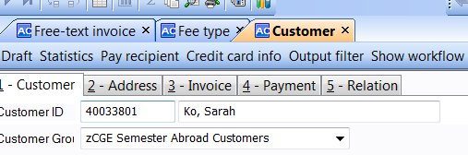
- Or
- 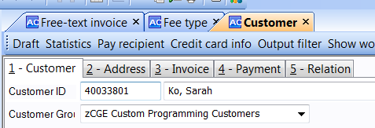
- Make sure that the relations are correct:
  - Empty will not feed your invoicing correctly:
  - 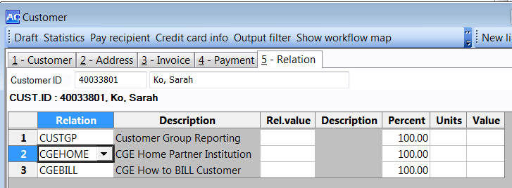
  - So enter the relations ZS(semester) or ZC(custom)
  - If your CGEHOME is new and does not enter make sure you get it entered into CGEHOME
  - Also the CGEBILL is driven by partner institution so look to the relation that you put on the CGEHome
  - 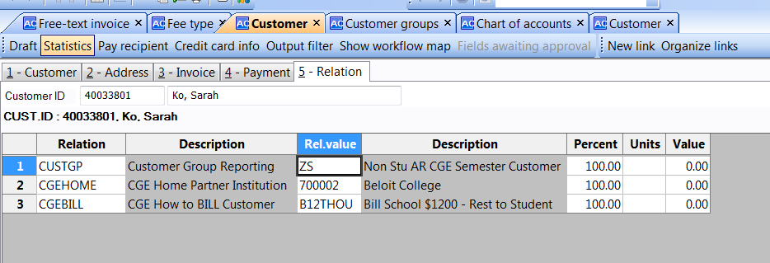
- Open up Free Text Invoicing: Agresso Financials/Accounts Receivable/Free Text Invoicing/Free-Text Invoice
  - On the Invoice TAB
    - Enter the Customer ID if you know it (For Schools CGE 700000 to 799999 and Students would user their STU_ID)
      - You can enter 7 and all customers starting with 7 will show in drop down
        - Double click on the ID you want
        - Or press F9 to do a lookup by *name* in the description(must be in range for schools and or Student ID) 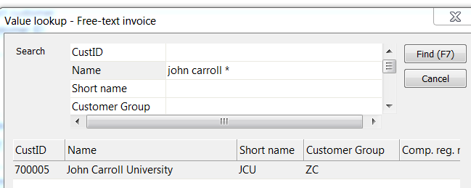
        - If it is not listed you will need to Enter new customer(directions-New Accounts Receivable Customer)
        - Double click on your customer
    - TAB forward through Customer info. (this is what you entered on the customer setup)
    - TAB through Invoice Information Period and Invoice Date which default to the current accounting period and today’s date. You can change the date just remember the date must be within the Period. Example: 201503 is August 2015.
        - Tab through the Due date, it will populate according to what you have set up on the Customer under the INVOICE tab in the field PAYMENT TERMS. You can override this if required.
    - Tab through References:
      - Tab through the Our Ref field, it will populate with the user that is entering this Invoice
      - Tab through the External Ref field it will be their CUST ID
      - Tab to the Reference field. You can enter whatever text you want to track for your own tracking purposes
    - Tab through Order Information:
      - leave Status at “To Invoice”
  - Under GL Analysis enter(when you fill this in it will appear on each of your detail lines)
    - Tab to CostC field and enter the CostC - 10607
    - Tab to Augsburg Projects and enter ProjCode
    - Tab to Subobj and enter IF AUGSBURG IS RESPONSIBLE FOR 1098T please enter one of following fee types: 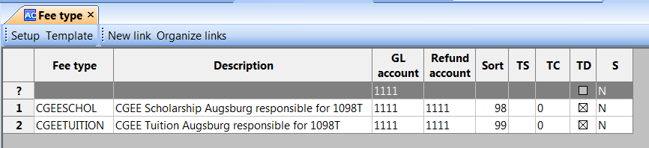
      - This will make it possible to pull all for 1098T at end of year
    - Tab to the Fund field and enter 1001
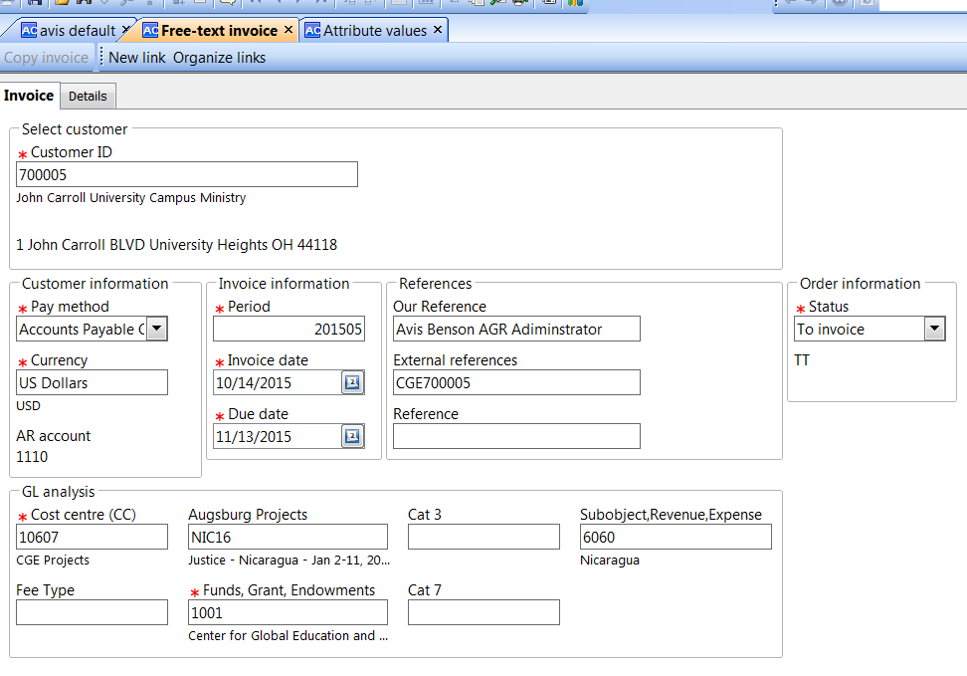
  - Tab to the DETAILS TAB
    - Invoice Summary Section:
      - Enter in the Description for item being invoiced, putting the projcode in description helps because it prints on the invoice, so think that the DESCRIPTION is what prints on the INVOICE so it will go to the customer, so make it understandable and enough info so when you pull it up you know what it is for. (Pull open the description more so you can see what you have on the line)
      - Enter the quantity.(you cannot have negative quantity or zero)
      - Enter the Unit type for this item. EA
      - Enter Unit Price( you can have negative dollars-use for your discounts)
      - Press TAB (Once you enter the unit price it automatically enters the Curr.amount)
      - Press Tab and you automatically move to the GL Analysis Tab
    - GL Analysis Detail Section:
      - Enter your account 2120 (CGE Accrued Projects)
        - Press TAB forward and it brings in the GL analysis from the INVOICE Tab
        - In the Description field, enter the same text as the item description. TAB
    - Example for Custom Program:
    - 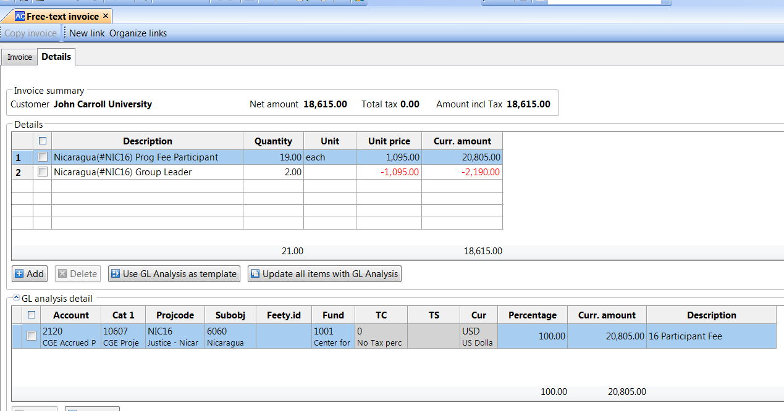
    - 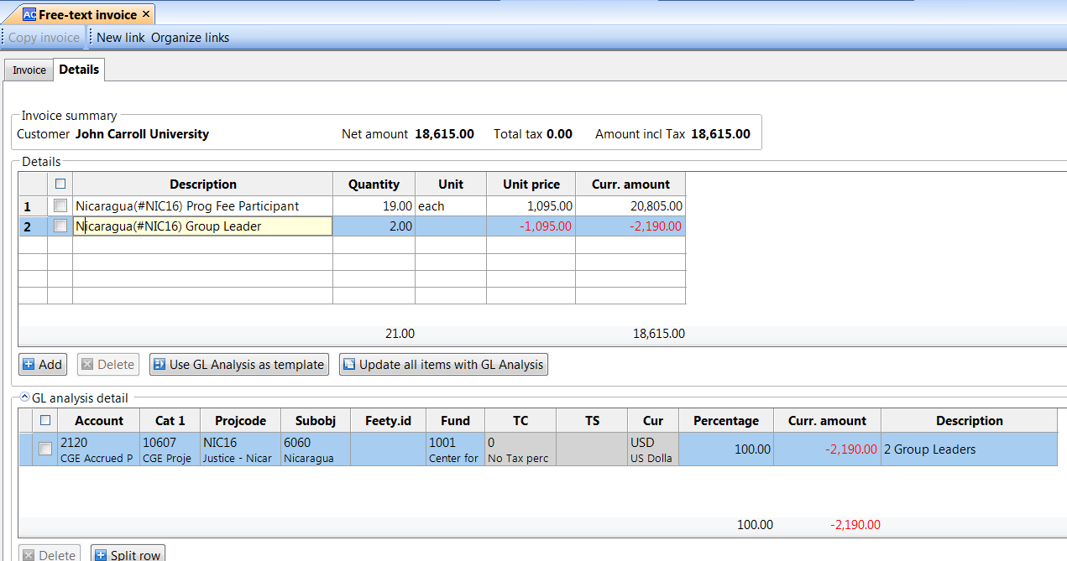
- Example for semester BILL all to Partner Instituition, dividing out Tuition so we can figure out 1098Table year end
  - 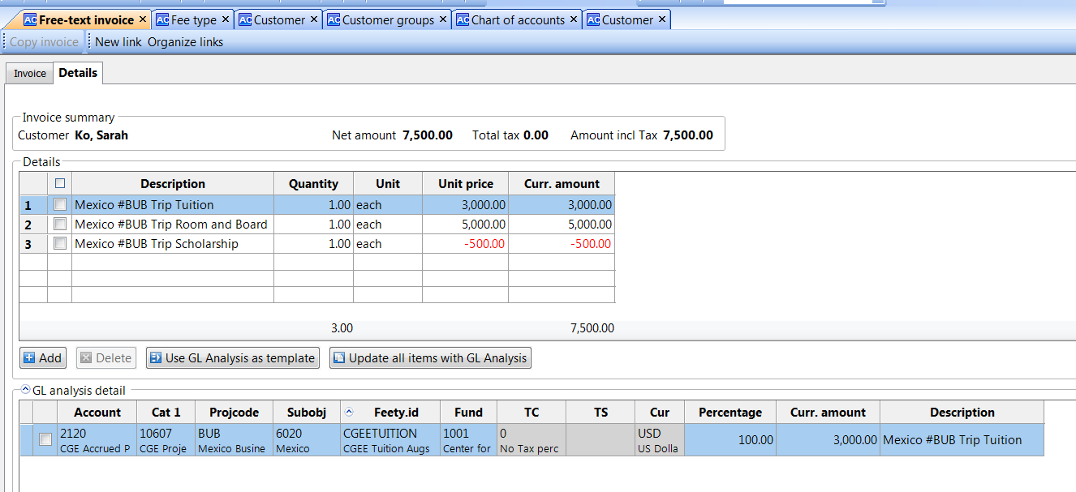
    - Remember to Copy Description to GL analysis Description
    - Make sure FEETY.id is correct
    - You will blank it out on Room and board line
  - 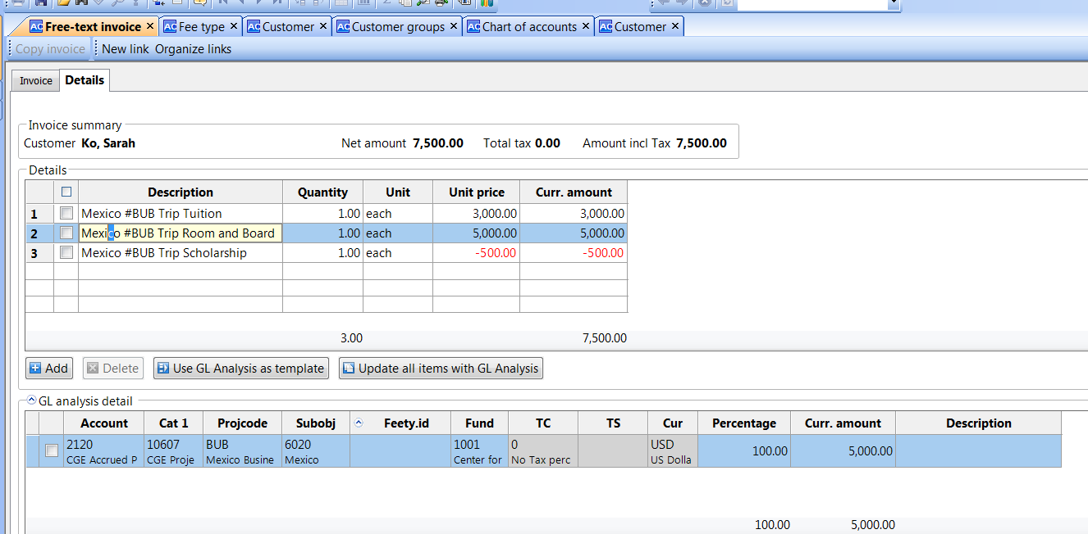
  - 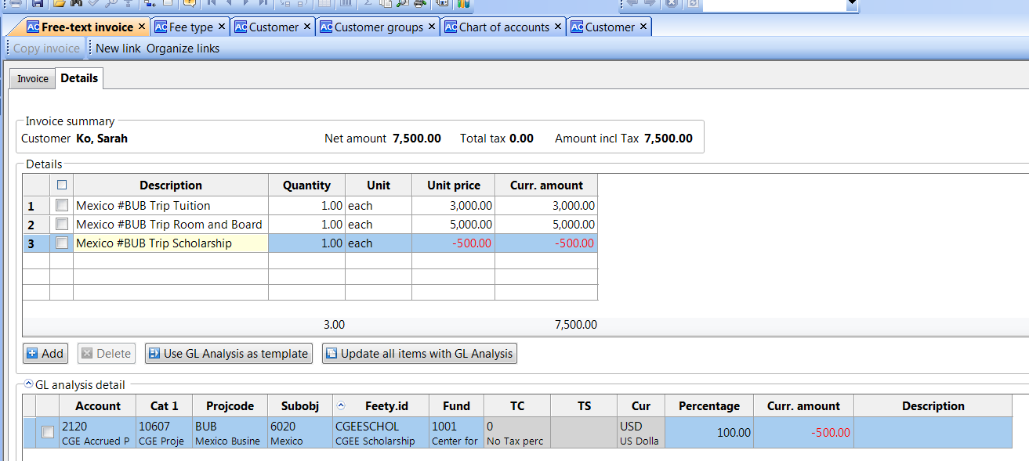
  - You will change the feetyp.id on Scholarship(all this helps to automatically put in the correct 1098T scholarship box.
- The school invoice example for above
  - We know the relation says to bill $12000 and rest to student
  - 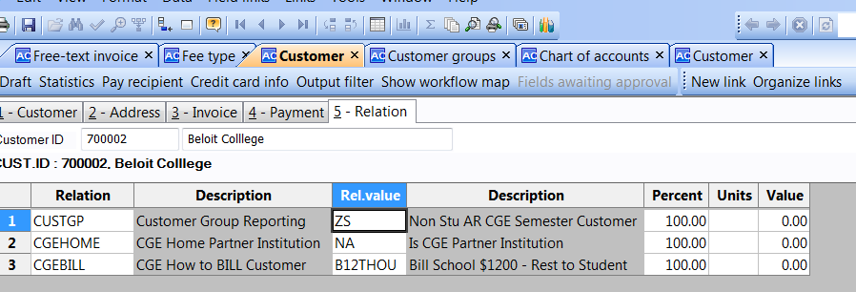
  - 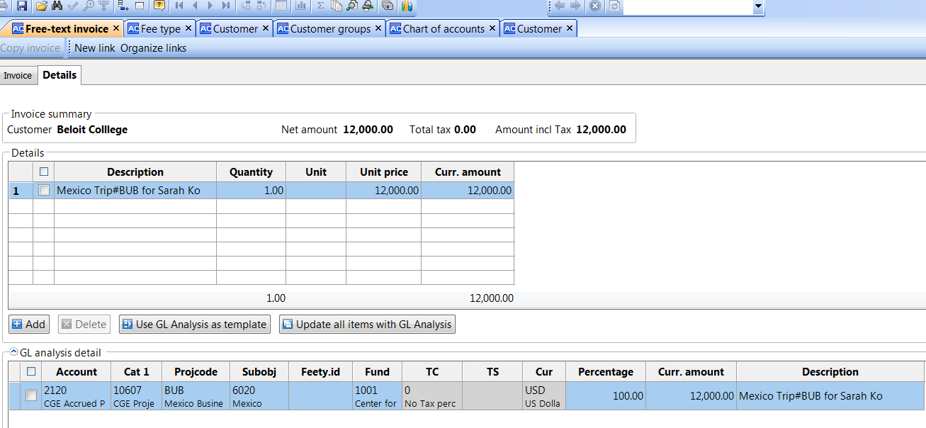
      - If you make a mistake and want to reenter anything on the Analysis Tab, click on the row (like row 1) it unchecks it and brings it up to the top where you can make changes and tab forward to pushing it back
    - Each row will have its own analysis tab
    - You can ADD and do another row starting at the DETAILS section
- When you are done entering items for this invoice, click the SAVE button and you will get a reference num (this is not the invoice number).
  - 