

**Verification Guide 2019-2020**

This information is intended for the 2019-20 FAFSA year and applies to the fall 2019, spring 2020, and summer 2020 academic semesters at Augsburg University.

1. **What is verification and who is selected?**
2. **What type of documents are required for verification?**
3. **What is acceptable tax return documentation?**
4. **How do I determine the number of people in my household?**
5. **I or my parent listed the tax return filing status as "Will File." What does that mean for verification?**
6. **What if my parents or I will not file taxes?**
7. **What happens if my application is selected for verification after I have received my  
   financial aid?**
8. **How can I complete my verification with Augsburg?**
9. **What happens once I submit all verification documents?**

**Glossary**

**What is verification and who is selected?**

Verification is the process of comparing the data on the student's FAFSA with actual documentation. Augsburg is required by federal and state law, to collect the necessary documentation and verify certain data elements for any discrepancies. If a student is selected for verification, the process must be completed before any federal or state financial aid can be disbursed.

The U.S. Department of Education selects students for verification and does not disclose their selection criteria. You could be selected for verification at any time during the academic year, so it is essential to check your Augsburg email account and Augnet account **at least once a week**.

The Financial Aid Office may verify some or all of the following data elements:

* Adjusted Gross Income
* Income Tax Paid
* Untaxed IRA Distributions
* Untaxed Pension Distributions
* IRA Deductions/Payments
* Tax Exempt Interest
* Education Credits

In addition, applicants may be required to provide:

* Documentation of a high school diploma, recognized equivalent or home  
  school credentials
* A copy of valid (e.g., unexpired) government-issued photo identification, such  
  as a driver’s license, passport, or military ID
* A signed statement of education purpose
* Documentation of other untaxed income not reported on your federal tax  
  form
* Clarification of parents’ marital status, number in the household and/or number in college.

**What type of documents are required for verification?**

To verify certain data elements, we may request the following; however, **this is not a complete list**. We may be required to ask for different information for each student.

* [Augsburg Verification Form](http://web.augsburg.edu/enroll/Forms/1920AVF.pdf)
* Signed copy of Tax Forms 1040, 1040A or 1040EZ. (See Image 1)
* IRS Tax Return Transcript(s) from the student, the student's spouse (if student is married)  
  and/or the student's parents (if student is dependent). IRS Tax Return Transcripts can be  
  obtained at: [www.irs.gov](http://irs.gov/transcript). (See Image 2)
* Other requested documentation such as wage and income transcript or non-filing letter
* W-2 form from employer (See Image 3)

**What is acceptable tax return documentation?**

Students may be able to link their and/or their parent's tax information electronically when completing the FAFSA via IRS Data Retrieval Tool (DRT) process, submit signed copies of your 1040, 1040A, or 1040EZ forms submitted to the IRS, or provide us with a copy of your IRS Tax Return Transcripts. To obtain tax return transcripts visit the IRS website, select either “Get Transcript ONLINE” or “Get Transcript by MAIL.” Students who wish to access their transcript online must first register as a user with the IRS website for security purposes.

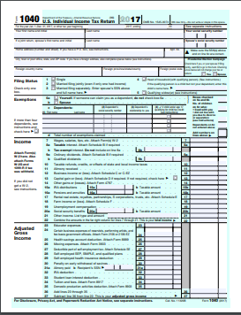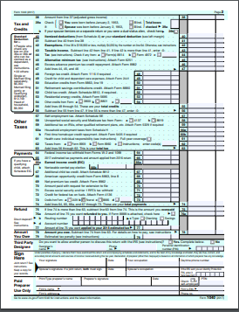  
Example 1040 Tax Form (Image 1)

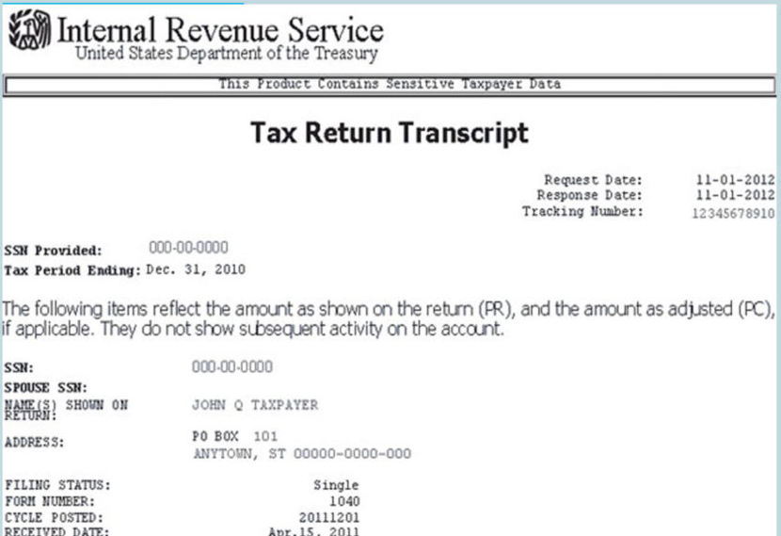

Example IRS Tax Return Transcript (Image 2)

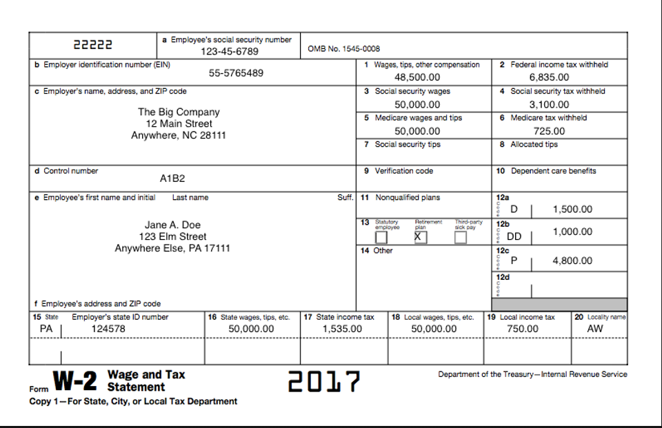

Example W-2 Form (Image 3)

**How do I determine the number of people in my household?**

Part of the verification process includes students reporting how many individuals are living in their household. For dependent students the number in household should include parents, and any dependents for which the parents provide more than 50 percent of the dependent's annual support, such as the student’s siblings. Parents cannot be counted as “in college” for dependent students. For independent students the number in household should include spouse (if student is legally married) and number of dependents for which the student provides more than 50 percent of the dependent's annual support. Generally, parents, siblings and other non-custodial minors should not be counted in an independent student's household.

**I or my parent listed the tax return filing status as "Will File." What does that mean for  
verification?**

When completing the FAFSA, students and parents are allowed to claim their current tax filing status as "Will File," which indicates the tax filer will file taxes for the year at a later date. Those who claim "Will File" are allowed to use reasonable approximations when reporting financial information on the FAFSA. The expectation when completing the FAFSA with a "Will File" tax status is that the applicant will update the FAFSA at a later date when the taxes have been completed so accurate data can be reported. Claiming "Will File" does not exempt a student from verification. Students and parents (if student is dependent) must provide a tax return in order for verification to be completed.

**What if my parents or I will not file taxes?**

Students or parents of students who are not required to file taxes are exempt from providing a tax return; however, non-filers must still report any income received for the year for verification purposes on the Augsburg Verification Form. Furthermore, if during the process of verification, the financial aid office discovers a student or parent is required to complete a tax return, but has not yet done so, then verification will not continue until taxes have been filed. For information concerning tax filing requirements, visit the [IRS Website](https://www.irs.gov/help/ita/do-i-need-to-file-a-tax-return).

**What happens if my application is selected for verification after I have received my  
financial aid?**

Aid recipients, who are subsequently selected for verification by the Department of Education, must resolve all verification requirements. A student’s  
failure to resolve this issue by the end of their enrollment period will result in all federal aid and state aid being returned.

**How can I complete my verification with Augsburg?**

It's very simple! Access your [Student Account](https://augnet.augsburg.edu/protected/administration/enrollment/cashnet) and identify the list of requirements and submit them to us as soon as possible. We also send occasional email reminders. We can accept your documents via:

* In-person
* Secure File Exchange at www.Augsburg.leapfile.net
* Fax (612)330-1308
* Mail
  + Augsburg University

Attn: Student Financial Services

Campus Box 309

2211 Riverside Avenue

Minneapolis, MN 55454

**What happens once I submit all verification documents?**

After all requested information is submitted to the Financial Aid Office, the student’s file will be reviewed. If we have further questions, the student will be contacted for additional clarification. It is the student’s responsibility to respond to these requests for information. Failing to do so will result in an incomplete financial aid application, which will delay the completion of your financial aid award.

**Glossary**

**IRS -** The Internal Revenue Service of the United States federal government.

**W-2 Form** - [Wage](http://www.investorwords.com/17820/wage.html) and Tax [Statement](http://www.investorwords.com/4701/statement.html). A [tax form](http://www.investorwords.com/8713/tax_form.html) prepared by an employer and given to an employee to be filed with his/her [1040 form](http://www.investorwords.com/12466/1040_Form.html), [listing](http://www.investorwords.com/2845/listing.html) [wages](http://www.investorwords.com/5273/wages.html) earned during that year, [federal](http://www.investorwords.com/1895/Federal.html) and [state taxes](http://www.investorwords.com/8701/state_taxes.html) withheld, and [Social Security tax](http://www.investorwords.com/4618/Social_Security_Tax.html) information. Employers must provide [employees](http://www.investorwords.com/1696/employee.html) their W-2 forms by the [deadline](http://www.investorwords.com/9389/deadline.html) that is set by the IRS.

**1040, 1040A, or 1040EZ Form -** U.S. Individual [Income](http://www.investorwords.com/2400/income.html) Tax Return. This [form](http://www.investorwords.com/13345/form.html) is used for individuals in [filing](http://www.investorwords.com/1934/filing.html) their [annual](http://www.investorwords.com/214/annual.html) [income tax returns](http://www.investorwords.com/10002/income_tax_return.html) with the IRS.

**IRS Tax Transcript -** A tax transcript is a line-by-line record of the information you provided to the Internal Revenue Service (IRS) on your tax forms.

**Adjusted Gross Income -**  Total gross income minus specific deductions.

**Wage and Income Transcript -** Listing of all the income information that the IRS has received for you.

**Non-filing letter** – Document requested from the IRS that provides proof that the IRS has no record of a filed Form 1040, 1040A or 1040EZ for the year you requested.

**Untaxed Income -** any income that has been earned by a student or parent which does not appear on a Federal tax return. This does not include scholarships and grants from the University.

**Income Tax Paid –** Reported on the tax return.