Campus Security Authority – SaVE Crimes Report Form
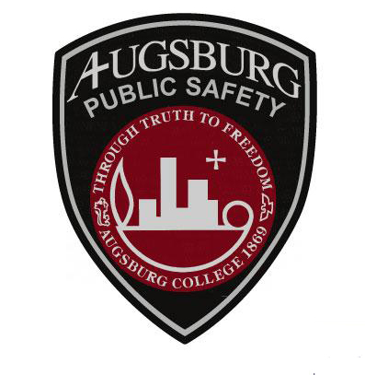
CSA Name: | Click here to enter text.
Date: | Click here to enter a date.
e-mail: | Click here to enter text.
Phone: | Click here to enter text.

Instructions: Use this form to report the following: (1) Dating Violence; (2) Domestic Assault; (3) Sexual Assault; or (4) Stalking. After completing this form, please save/print this form as a PDF and e-mail the form to cleryreports@augsburg.edu. Please contact the Director of Public Safety if you have any questions about this form.

Crime reported by: | Click here to enter text. | Phone No.: | Click here to enter text.
Classification – 1:  Classification – 2: | Choose an item.  Choose an item. | Date Occurred: | Click here to enter a date.
Location: | Choose an item. | Previously Reported to DPS? | Yes ☐ No ☐
Specific Location: | Click here to enter text.
Brief Description of Incident: | Click here to enter text.

Did the crime occur in a building, street, or outside? Building ☐ Street ☐ Outside ☐

If the crime occurred in a building, was it a residential building? Yes ☐ No ☐

Did the crime occur on school owned, controlled, or leased property? Yes ☐ No ☐

Did the crime occur at an Augsburg College-sponsored activity or event? Yes ☐ No ☐

Check the box if the incident involved: Alcohol ☐ Drugs ☐ Weapon ☐

Was the crime a Hate Crime†? Yes ☐ No ☐ If yes, crime type: Choose an item.

If yes, victim was intentionally because actual or perceived: Choose an item.

†Under the Clery Act, a “hate crime” is one of the Clery Reportable crimes; larceny (theft); simple assault; intimidation; destruction, damage, or vandalism of property, and other crimes involving bodily injury to any person in which the victim is intentionally selected because of the victim’s actual or perceived race, gender, religion, national origin, sexual orientation, gender identity, ethnicity, or disability.

DEFINITIONS OF SaVE CRIMES

Dating Violence: Any violence committed by a person—

(A) Who is or has been in a social relationship of a romantic or intimate nature with the victim; and
(B) Where the existence of such a relationship shall be determined based on a consideration of the following factors:
- The length of the relationship.
- The type of relationship.
- The frequency of interaction between the persons involved in the relationship.

Domestic Violence: Any felony or misdemeanor crimes of violence committed by a current or former spouse or intimate partner of the victim, by a person with whom the victim shares a child in common, by a person who is cohabitating with or has cohabitated with the victim as a spouse or intimate partner, by a person similarly situated to a spouse of the victim under the domestic or family violence laws of the jurisdiction receiving grant monies, or by any other person against an adult or youth victim who is protected from that person’s acts under the domestic or family violence laws of the jurisdiction.

Sexual Assault: Forcible and non-forcible sexual offenses.

Sex Offenses, Forcible: Any sexual act directed against another person, forcibly and/or against that person’s will; or not forcibly or against the person’s will where the victim is incapable of giving consent.

Forcible Rape: The carnal knowledge of a person, forcibly and/or against that person’s will; or not forcibly or against the person’s will where the victim is incapable of giving consent because of his/her temporary or permanent mental or physical incapacity or because of his/her youth.

Forcible Sodomy: Oral or anal sexual intercourse with another person, forcibly and/or against that person’s will; or not forcibly against the person’s will where the victim is incapable of giving consent because of his/her youth or because of his/her temporary or permanent mental or physical incapacity.

Sexual Assault With An Object: The use of an object or instrument to unlawfully penetrate, however slightly, the genital or anal opening of the body of another person, forcibly and/or against that person’s will; or not forcibly or against the person’s will where the victim is incapable of giving consent because of his/her youth or because of his/her temporary or permanent mental or physical incapacity.

Forcible Fondling: The touching of the private body parts of another person for the purpose of sexual gratification, forcibly and/or against the person’s will where the victim is incapable of giving consent because of his/her youth or because of his/her temporary or permanent mental incapacity.

Sexual Offense, Non-Forcible: Unlawful, non-forcible sexual intercourse.

Incest: Non-Forcible sexual intercourse between persons who are related to each other within the degrees wherein marriage is prohibited by law.

Statutory Rape: Non-forcible sexual intercourse with a person who is under the statutory age of consent.

Stalking: Engaging in a course of conduct directed at a specific person that would cause a reasonable person to—
(A) Fear for his or her safety or the safety of other; or
(B) Suffer substantial emotional distress.

