Working from Home
  - Strategies & Tips
As students across the globe navigate to the online world for education, many are finding out the pros and cons of working and studying from home. Here are some pointers to help you successfully work from home.

Your workspace
Put distractions away.
- Turn the TV off and try not to use your phone for texting or social media.
- Stick to the tasks you would normally do at work/school.
Dedicate a workspace/area for yourself.
- Declutter and clean your space to promote a distraction-free environment
Take breaks away from your workspace as appropriate.
- Take some time for yourself in between classes or work.
- Take care of yourself physically and mentally.
- Calm is an app that allows you to take a break with guided relaxation and meditation exercises.

Organization
Create & maintain a schedule.
- Balancing work, school, and home life can be a major challenge during this time. However, using time tracking apps or a planner may help you to stick to your school schedule.
- Pocket Schedule Planner is an app that helps keep track of your schedule while being able to remind you of assignments and exams.
Organize/plan your day out.
- Using planning tools to organize your time such as planners, calendars, charts, apps, etc. can be a good first place to start.
- Set goals or a “To do” list for the day.
- Prioritize tasks by importance and/or due dates.
- Focus on completing one task at a time.
  - Flora, Forest, and Pause are all apps that may help you get focused when you’re ready to perform tasks.

Communication
Set ground rules.
- Communicate with others in your household or living space by letting them know what you need during the school day and how your schedule is structured.
- This may minimize distractions for you and allow you to focus when you need to.
Communicate with others.
- Especially when working/studying independently, questions might arise. Ask your professor or classmate for assistance when needed.
Hold yourself accountable.
- Document when due dates, deadlines, and exams are taking place.
  - Writing them down in your planner, Google Calendar, or setting reminders on your phone are some helpful tips to keep track of everything going on.

Helpful Applications
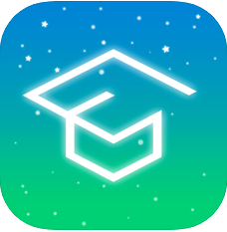 Pocket Schedule Planner: An app that assists with tracking class or homework schedules & tasks.
- Cost: Free, but only available for iOS devices
- More information: Visit the Apple App Store
Google Tasks & Google Calendar: Available apps within your Augsburg Gmail account that can help you organize your “To Do” lists and sync them with calendar reminders.
- Cost: Free through your Augsburg email account
- More information: Visit the Apple App Store
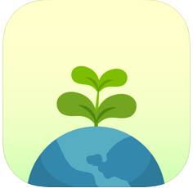 Flora & 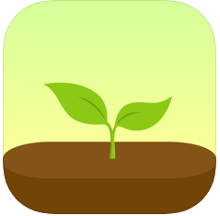 Forest: Apps that assist with productivity through interactive components that help you track your habits and goals while staying focused.
- Cost: Free for the Flora app and $1.99 for the Forest App
- More information: Visit the Apple App Store for iOS devices & Google Play for Android
Pause: A Chrome extension that keeps you from looking at distracting websites by temporarily blocking them while you are working.
- Cost: Free
- More information: https://freedom.to/ or the Chrome web store
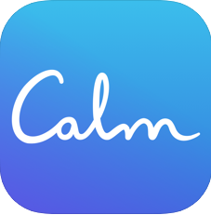 Calm: An app to assist with sleep, meditation and relaxation.
- Cost: Free with available in-app purchases
- More information: https://www.calm.com/ (iOS & Android compatible)

Augsburg Resources
- Helpline: 612-474-3100 or helpline@augsburg.edu
- Center for Wellness & Counseling: www.augsburg.edu/cwc/
- Planning: https://inside.augsburg.edu/outbreak-planning/resources-for-students/
- IT Support: https://inside.augsburg.edu/it/services-we-provide/student-laptops-and-internet/
- Writing Center: https://inside.augsburg.edu/writingcenter/

CLASS Office: class@augsburg.edu

