Sources for Documentation
(Updated June 2023)
These sources, among others in our communities, offer psychoeducational assessments. Some common diagnoses explored in testing include Attention Deficit/Hyperactivity Disorder (ADHD), specific learning disabilities, and more.
Note that provider services may change. Please contact providers directly for their most current information.

Academic Tutoring and Testing
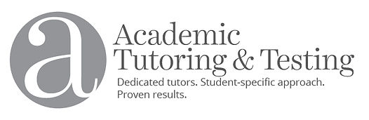
Academic Tutoring & Testing Website

Contact Information:
- 952-591-9437
- acatutormpls@gmail.com
- 8401 Wayzata Blvd. Suite 201; Minneapolis, MN 55426

Services Information:
- Psychological testing for ADD, ADHD, and Learning Disabilities
- Testing and results typically happen over three sessions

Anderson Psychological Services (Dr. Anderson)
Anderson Psychological Services Website

Contact Information:
- 612-374-240
- Woodhill Office Park; 2155 Woodlane Drive, Suite 201; Woodbury, MN 55125

Services Information:
- Assessments for Learning Disabilities and ADHD
- Evaluations occur over 2-3 sessions

Associated Clinic of Psychology
Associated Clinic of Psychology Website

Contact Information:
- 612-925-6033
- Locations throughout the Twin Cities, MN

Services Information:
- ADHD Testing

Autism Society of Minnesota
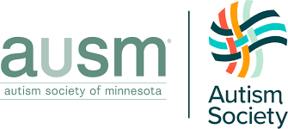
Autism Society of Minnesota Website

Contact Information:
- 651-647-1083
- info@ausm.org
- 2380 Wycliff St. #102; St. Paul, MN 55114

Services Information:
- Diagnostic assessments for adults
- Functional or behavioral assessments for all ages

Clinic for Attention, Learning, and Memory
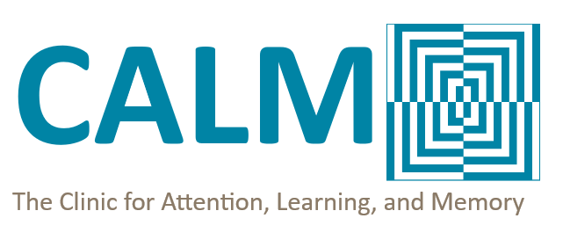
Clinic for Attention, Learning, and Memory Website

Contact Information:
- 612-872-2343 (ext. 2)
- mercey@calm.us
- 1409 Willow St, Suite 600; Minneapolis, MN 55403

Services Information:
- Neurocognitive assessments (over a series of five separate appointments, telehealth and in-person)
- Areas Assessed Include: IQ, executive function, processing speed, learning disorders, social interactions, working memory, ADHD

Fraser
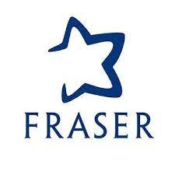
Fraser Website

Contact Information:
- 612-767-7222
- 2400 West 64th St; Minneapolis, MN 55423

Services Information:
- Autism evaluations
- Neuropsychology evaluations

Groves Learning Organization
Groves Learning Organization Website

Contact Information:
- 952-920-6377
- 3200 Highway 100 South; St. Louis Park, MN 55416

Services Information:
- Psychoeducational evaluation

Dr. Janette Schaub
Dr. Janette M Schaub Website

Contact Information:
- 952-832-9094
- 7400 Metro Blvd, Suite 417; Edina, Minnesota, 55439-2316

Services Information:
- psychological testing

Learning and Language Specialists
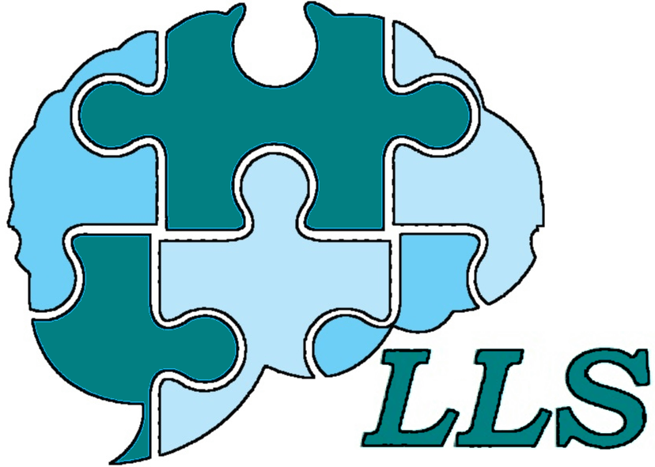
Learning and Language Specialists Website

Contact Information:
- 763-545-7708
- 1405 Lilac Drive N, Suite 200; Golden Valley MN, 55422

Services Information:
- neuropsychological assessments

Learning Disabilities Association of Minnesota
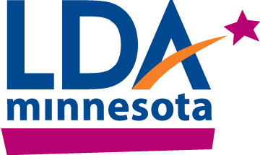
Learning Disabilities Association of Minnesota Website

Contact Information:
- 952-582-6000
- info@ldaminnesota.org
- 6100 Golden Valley Road; Golden Valley, Minnesota 55422

Services Information:
- diagnostic assessments that interfere with learning
- learning disabilities, dyslexia, ADHD

LynLake Centers for Wellbeing
LynLake Centers for Wellbeing Website

Contact Information:
- 612-979-2276
- 621 West Lake Street, Suite 350; Minneapolis, MN 55408

Services Information:
- Telehealth and in-person options
- Psychological testing, neuropsychological assessments, evaluations for ADHD and Learning Disabilities

Minneapolis Clinic of Neurology
Minneapolis Clinic of Neurology Website

Contact Information:
- (763) 302-4100
- 4225 Golden Valley Road; Golden Valley, MN 55422

Services Information:
- neuropsychological testing

Minnesota Department of Human Resources
Minnesota Department of Human Resources Website

Contact Information:
- Info Desk: 651-431-2000
- General Questions: DHS.info@state.mn.us

Monarch Learning & Attention Center
Monarch Learning & Attention Center Website
Contact Information:
- 612-562-9007
- admin@monarchassessment.com
- 6600 City West Parkway, Suite 207; Eden Prairie, MN 55344

Services Information:
- psychoeducational evaluation
- autism evaluation
- adult ADHD evaluation

Native American Community Clinic
Native American Community Clinic Website

Contact Information:
- 612-872-8086 (press 1 for Medical)
- 1213 E. Franklin Avenue; Minneapolis, MN 55404

Services Information:
- ADHD treatment. See website or call for all services.
- Walk-in hours and sliding fee application options.

Noran Neurological Clinic
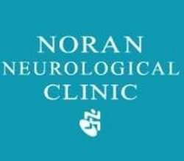
Noran Neurological Clinic Website

Contact Information:
- (612) 879-1000
- Several locations throughout Twin Cities, MN

Services Information:
- neuropsychological assessments

Psychology Consultation Specialists
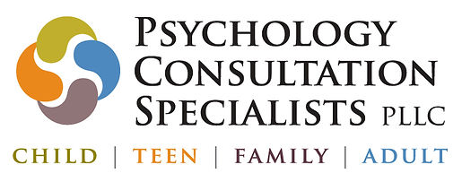
Psychology Consultation Specialists Website

Contact Information:
- 763-559-7050
- info@pcsmn.com
- 3300 Fernbrook Lane North, Suite 120; Plymouth, MN 55447

Services Information:
- neuropsychological evaluation

Twin Cities Psychological Testing (Dr. Richard Douglass, PhD, LP)
Twin Cities Psychological Testing Website

Contact Information:
- 612-433-3065
- 5200 Willson Rd, Suite 150; Edina, MN, 55424

Services Information:
- neuropsychological testing

University of St. Thomas Psychological Services
University of St. Thomas Psychological Services Website

Contact Information:
- 651-962-4820

Services Information:
- psychoeducational assessment

University of Wisconsin- Stout: Clinical Services Center
University of Wisconsin- Stout Clinical Services Center Website

Contact Information:
- 715-232-2404
- Info.csc@uwstout.edu
- Vocational Rehabilitation Building, Room 221; Menominee, WI 54751

Services Information:
- In-person and telehealth
- Seasonal hours
- Comprehensive psychoeducational evaluations (typically require at least 3 visits to complete)

