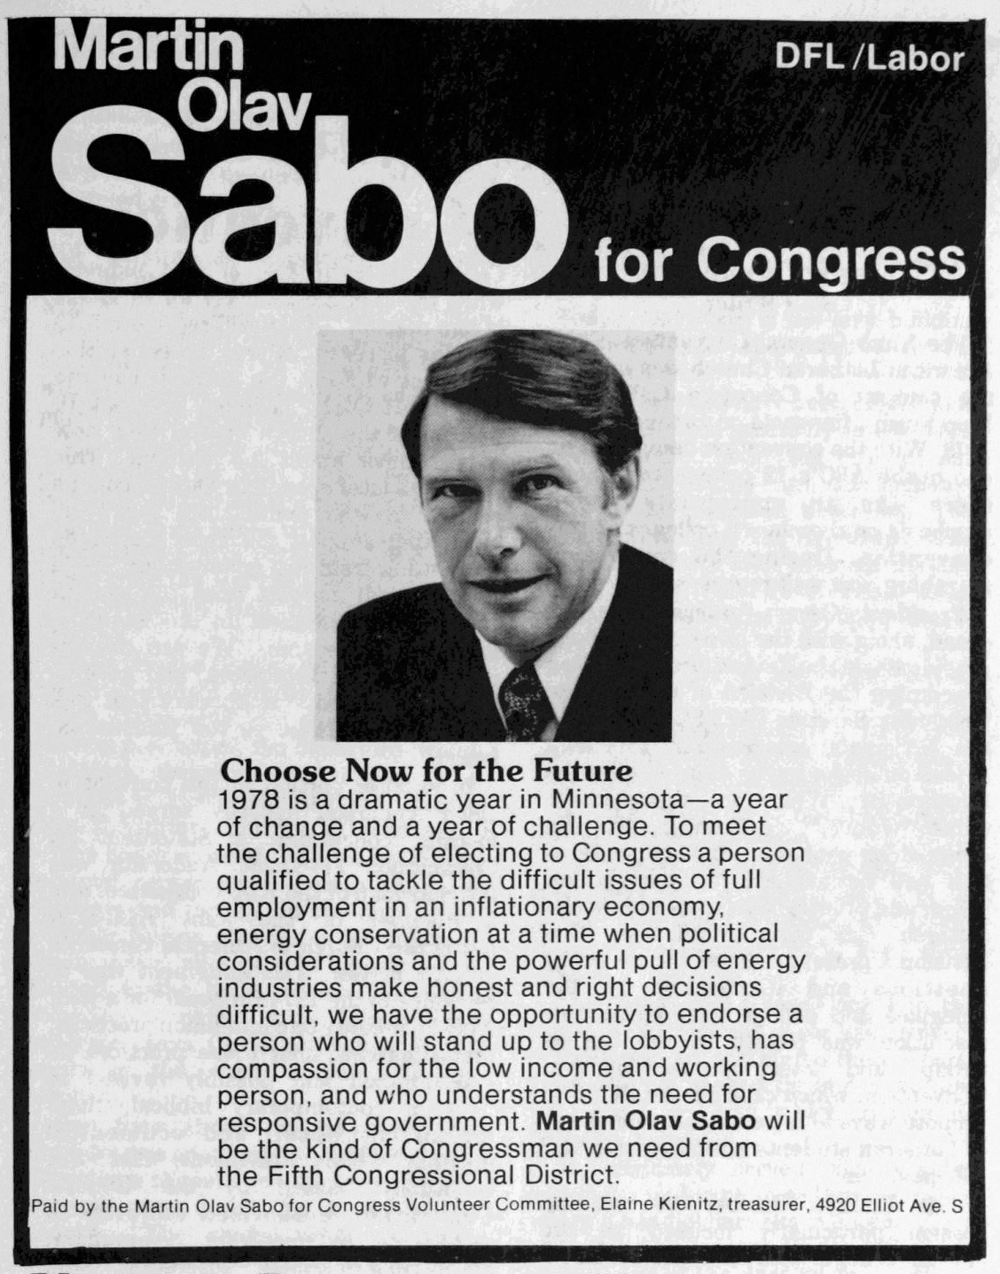

*This is an excerpt from professor Phil Adamo’s sesquicentennial history of Augsburg College. This is a work in progress containing copyrighted material. All rights reserved.*

Martin Olav Sabo for Congress

*Political advertisement, 1978*

On 13 March 2016, an email from President Paul C. Pribbenow went out to the Augsburg community. “I write with great sadness today,” it began.[1] Martin Sabo, 1959 alumnus of Augsburg College and Representative of Minnesota’s Fifth District in the United States Congress, had passed away. Sabo served the citizens of Minneosta for a total of fourteen terms, from 1979 until his retirement in 2007.

While it’s typical for college histories to tout the accomplishments of their successful alums—and Sabo is certainly deserving of this treatment—after reading the many tributes in local and national newspapers, and on the College’s own website, it seems more fitting for *this* college history to remember Sabo as a college student, who arrived at Augsburg from an immigrant background with huge dreams for himself and his family’s adopted country. This focus is not intended to diminish all of Sabo’s later accomplishments. Instead, I hope it might provide some context for what was to come.

Martin Sabo was born in 1938 in Crosby, North Dakota. He grew up in the nearby town of Alkabo, near the Montana state line and the Canadian border, in North Dakota’s northwestern-most corner. His parents were Norwegian immigrants, whose house did not have electricity for the first ten years of Sabo’s life.[2] He attended the Alkabo School, not quite a one-room schoolhouse, but close, which was built in 1934, closed in 1963, and in 2010 was listed on the National Register of Historic Places. Martin was first in his high school class in Alkabo, though he would often joke—in classic Scandinavian self-deprecating style—that there were only three students in his class. His older sister Anna Marie left Alkabo for the big city of Minneapolis to attend Augsburg College. She graduated in 1949.[3] Martin followed in Anna Marie’s footsteps in the fall of 1955.

During his time at Augsburg, Sabo studied history and political science, though he is famous (especially in Augsburg history department) for claiming that he “majored in Chrislock.” Indeed, Sabo’s relationship with Carl Chrislock must have been one of mutual admiration and support. Soon after his arrival, Sabo became involved with the Democratic Club on campus, as well a student group called the Public Affairs Federation (PAF), whose stated purpose was “an intelligent interest in what goes on outside Augsburg’s sheltered quadrangle. The PAF was comprised of members of the Republican Club, the Democrat Club, and “non-partisan civic-minded members” who acted as arbiters. Both of these groups had Chrislock as faculty adviser. Indeed, the student/mentor relationship seems to be expressed in a 1957 *Augsburgian* photo of the PAF group, which shows Sabo standing in the second row, next to his mentor on the far left.[4]

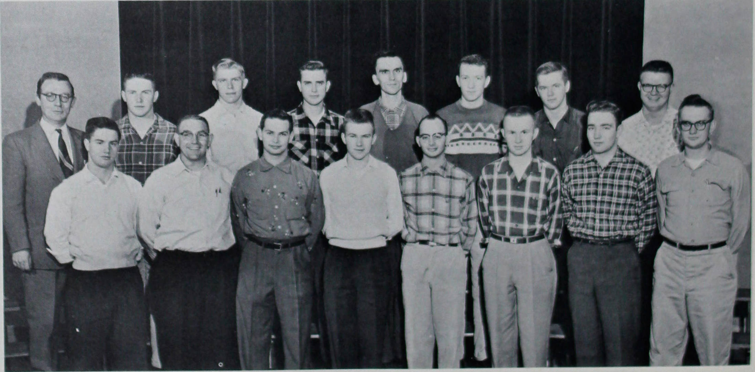

*The Public Affairs Federation in 1957. Professor Carl Chrislock is   
wearing the suit, second row, left. Martin Sabo is next to him.*

The close relationship between Sabo and Chrislock did not mean that the student always agreed with the teacher. For example, in August 1958, The People’s Republic of China, a communist power known in the West as “Red China,” was at odds with the nationalist government on the island of Taiwan, the so-called “Republic of China.” Red China bombed contested Taiwanese territory in the China Sea, an action which became known as the Taiwan Strait Crisis, a critical moment in the Cold War. The United States refused to recognize Red China diplomatically, though it did recognize the legitimacy of Taiwan. The U.S. was also actively blocking Red China’s entry into the United Nations. Many people criticized these policies because, in spite of its being communist, Red China was larger in population and landmass than the tiny island of Taiwan. In December 1958, the *Echo* posed the question: “Do you agree with the U.S. Red China policy?”

Dwight Sorheim, president of the campus Republican Club stated that he was:

In total agreement with United States policy with Red China … we should not violate agreements with the Nationalist government … as for the Red Chinese government, when it can display in its international associations that it can act in contrast to that of the Korean situations, where it showed no concern or interest for repatriation of the ravages of battle, of prisoners of war and most of all our war dead, then we might well consider it a candidate for official United States recognition as well as a member of the family of nations.[5]

Martin Sabo, president of the Democratic Club:

No, I do not agree with our foreign policy in dealing with Red China. I believe that we should permit our newspapers to send reporters to Red China. We should also recognize the government of Red China. The policy of refusing to let our reporters go into Red China would seem to be a restriction of our constitutional right of the freedom of the press … It is only by such cultural exchange that we can hope to arrive at a little better understanding of each other and so have a little better chance for coexistence. The belief that we can hinder the progress of Red China by standing in moral aloofness is the height of illusion.[6]

Carl Chrislock tempered the passion of both young men with a more nuanced answer to the question:

In part, yes; in part, no. I agree that Red China is a formidable threat to the values and interests of the Free world. This being so, the United States has to oppose the extension of Chinese inf1uence. However, I do not believe we are achieving this end by doggedly and dogmatically holding on to the policy of non-recognition. It seems to me that we should extend diplomatic recognition to the Red government and that we should cease opposing Peking's admission to the United Nations.[7]

Chrislock framed the question in terms of threat and looks for a way to avoid it or disarm it. Sabo framed the discourse in terms of understanding and co-existence informed by pragmatism. What is interesting is watching the young Sabo in the public forum on campus, working out his worldview, engaging his opponents, and being challenged under Chrislock’s tutelage.

But for Sabo, politics was not just for classroom discussion and polite debate in the newspaper. Throughout his time at Augsburg, he involved himself in campus politics and clubs. In 1956, he led “Students for Stevenson,” a group of undergraduate Democrats that worked on Adlai Stevenson’s presidential campaign.[8] Keep in mind that Sabo was only 18 at a time, and the 26th Amendment that would have given someone his age the right to vote was a decade and a half away.[9] As part of his work on Stevenson’s campaign, Sabo attended workshops in Chicago where he learned about campaign organizing, and even got to meet the candidate in an informal setting with other students from across the country.[10] As president of the Democratic club, Sabo organized DFL activities on campus, including a dinner with Lieutenant-Governor Karl Rolvaag.[11] Sabo also chaired a retreat in which President Bernhard Christensen met with students to address the issue of student participation in the administration of the college.[12]

At a 1958 meeting of the campus Democratic Club, Sabo organized a showing of the film “How to Win Elections.”[13] This must have been a very informative film because by 1960, then 22-year-old Martin Sabo ran for office and got himself elected to the 31st district, becoming the youngest legislator in the Minnesota House of Representatives. In the *Echo* report of his successful campaign, Sabo recounted the story of a woman who was so impressed by his victory that she told him how disappointed she was in her own son. Sabo admitted that playing the “son” card helped him win over voters:

Youth was my main asset … Maybe the people were also impressed that I used to empty garbage in the men’s dorm while at Augsburg. I even had a campaign picture of myself pushing a broom.[14]

By 1973, Sabo had become Speaker of the House in Minnesota, and was serving as a member of Augsburg’s Board of Regents. In a 1974 interview in the *Echo*, which featured Sabo on a full-page, magazine-style cover, now Speaker Sabo related how his experience at Augsburg had gotten him started in politics:

I was never involved in politics before I went to Augsburg. I walked on campus, met Harlan Christianson, and he had me on the way to a political meeting within a week or two … I was on the Student Council. Student Vice President my Junior year … We had an office in [the] 6th Ward DFL organization. We lived on the corner there on 22nd and Riverside, above the grocery store. It must have been headquarters for two or three Student Body President campaigns, two or three campaigns for statewide DFL chairman. My first legislative campaign was run out of there. A group of us were good friends and all involved in politics.[15]

Historian Winston Chrislock (son of Carl) called this group the “Augsburg mafia,” on account of the political clout that they would develop and wield.[16] In 1978, Sabo ran for Congress in the 5th District. The ad from the *Echo*, seen at the beginning of this chapter, is from that campaign.[17] By then, 18-year-olds could vote in federal elections, and the newspaper from Sabo’s alma mater endorsed Augsburg’s favorite son:

Sabo has done more for Minnesota in the areas of education and housing than any other legislator we can recall. The education aids formula and one of the finest state housing agencies in the nation were the result of his excellent legislative leadership … Sabo has shown courage … commitment … and compassion … This country, as well as Minnesota, needs men like Martin Olav Sabo.[18]

Sabo won the election, and served the people of Minnesota for 28 years. In 2009, to honor its alum, the College created the Sabo Center for Citizenship and Learning, now the Sabo Center for Citizenship and Democracy. It is difficult to sum up such a rich life of service. Paul Pribbenow’s email did the best we might hope for:

[Martin Sabo was] a national leader and public servant, and an inspirational legend dedicated to revitalizing the role of higher education in equipping students for active engagement in citizenship and democracy.[19]

For members of the College community, Representative Sabo will always be a part of Augsburg. We knew him when.

1. Email from Paul C. Pribbenow, “[faculty] Martin Olav Sabo ‘59,” (13 March 2016).
2. Paul Walsh, “Martin Sabo, longtime DFL congressman and politician, dies,” *Star Tribune* (13 March 2016) at http://www.startribune.com/martin-sabo-longtime-dfl-congressman-and-politician-dies/371916411/#1.
3. *Augsburgian* (1949), 73.
4. *Augsburgian* (1957), 74.
5. “Do you agree with the U.S. Red China policy?” *Echo* 65:6 (11 December 1958), 6.
6. “Do you agree …?” *Echo* 65:6, 6.
7. “Do you agree …?” *Echo* 65:6, 6.
8. “Democratic Club Organizes Students for Stevenson,” *Echo* 62:10 (14 March 1956), 1.
9. The 26th Amendment became law on 1 July 1971.
10. “Martin Sabo Attends Workshop in Chicago,” *Echo* 62:12 (12 April 1956), 2.
11. “Rolvaag To Speak at DFL Dinner,” *Echo* 63:10 (13 March 1957), 1.
12. “Leadership Retreat Meetings Focus on Student Role in Administration,” *Echo* 63:13 (1 May 1957), 1.
13. “Thye, McCarthy Speak During Political Week,” *Echo* 65:2 (2 October 1958), 1.
14. “Youthful Sabo Wins Congressional Seat,” *Echo* 67:4 (10 November 1960, 5.
15. Karen M. Johnson, “Martin Sabo: Never a Normal Day,” *Echo* 80:15 (15 February 1974), 6.
16. Winston Chrislock, discussion with students in HIS 331: History of Augsburg College (9 March 2016).
17. *Echo* 85:8 (27 October 1978), 5.
18. “Martin Olav Sabo for Congress,” *Echo* 85:9 (3 November 1978), 2.
19. Email from Paul C. Pribbenow, “[faculty] Martin Olav Sabo ‘59,” (13 March 2016).