Augsburg University Faculty Meeting Minutes
Wednesday, April 28, 2021 at 3:40 p.m.
Augsburg University
Held via Zoom

Provost Karen Kaivola presided and called the meeting to order at 3:40 p.m.

First Word
Doug Green, Professor of English, provided the first word.

Approval of Minutes
The previous meeting’s minutes were approved.

Approval of Agenda
The agenda was approved.

Announcements
Critical Race and Ethnicity Studies (CRES) searches update - Ryan Haaland, Dean of Arts & Sciences
Search committees have identified 5-7 candidates within each area for initial interviews over the next few weeks. Second round interviews would begin 2 wks following, with a broader audience (including students and faculty in late May or early June). The Zoom paradigm gives flexibility and can accommodate as many people as would like to participate.

President’s Report – Paul Pribbenow
President Pribbenow extended gratitude for work over the 151st year of Augsburg, highlighting the continued social justice work of the community and the continuing efforts on behalf of the institution’s strategic plan. He shared that there is no final decision on a vaccine mandate at this point. He wants to hear faculty and staff perspectives in conjunction with the legal, ethical conversations that are ongoing. He thanked Jennifer Bankers-Fulbright for the planning that is going on in preparation for Days in May. He is looking ahead to both the virtual and in-person commencement ceremonies over the next week.

Provost’s Report – Karen Kaivola
Provost Kaivola also thanked the Faculty for their work in these demanding circumstances. She spoke to the achievements in growing into a sustainable university. Looking ahead to next year she noted the goal of maximizing face-to-face interaction on campus and in classrooms.

Throughout the year, the following three initiatives have played a part in growing the institutional strength, and were designed to advance the goals of Aug150 and the 2025 Academic Plan:
- HLC Quality Initiative
- Grow Sustainably Task Force
- Task Force on Academic Structure

Karen reviewed institutional goals moving forward that seek to enhance our distinction as a diverse institution, improve undergrad retention, grow and optimize graduate enrollment, and redesign offerings for working adults.

The common goal of these efforts is to grow institutional quality, capability, anad sustainability.

Faculty Senate Report – Milda Hedblom, President, Faculty Senate
Milda Hedblom reported that the workload guidelines document has been handed off to Senate for consideration and recommendation. Questions were raised regarding clarifying the NILC and whether the document opens the door to a 4:4 teaching model. Phyllis Kapetanakis noted that the NILC was to recognize the work faculty already perform, as opposed to adding workload. This is not for a 4:4 model. While a preliminary vote indicated the majority were in favor of this, senate decided to discuss this report further.

Senate will hold a special session in May to conclude their work.

Senate discussed the advisory grade pilot with Katie Bishop, and an ongoing evaluation. Senate was asked to approve continuation of this pilot, but deferred their decision pending receipt of more data.

Senate approved the report from the joint task force on opening and closing programs criteria – specifically to form the criteria guiding these decisions ultimately to be made by the Board of Regents.

Senate noted the work by the faculty governance work group, and thanked Andy Aoki for his leadership.

Senate discussed the question of requiring vaccinations by fall. All agreed that the faculty should be heard from and senate will assist however possible.

Committee on Committees - 2021-22 committee election results - Pavel Belik
Pavel Belik reported the results of the faculty elections for the standing committees, University Council, and the at-large representatives to the Faculty Senate. Those results were also shared with the Faculty by email.

Faculty survey (TEL) results - Jenny Hanson, Director of Online and Blended Learning Pedagogies
Jenny Hanson shared preliminary results from the recent survey, which would not close officially until May 1. So far, 116 responses have been received. The survey was created in collaboration with senate, TEL, and Classroom and Presentation Spaces Working Group.

Jenny shared some emerging themes:

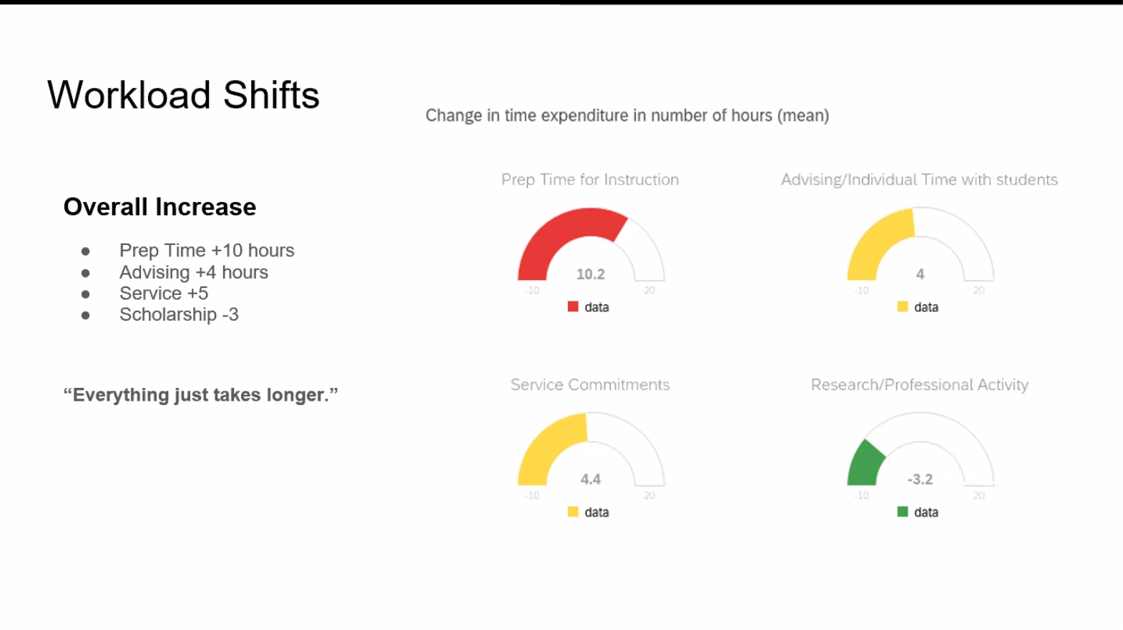
Prep time has, on average, gone up 10 hours. “Everything just takes longer.” Faculty have seen diminished time for research and professional activity.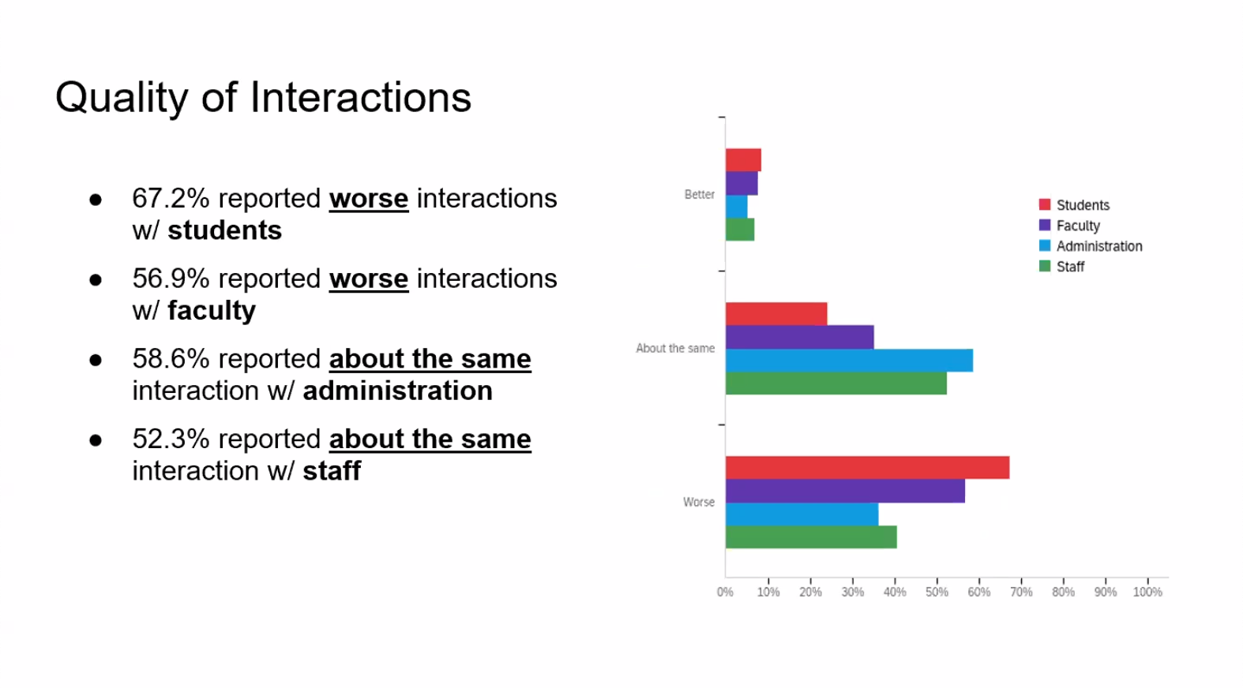“Worse” defined as less/lower quality
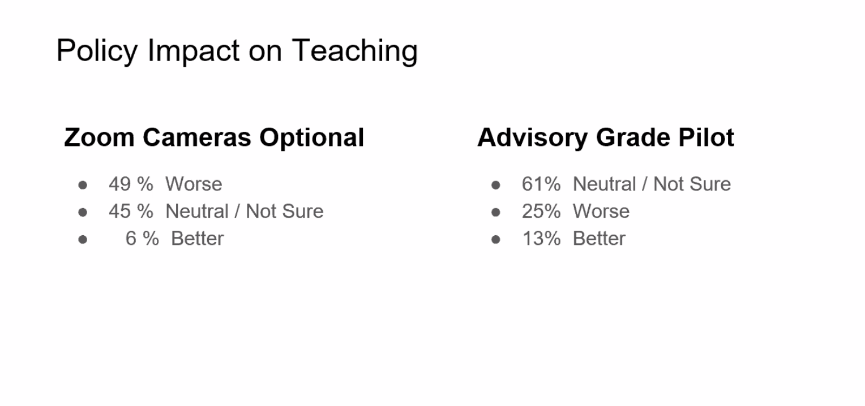
Seeing a trend in worse/neutral in zoom – “it’s hard to stare at cameras that are off.” Questions continue: how to increase efficiency and effectiveness in this modality. Most are neutral/not sure on the advisory grade pilot and are working through it.
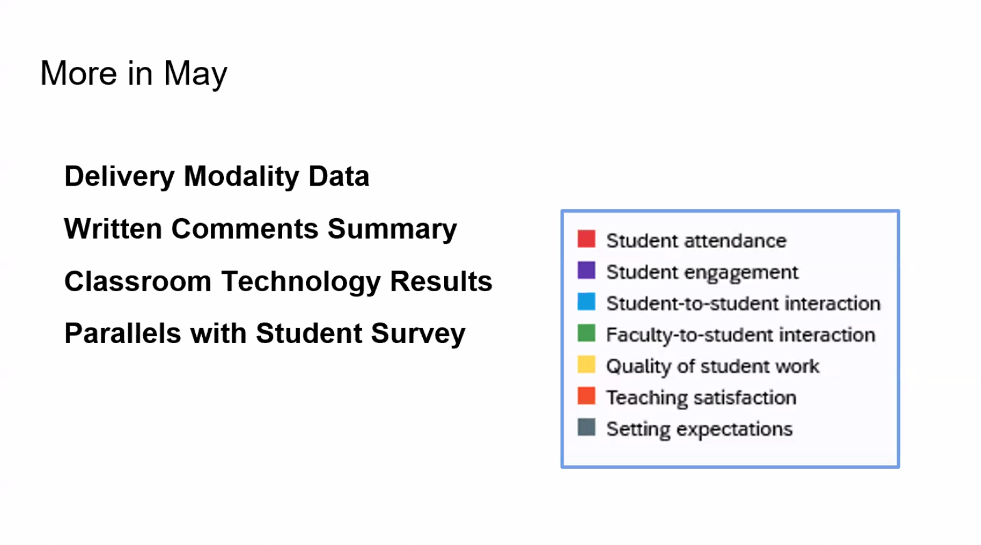
Jenny noted they are hoping for more in-depth discussion during Days in May. Summaries of key themes from written comments forthcoming. Hoping to parallel these responses with those from the Student Survey.

General Education Learning Outcomes and Assessment: Implications for fall syllabi - Stacy Freiheit, Director of General Education

Stacy made the following suggestions:
- Consider what assignments will lend themselves well to program-level assessment. Integrated learning and outcomes are being assessed.
- Include relevant Gen Ed info on syllabi. Info available on Augsburg websites and Moodle sites. Stacy is compiling these into a resource guide to be delivered later this summer.
She expressed her thanks to all for the many contributions in Gen Ed this year.

Parting words from retiring faculty
Retiring faculty offered their parting words and thoughts to the Faculty
- Mark Carlson-Ghost
- Suzanne Gikas
- Cheryl Leuning
- Alan Tuchtenhagen
- Eileen Uzarek
- Barbara West
- Doug Green

Doug Green, Professor of English adjourned the meeting at 4:54 p.m.

Arielle Mayper, Recorder

