Augsburg University Faculty Meeting Minutes
Wednesday, January 20, 2020 at 3:40 p.m.
Augsburg University
Held via Zoom

Provost Karen Kaivola presided and called the meeting to order at 3:40 p.m.

First Word
Rachel Lloyd, Associate Professor of Education, provided the first word.

Approval of Minutes
The previous meeting’s minutes were approved.

Approval of Agenda
The agenda was approved.

Announcements
- Center for Teaching and Learning - Jennifer Bankers-Fulbright, CTL Director
CTL will offer grants and awards again this year. All information can be found on the CTL website. Of note, grant applications are due February 15, 2021 at noon. Nominations for Distinguished Teaching and for Scholarship and Service are due March 1. Email Jen Bankers-Fulbright (bankers@augsburg.edu) with any questions.
- New director of First Year Experience - Ryan Haaland, Dean of Arts & Sciences
Lyz Wendland will continue on officially as the Director of First Year Experience. A Teaching Fellows program, creating a cohort of instructors to discuss anti-racist pedagogy as it relates to first year experience and teaching, is also being established.
- CRES Search Committee - Ryan Haaland
The committee has been formed, as outlined in the provost's update letter, and includes three students. The group is supported and empowered by support from Faculty and Staff in recognizing the work involved. Dawn Miller, Kerri Maher, Joanne Reeck are serving in support and advisory roles.
- Augsburg Bold Scholarship - Robert Gould, VP for Strategic Enrollment Management
Please make Seniors aware of the graduate student component of the Augsburg Bold scholarship, which provides a 50% discount on tuition for the whole degree, for specific programs. The program hopes to help students with more limited opportunities. Deadline for application is March 1.

Reports from University Officers
- Paul Pribbenow, President
President Pribbenow reported that the state of the institution’s finances and enrollment were set to come in on target, based on the models created. This, combined with the ~$5million coming from the stimulus bill will allow us to meet student needs, and ideally end the year on budget. He also reported that all Faculty and Staff impacted by pay reductions would be fully reinstated for the January 24 paycheck, with the 403(b) benefit slated to be restored next fiscal year.
At the time of the meeting, Enrollment was running at ~700 applications ahead of where they were the previous year, a historic rate.
President Pribbenow called attention to the need to ask why Augsburg continues to see these record setting figures. Although we have anecdotal answers, we also need to have a clearer understanding of Augsburg’s distinction. To that end, Augsburg has signed a letter of engagement with Art & Science Consulting Group, who specialize in market studies for institutions, for a 2-year contract. The group will track students through a cycle to see what attracts and what sustains them. This effort will be managed by Robert Gould, with a roster of Faculty, Staff, and Students to serve as an advisory group. President Pribbenow marked this project as his highest strategic priority.
He also reported that Augsburg has partnered with Seward Redesign to evaluate how to renovate and revive Bethany Lutheran Church, which Augsburg was gifted last June, and create a community anchor on Franklin Ave.
- Karen Kaivola, Provost
Provost Kaivola introduced the rest of the day’s agenda. She expressed that CRES has received strong support from UCAP, AAC, and the Faculty Senate, in addition to the enthusiastic, unprecedented support from Students. The CRES Proposal would come for its Second Reading and Vote in the February Faculty Meeting. In the meantime, the search committee would be moving forward with its Faculty search, although offers would not be extended until appropriate approvals on the program were secured. She expressed the strategic and moral importance of approving the CRES Department, as an investment in redesigning for today’s students, fostering a deeper sense of belonging at Augsburg and in providing an academic perspective on students’ own communities and lived experiences.
Provost Kaivola also spoke to the advisory early grade pilot, which was endorsed by AAC and the Faculty Senate. This initiative would not be put to a vote, because it is a pilot, but would be brought back through appropriate governance before becoming an established policy. The pilot responds in part to student requests for transparency, but falls short of providing what they were asking for (real time access to grades). The pilot provides structural support for the best interest of our students, early, wise feedback, transparency in the course. It aligns with research on student success, as well as best practices in the industry.
She previewed that the Task Force on Workload and Curricular Parameters would have a presentation coming soon, possibly in February.
Provost Kaivola also thanked Dave Lapakko for being Parliamentarian while Bob Groven is away.

Faculty Senate Report - Milda Hedblom, Faculty Senate President

Milda Hedblom noted that the Senate did vote to recommend the Faculty approve CRES and that they hire new Faculty to teach in the department (3 in the first year, 2 in the second). This decision was reached based on the AAC recommendation and the Provost’s optimism in being able to fund the program. The Senate stressed that in moving to create this program, language around expectations for the new Faculty should be written with careful attention paid to their unique responsibilities.

With respect to the grading policy, the Senate’s essential feeling was that if this pilot may help to improve the student experience, it is worth doing. Milda also noted the importance of a proper evaluation process in conjunction with the pilot, which is being incorporated.

Milda closed by saying that the Joint Task Force on Opening and Closing Programs is moving forward, and that the Senate strongly supports this action.

First Reading: Proposal to create the department of Critical Race and Ethnic Studies
Joaquin Munoz opened the proposal.

Elise Marubbio continued, in November 2019, an ad hoc group of Students, Staff, and Faculty convened with a common goal of creating this program as a core component of the university. The group has met regularly since then, working towards that vision, researching what this unique combination may look like, and what it may bring to Augsburg.

Michael Lansing continued, this work started with what happened in spring 1968. At One Day in May, students of color expressed their clear need for representation, and all departments were called upon to fill the gap. It became clear, looking at the memos from that demand, that there was still a gap, one that continues to exist 53 years later. A gap between what we promise and what we deliver. This addition will address that gap in some small way, and provide a place to build out from.

Maheen Zaman continued, students in the CRES group have done multiple surveys and provided anecdotal evidence of broad support with students. The naming order is chosen for poetic reasons. Elsewhere this program would be American Studies, but CRES seeks to focus the student demand in the way this department is framed and named. Maheen noted that American Studies becomes gentrified academically and curricularly, and the group wants to continually center students of color and their histories.

Joaquin Munoz concluded by bringing to the front the needs of students now and in the future. There have been a number of developments in the Twin Cities and throughout the state, including both Minneapolis and St. Paul approving students’ need to have an Ethnic Studies course to graduate. The group envisions the critical and financial importance of this department, which will be beneficial to our school and our community.

Provost Kaivola called for clarifying questions and noted that the full proposal was available in the Provost’s Update. The AAC link included documentation of the review of the proposal.

A Faculty member asked if there was an open discussion forum planned before the vote. Joaquin Munoz noted they were open to possibility, and asked to clarify whether there were specific aspects desired for discussion. Michael Lansing echoed this ask for specifics, and both noted that everyone from the group is available to answer questions.

A Faculty member wanted to respond to a request from Faculty to hear from folks teaching in related areas. They noted that many departments taken for granted in the liberal arts experience have been around since the Middle Ages. Many others we take for granted as mainstream were added after, in moments of social change and upheaval. They advised Faculty to consider the times a student has had a very specific interest and tried to push a class in that direction, or the times a student has asked for direction and you’re not sure where to send them. They pointed out that early or late adopters of new curriculum are clear, and that students chose Augsburg because they thought we’d be quicker on the update.

A Faculty member noted, with respect to hiring multiple new Faculty at once, that they are both someone who comes from a cognate discipline and someone who exists as a department of one, and that they would not wish the experience on anyone. They stressed the importance of establishing a cohort, and repeated Eric Buffalohead’s note about the importance of having a tenured member of the Faculty in leadership for this department. They were very happy with the proposal and expressed excitement to see this scholarship continue and center itself in one place.

A Faculty member noted they felt it was clear the momentum around this department is strong and compelling. They also expressed that their department has a strong anchor in Critical Race Theory, and wanted to know how a discipline that is already involved in this work can be involved in the implementation of this program going forward.

Proposal to pilot early grade feedback in Spring 2021
Jenny Hanson reported that work is underway to think about how to implement this pilot. It has been a collective effort to get this together to satisfy Faculty, Students, and Academic Advisors. They are building a system that satisfies those audiences and provides meaningful and productive engagement for them all. There will be information provided on how to use the system, and there will be training both for Faculty and Students on how to use and access the pilot. The proposal’s full details were shared in the Provost’s Update, and questions could be sent to Jenny at hansonjl@augsburg.edu.

Jenny also pointed to plans to evaluate the pilot to make sure it is meaningful and successful before permanent implementation. She noted that 93% of institutions have an early progress reporting system.

A Faculty member asked about the format of delivery, and whether there was discussion around making this feel more personal and from Faculty. Jenny clarified that students are going to get effectively a report card email with their information and feedback. She also noted that these comments (both in the current system and in the pilot) become part of the student’s academic record, so they needed to be mindful of what was being sent out this way. The Faculty member asked whether WISE feedback was being used, and Jenny said yes, and that additional training would be provided on WISE feedback for Faculty modeling.

A Faculty asked if this pilot was being used for graduate programs as well, and if it was replacing Academic Alerts. The pilot is not being used for grad. It does replace Academic Alerts, but it does not replace the Safety Wellness Alert, which can be submitted at any time.

In lieu of an academic alert, Faculty can email their student and that student’s Academic Advisor (as listed on class roster).

Everyone outside of grad is automatically part of the pilot.

A Faculty member asked why we are dismantling a feature that works (Academic Updates). Jenny expressed that the group is open to discussing academic alerts, if people feel strongly about them. The Faculty member noted that they were using the old system at 4, 8, and 12 weeks, as well as if there was a sudden change, or for students at the end of the semester who were in danger of failing. They felt there is functionality there that has previously helped students be successful.

Discussion: Fall Student Surveys and Assessment/TEL Workshops, Implications for Spring Teaching - Ben Denkinger, Director of Assessment, Jenny Hanson, Director Online and Blended Learning Pedagogy

Ben Denkinger expressed this presentation as a Greatest Hits of what was presented at the workshops, an opportunity to chat, and to discuss what comes next.

One survey had 900 respondents, the other had 600.

Ben shared the following slides:
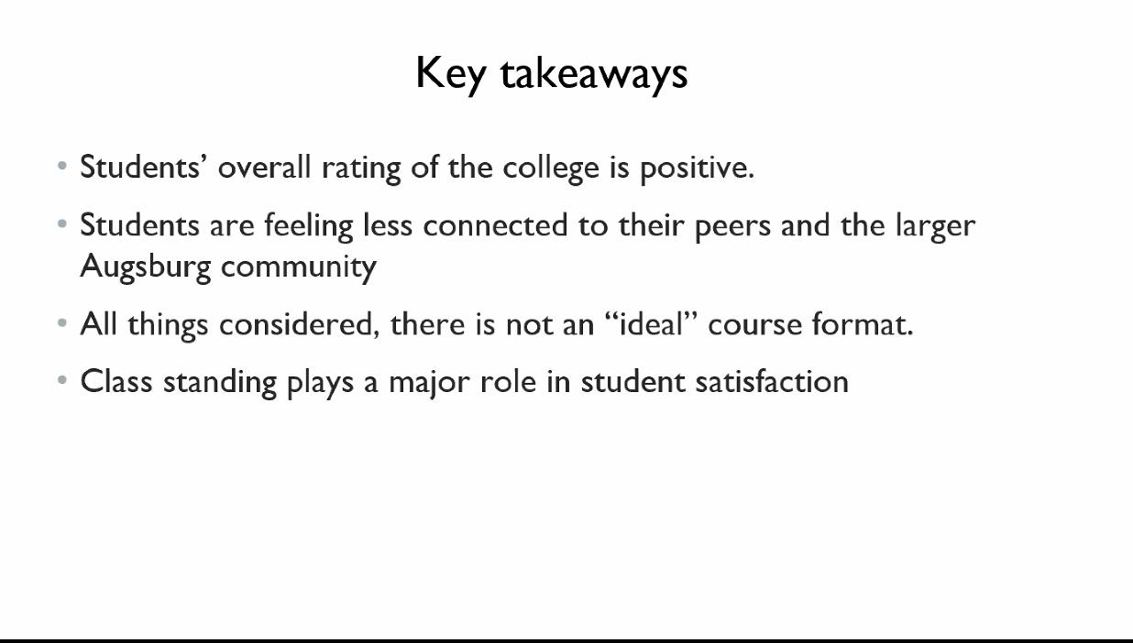

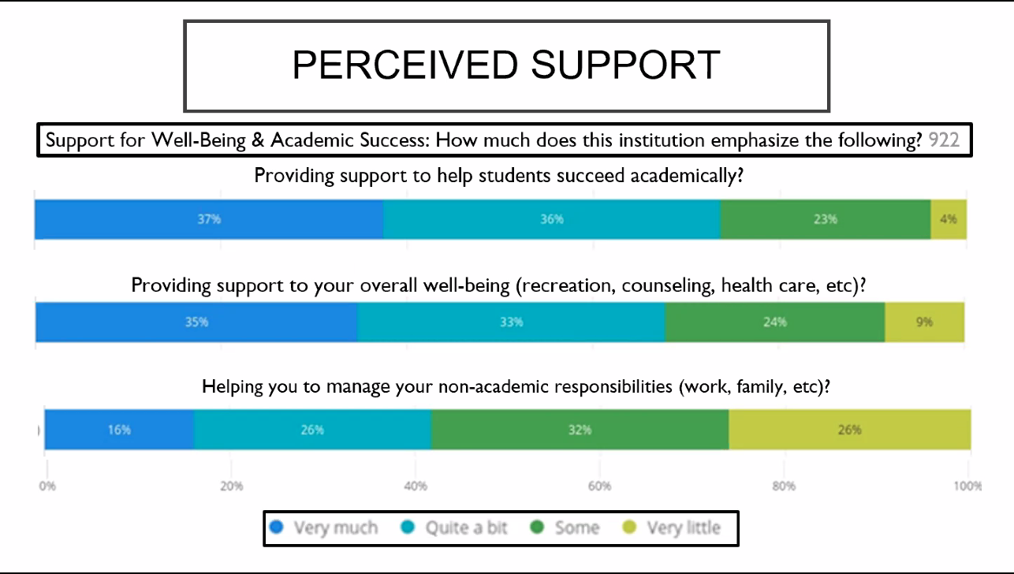
Augsburg did fairly well in academic support. Students in visual connection with Faculty felt most connected. We've heard perennially about the last point, re: how to manage school-life balance.

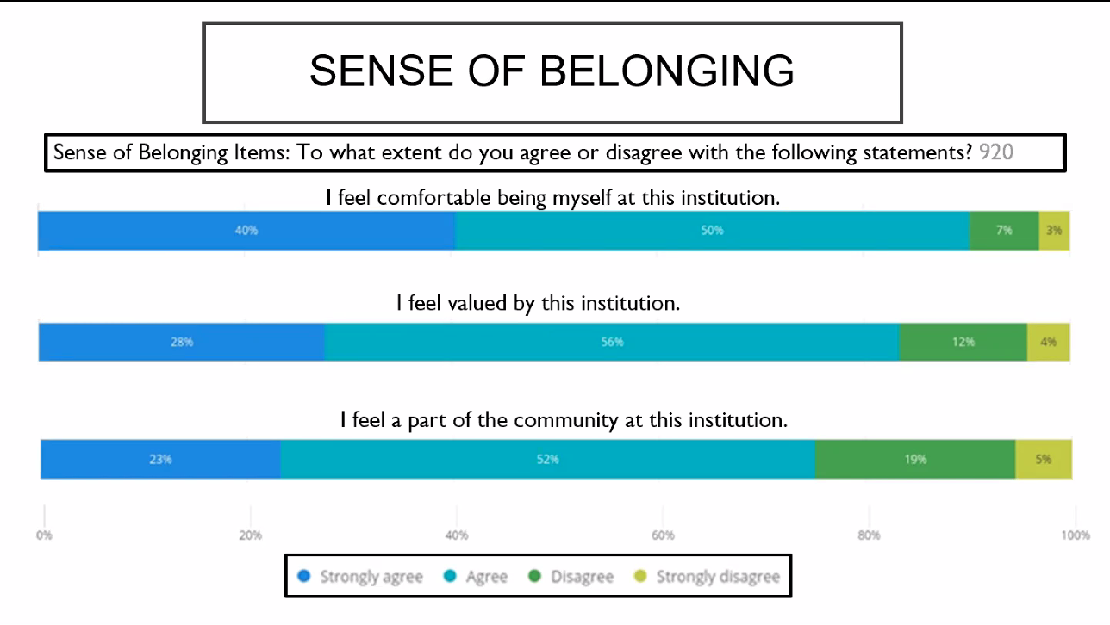

There were relatively lower scores for feeling part of the community. This was from NSSE, students in TEL reported lower levels of community.

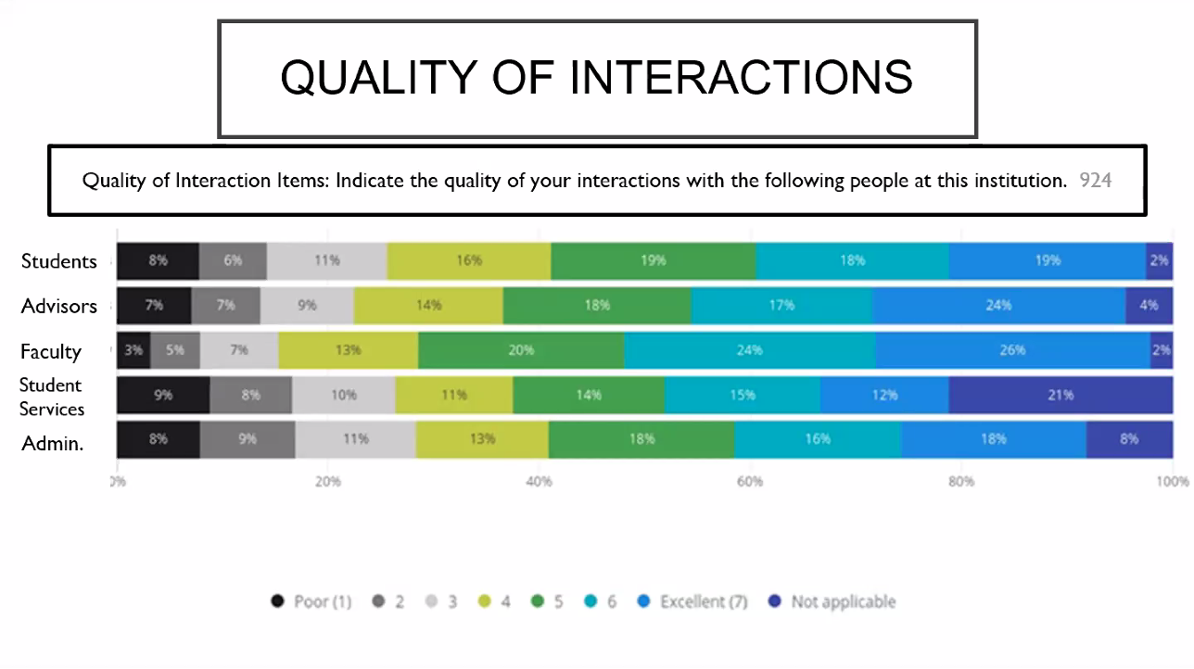
Faculty got relatively high scores, with one area re: lack of connection/interactions with students scoring subpar.

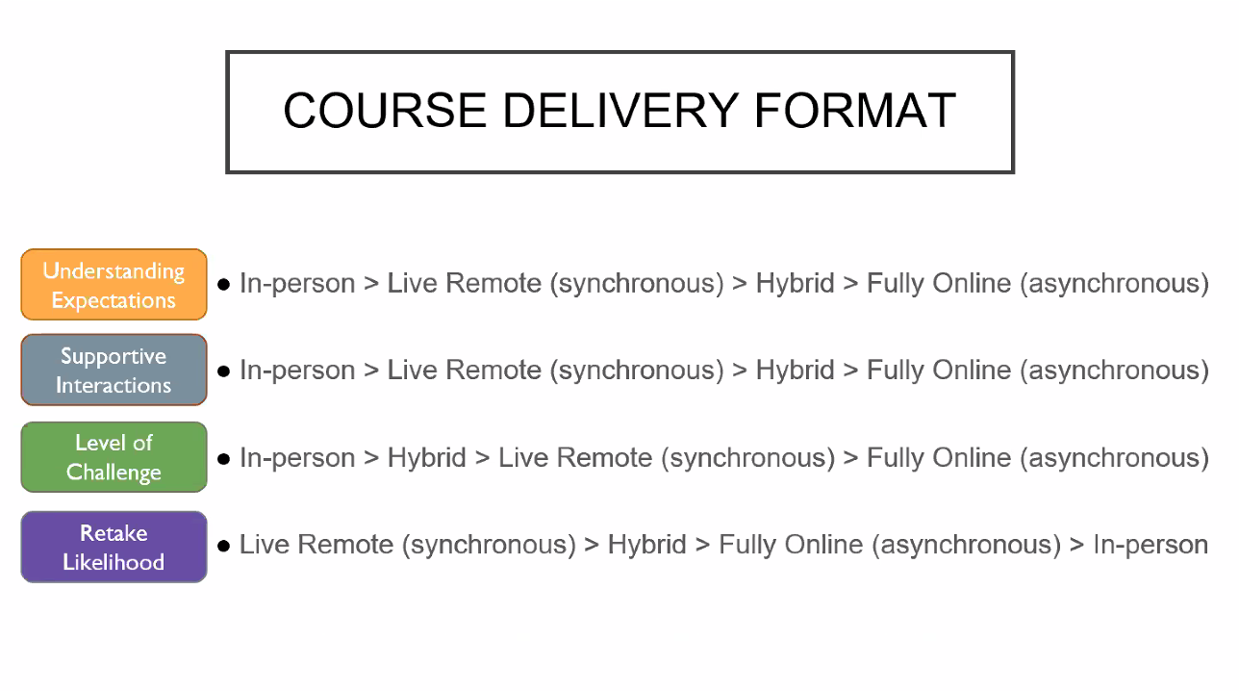
The more face to face, generally, the more students felt they understood, felt supported, felt challenged. This was used to determine how to shape course adoption for this semester.

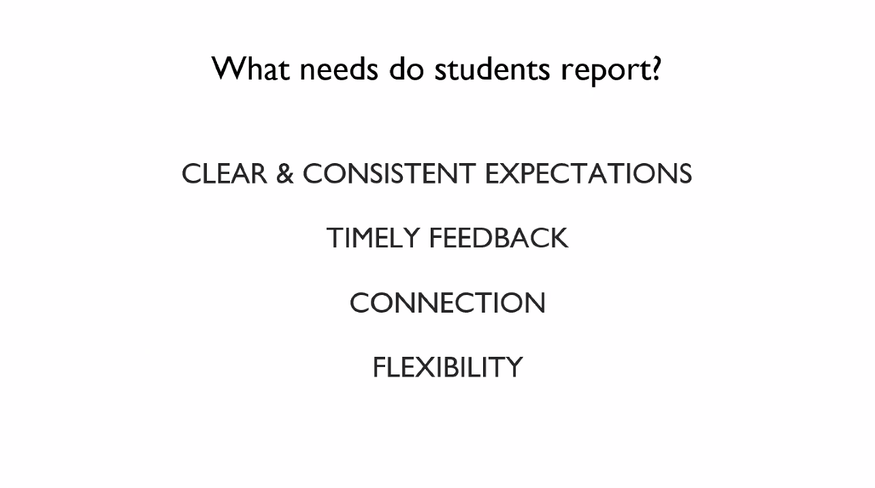

Jenny Hanson introduced the breakout activity, which included questions also posed to groups in the workshops.
LINK TO BREAKOUT
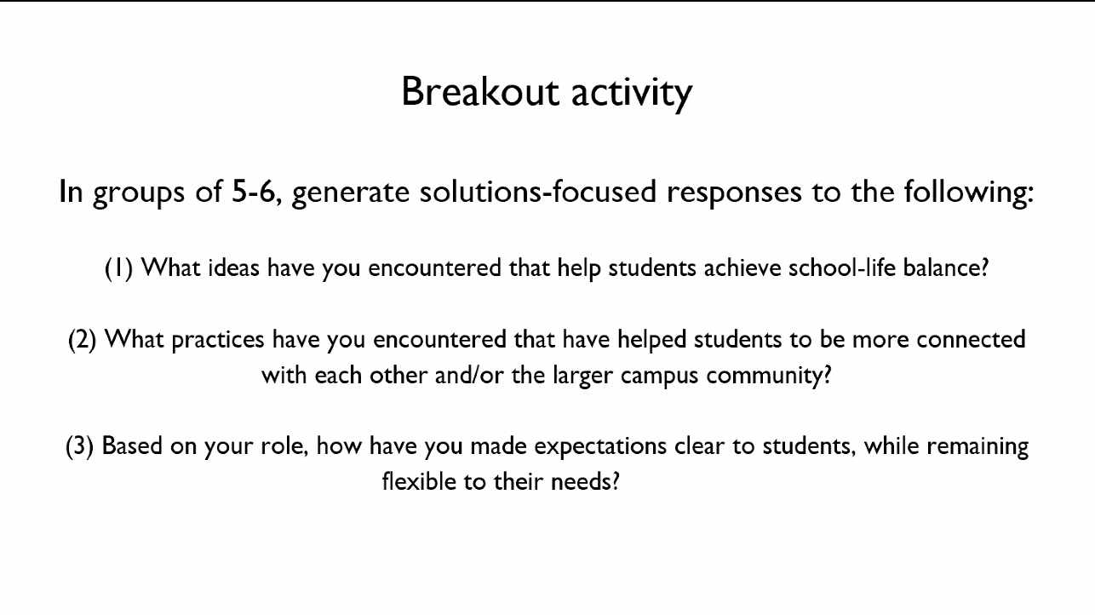
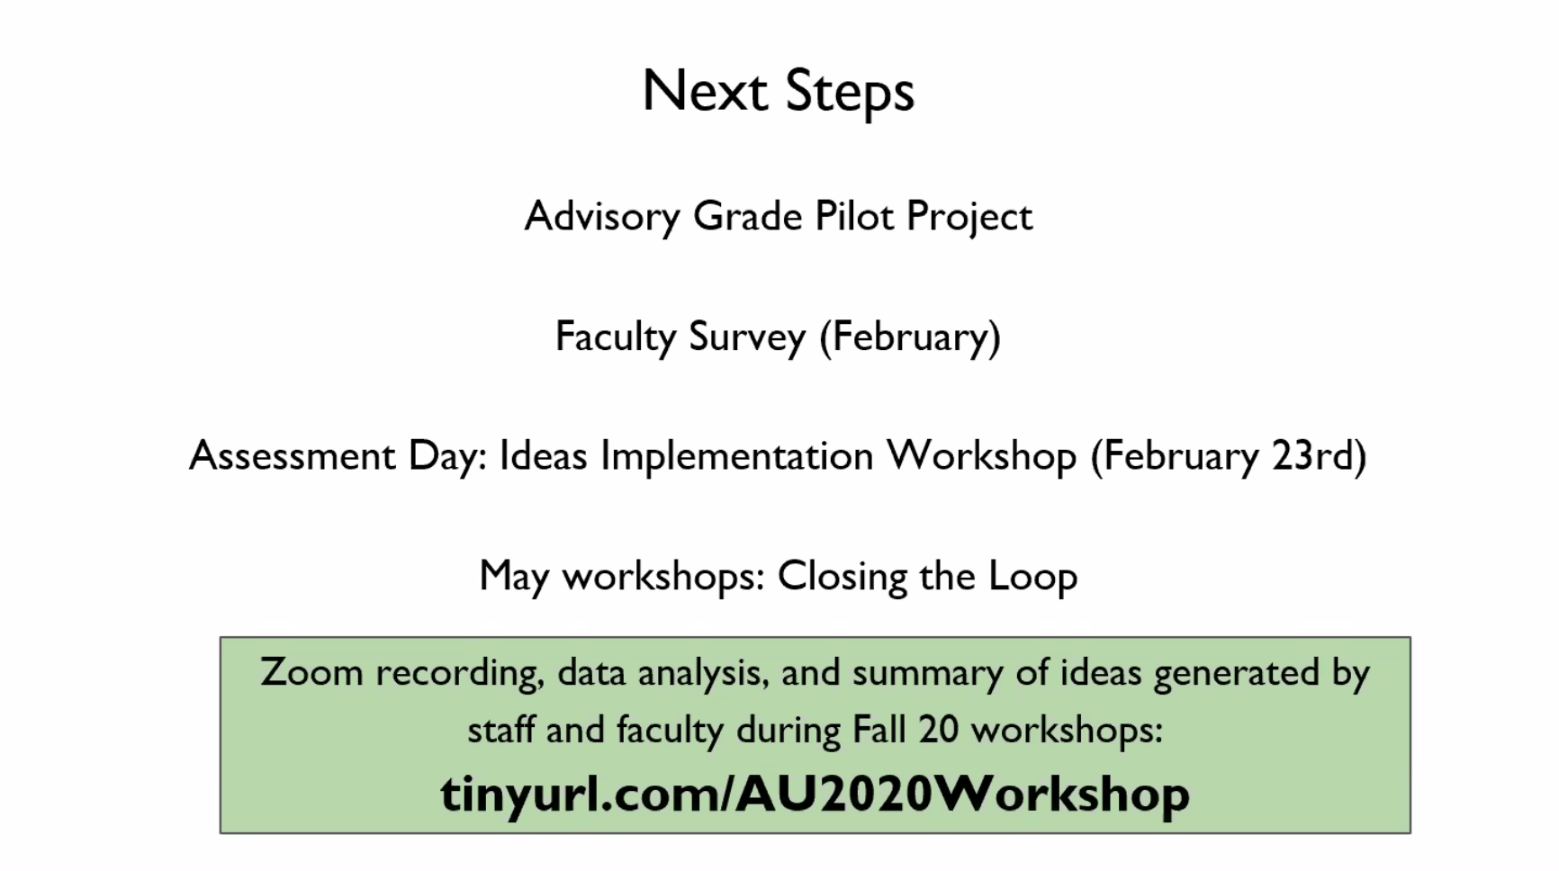

There will be a Faculty survey that mirrors what students were asked in the Fall. In May we will revisit the data and various efforts to see where we were successful and how to grow.

The meeting adjourned at 5:10pm.

