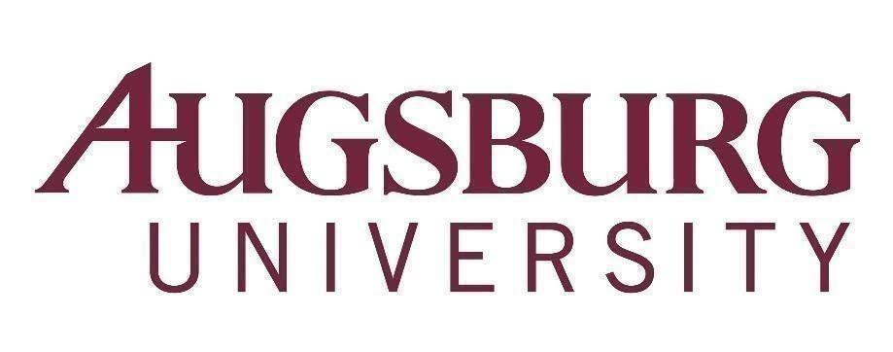

To: All Faculty
From: Karen Kaivola, Provost
Date: December 11, 2020
Re: Faculty Meeting, Wednesday, December 16, 2020, 3:40 p.m. (via Zoom meeting*)
*Register in advance for this meeting here

CTL EDTalk: Internships in the Age of COVID. Presented by: Lee George and Sandy Tilton from the Strommen Center for Meaningful Work and Melissa Hensley from the Department of Social Work. What has happened to internships since the onset of the COVID-19 pandemic? How can students connect with meaningful experiences? How can faculty support students in online or remote internships? This ED Talk will discuss processes and resources for students who are seeking internships. Informational updates and resources for faculty will also be shared. The internship process used by the Social Work Department will be discussed as an example of facilitating both online and in-person internship experiences. This recorded EdTalk premieres at 3:10 pm and will end by 3:30 pm. Log-in using this link.
Summaries of committee actions are linked here (as informational updates):
Academic Affairs Committee
Graduate Academic Affairs Committee

Agenda

- Convene and welcome - Karen Kaivola, Provost (3:40 p.m.)
- First Word – Lyz Wendland, Assistant Professor of Art & Design
- Approval of Agenda and Minutes (11/18 meeting)
- Announcements
- 2021 Zyzzogeton and Convocation update - Rebekah Dupont, Director, STEM Programs
- Martin Luther King, Jr. Day – Azania Tripp, Director, Pan-Afrikan Center
- Provost’s Report – Karen Kaivola
- Faculty Senate Report – Milda Hedblom, President, Faculty Senate
- Personnel Policies Committee Report - Bob Groven, Christina Erickson, Co-Chairs
- Motion to revise Faculty Handbook sec. 2.3 Statement on Academic Freedom
- Motion to create a Joint Task Force on Criteria for Starting and Ending Academic Programs or Departments
8. Augsburg Day Student Government on proposal for a Critical Race and Ethnicity Studies department - Berlynn Bitengo, ADSG President; Suaado Omar, ADSG Vice President
9. Insights from the Assessment/TEL Institutional Data Workshops - Ben Denkinger, Director of Assessment,
Jenny Hanson, Director Online and Blended Learning Pedagogies
10. Adjourn (5:10 p.m.)

Announcements due to the Academic Affairs Office
by Monday, December 14, 2020

