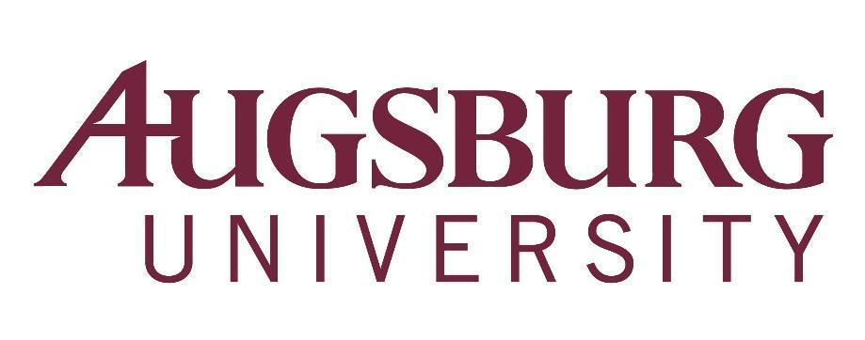

To: All Faculty
From: Karen Kaivola, Provost
Re: Faculty Meeting, Wednesday, September 18, 2019, 3:40 p.m.
*HAGFORS 150 (Coffee served beginning at 3:00 p.m.)

3:20-3:35 p.m. CTL EdTalk: Trauma: 3 Interdisciplinary Perspectives, Hagfors Center 151
Professors Matt Beckman (Biology), Barbara Lehmann (Social Work), and Mary Lowe (Religion) will describe how trauma is currently understood in their disciplines and highlight the points of tension and coherence among these disciplinary approaches to trauma.
Agenda

- First Word – Michael Wentzel (3:45 p.m.)
- Approval of Minutes
- Approval of Agenda
- Announcements
  - Writing Center – Jennifer Forsthoefel
  - AugSem – Rebekah Dupont
5. Provost’s Report – Karen Kaivola (3:55 p.m.)
- HLC Response to our Assurance Argument
- Faculty Handbook Revision
- General Education Redesign
- Academic Plan 2025
6. Faculty Senate Report – Milda Hedblom
7. Introduction of new colleagues (see p. 2 of this agenda for this list)
8. Adjourn

All are invited to a reception from 4:30 - 6pm, immediately following the faculty meeting. Hosted by the Library in the newly configured Learning Commons (street-level) of the Library, this reception honors new and returning faculty. Refreshments will be served. Please plan to stop by!

Announcements due to the Academic Affairs Office
by Monday, September 16, 2019

New full-time faculty, 2019-20:

Nimanthi Atukorala, Department of Mathematics/Statistics, and Computer Science

Margit Berman, Clinical Psychology Program

Jeff Brown, Clinical Psychology Program

Mark Carlson-Ghost, Clinical Psychology Program

Moumita Dasgupta, Department of Physics

Cory Erickson, Department of Business Administration

Soebin Jang, Department of Business Administration

Amy Larson, Department of Mathematics/Statistics, and Computer Science

Juyoung Lee, Department of Music (Music Therapy)

Jason Tan, Department of Biology

Jeff Walter, Department of Physics

