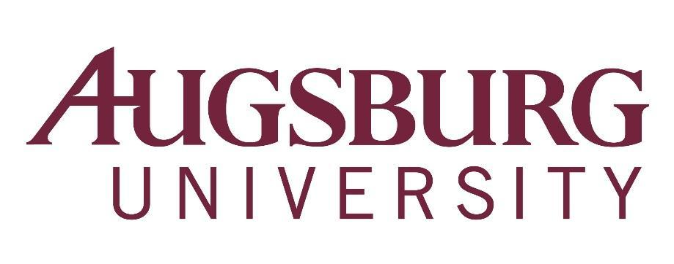

To: All Faculty
From: Karen Kaivola, Provost
Re: Faculty Meeting, Wednesday, March 13, 2019, 3:40 p.m.
*HAGFORS 150 (Coffee served beginning at 3:00 p.m.)

3:20-3:35 p.m. CTL EdTalk with Diane Pike, Professor of Sociology, on Long Live the Lecture! Hagfors Center 151
Everyone talks in class and doing so as effectively as possible is important. Focusing on interactive lecture pedagogy, this session introduces rationale for paying attention to lecture style and strategies for making it work.

Agenda

- First Word – Mission, Identity, and Educational Vision (3:40 pm), Sarah Degner Riveros, Lecturer, Department of Languages and Cross-Cultural Studies
2. Approval of Agenda
3. Announcements (3:50 pm)
  - Sesquicentennial Gala – Darcey Engen
  - First Year Experience – Rebekah Dupont
  - Admissions update – Robert Gould
4. Faculty Senate Report – Milda Hedblom (4:00 pm)
5. General Education Redesign update – Jacqui deVries (4:15 pm)
6. Personnel Policies Committee – Matt Haines, Bob Groven (4:55 pm)
7. Adjourn (5:10 pm)

Announcements due to the Academic Affairs Office
by Monday, March 11, 2019

