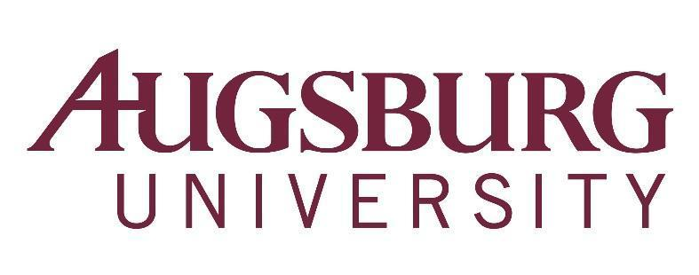

To: All Faculty
From: Karen Kaivola, Provost
Re: Faculty Meeting, Wednesday, April 11, 2018, 3:40 p.m.
Hoversten Chapel (Coffee served beginning at 3:00 p.m.)

Agenda

- First Word – (3:40 p.m.)
  - Jeremy Myers, Associate Professor of Religion/Youth Ministry
  - Nancy Rodenborg, Professor of Social Work
- Approval of Minutes
- Approval of Agenda
- Announcements (3:50 p.m.)
- Provost’s Report – Karen Kaivola (3:55 p.m.)
  - Test optional admissions - Senate recommendation (Hedblom) - discussion and vote
  - Bias reporting proposal - Senate recommendation (Hedblom) - discussion and vote
- Faculty Senate Report – Milda Hedblom (4:30 p.m.)
  - Statements from Candidates for University Council
  - Committee elections and ratifications
- Personnel Policies Committee Report – Matt Haines, Joan Kunz (5:00 p.m.)
- Adjourn – 5:10 p.m.

Announcements due to the Academic Affairs Office
by Monday, April 9, 2018

