Report without Additional Comments
Gen Ed Redesign Committee Survey - Copy
October 7th 2017, 10:22 am CDT
Q5 - A large and increasing proportion of our students come from MnSCU institutions. Transfer students often prefer universities that accept the Minnesota Transfer Curriculum. Is it important to change our General Education requirements in ways that more closely align with the MN Transfer Curriculum (which may involve reducing requirements in some areas, offering themed courses, etc.) so that we are more attractive to transfers?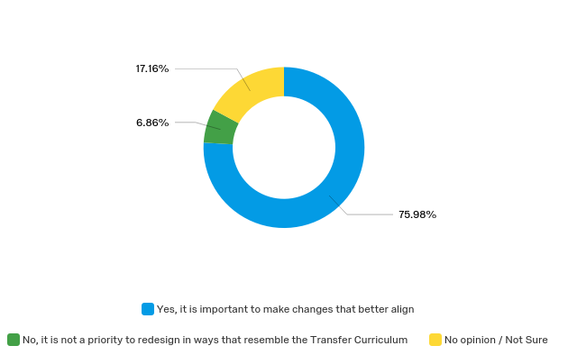

Q6 - Should we move from organizing the Liberal Arts requirements purely around the disciplinary domains and divisions, or reframe the requirements in terms of a mixture of disciplines, interdisciplinary perspectives, and themed goals (e.g. Environmental Sustainability) as is the case with the Minnesota Transfer Curriculum?
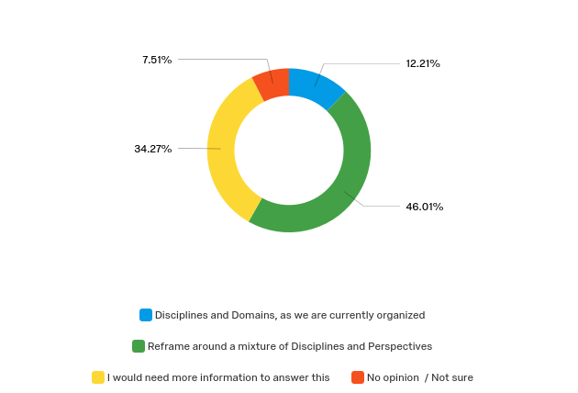

Q7 - Do you think that all undergraduate students should be required to have common coursework (in other words, one or more common courses that all students are required to take) in order to build campus community and make students' experience at Augsburg distinctive?
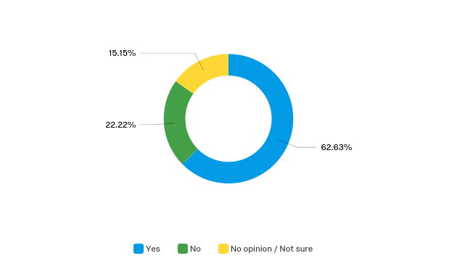

Q8 - Would you support replacing our current AugSem courses with interdisciplinary and/or themed courses on a big question (such as "How do we talk across difference")? (Currently, AugSem is linked to various LAF and/or major courses.)
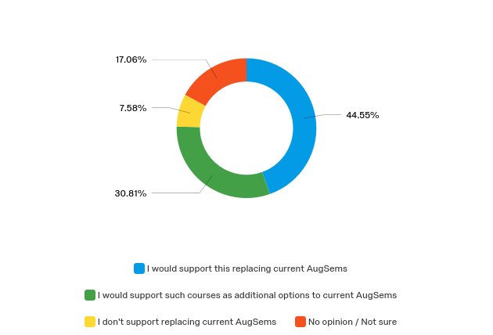

Q9 - We have also discussed offering upper-level interdisciplinary and/or themed courses that would be required for all students (including transfers) that focus on problem-solving among the disciplines (for example, "Combating Climate Change.") Would you support this curricular change?
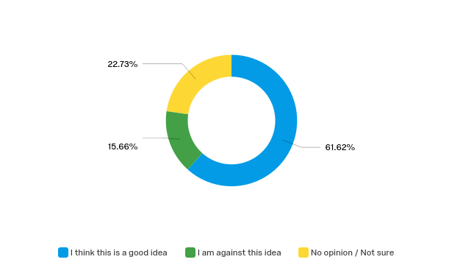

Q10 - If the budget supports fully compensating each faculty member, would you be in favor of interdisciplinary, themed courses being team-taught?
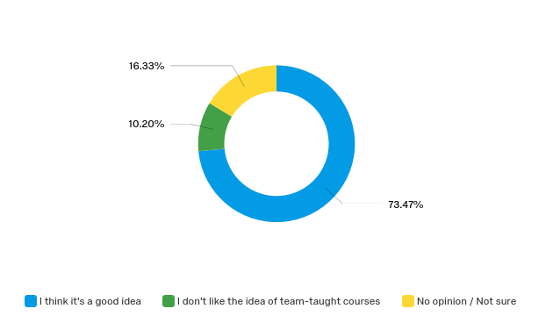

Q11 - Would you be willing to develop and/or teach (or co-teach) an interdisciplinary, themed course in a new curriculum?
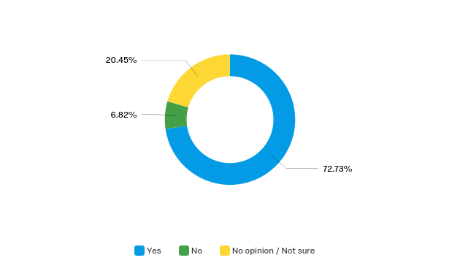

Q12 - Would the addition of 2 interdisciplinary/themed common courses to the curriculum be worth reducing by 2 the total number of LAFs (distribution requirements) that students take?
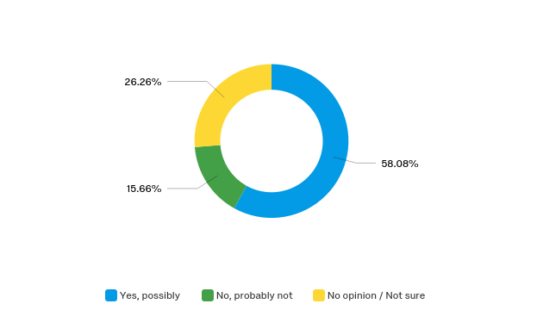

Q13 - We will continue to develop experiential education at Augsburg. Should Experiential Education efforts (in terms of coursework) be centered in the General Education curriculum (LAFs, for example) or in the Majors?
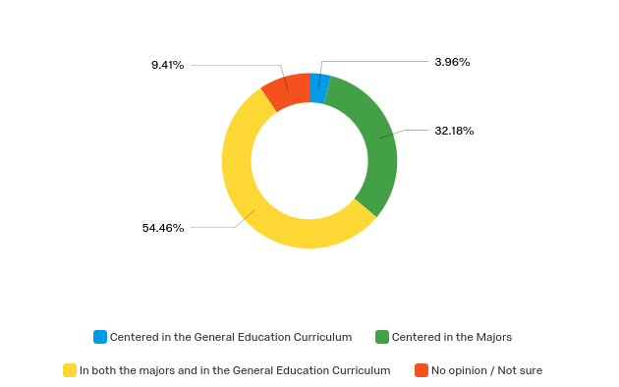

Q14 - Many universities require students to take a course that fulfills a diversity requirement. We currently offer elective options that address racial, gender, sexual, and social class inequalities and bridging differences. Do you think such courses should instead be required of all Augsburg students?
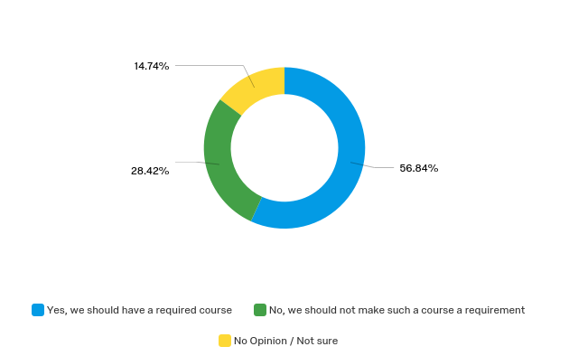

Q15 - In the current curriculum, there are two Religion requirements: REL100 The Search for Meaning, and a second Religion course. Of these two, Religion 100 The Search for Meaning, is a common course that all students at Augsburg (transfer & four-year) must take. Should "The Search for Meaning" remain the one common course taken by all Augsburg undergraduates?
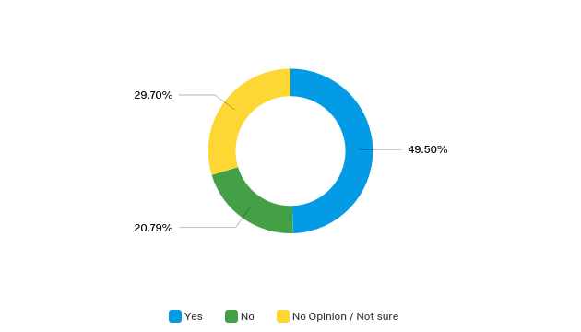

Q16 - Our curriculum currently requires the equivalent of two modern language semesters. How many language courses should we require of our students who come without prior training in another language?
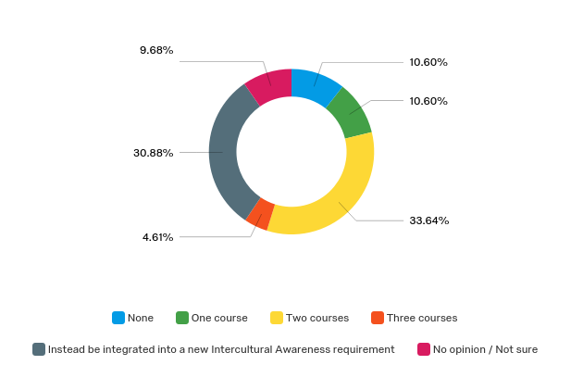

Q17 - Our curriculum currently requires two (1-credit) Wellness courses, Foundations of Wellness and Recreational Wellness. How many Health and Wellness courses should we require of our students at the 1-credit level?
