2013-14 Assessment Results for Critical Thinking and Reading
Undergraduate assessment of student learning is conducted for both institutional student learning outcomes and for major outcomes. Augsburg College has articulated institutional learning outcomes for undergraduates (the Grad Skills) which are: writing, critical thinking, quantitative reasoning and speaking. The institutional assessment activities for 2013-14 were focused on writing and critical thinking and employed three data collection methods. First, a samples of first-year and senior students completed the Collegiate Learning Assessment (CLA) that directly measures writing and critical thinking skills. Second, a sample of faculty were asked to provide data for students in a section or two of their classes using the VALUE rubrics for either critical thinking or writing (developed by the American Association of Colleges and Universities or AAC&U). Third, all first-year and senior students were invited to complete the National Survey of Student Engagement which provides data from students about their engagement in learning activities and their perception of their learning. The three sources of assessment data provide a well-rounded picture of student learning.
The Assessment Committee coordinated the sample selection for both the CLA and for the faculty evaluations using the AAC&U Value rubrics. The committee (or its members) conducted training with faculty members to increase the reliability of the Value rubric assessments. The data from the three sources has been compiled in this document organized by Grad Skill. During the 2014-15 academic year, the Assessment Committee will facilitate sessions with faculty to support a broad analysis of the assessment process and the data. By the end of May 2015 a document will be generated that describes all of the process, curriculum, and pedagogy changes that will be made in response to the analysis of the data from 2013-14. Those changes will be implemented in the 2015-2016 academic year.

Critical Thinking
Direct Assessments of Student Learning: Critical Thinking
The Collegiate Learning Assessment (CLA) evaluates critical thinking in three different contexts by assigning students to complete three different performance tasks: scientific and quantitative reasoning; critical reading and evaluation; and critique an argument (see the graphs below). The mean scores for Augsburg students are compared to mean scores from all other students. From these results observe that
Augsburg students improve in these types of critical thinking from their first-year and their senior year.

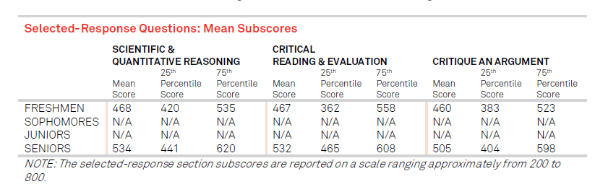

Faculty members directly evaluated students’ critical thinking skills using a shared rubric. A sample of faculty members evaluated the students in one (or more) of their course sections using a single learning activity and the American Association of Colleges and Universities (AAC&U) Value rubric for critical thinking. Every student was given a score for each of five dimensions of critical thinking: explanation of issues; evidence; influence of context and assumptions, the student’s position; and conclusions and related outcomes. The Assessment Committee set goals for each class of students and a percentage of each obtaining specific levels:
- 75% of first-year students will be at level 2 or higher,
- 50% of sophomores will be at level 3 or higher,
- 65% of juniors will be at level 3 or higher, and
- 85% of seniors will be at level 3 or higher.
The data is presented below compared to the goals set by the Assessment Committee. The data collected by faculty for first year students indicate students only met the explanation of issues. The data collected for sophomores, juniors, and seniors shows demonstrate increases between the sophomores and juniors in all areas. We also observe increases between the juniors and seniors in all areas except influence of context and assumption. Overall, none of the scores for these students met the goals.

Indirect Assessments of Student Learning: Critical Thinking
The National Survey of Student Engagement (NSSE) provides indirect measures of student learning related to critical thinking. All first-year and senior students were invited to participate in the survey. For 2013-14, responses were collected from 20% of the first-year students and 32% of seniors. The scores for the survey items related to critical thinking show:
- Slight improvements between Augsburg College first-year students and seniors;
- Augsburg College seniors report significantly less memorization than both the Plains Private group seniors and the Carnegie Class group seniors;
- Augsburg College seniors report statistically significant smaller gains in critical thinking than their peers in the Plains Private group, and
- Augsburg College seniors report all other activities related to critical thinking at similar levels to their peers in the benchmark groups.

Writing
Direct Assessments of Student Learning: Writing
The Collegiate Learning Assessment (CLA) provides scores for writing effectiveness and writing mechanics. Scores are presented on a scale from 1 to 6, with 6 being the highest score possible. The data below shows the distribution of scores for both first-year students and seniors. While this data is not compared to bench mark groups, we can note some observations from the data provided:
- First-year students are generally more proficient at writing mechanics than writing effectiveness; and
- A higher percentage of seniors demonstrate scores of 4 and 5 in writing effectiveness and writing mechanics compared to first-year students.

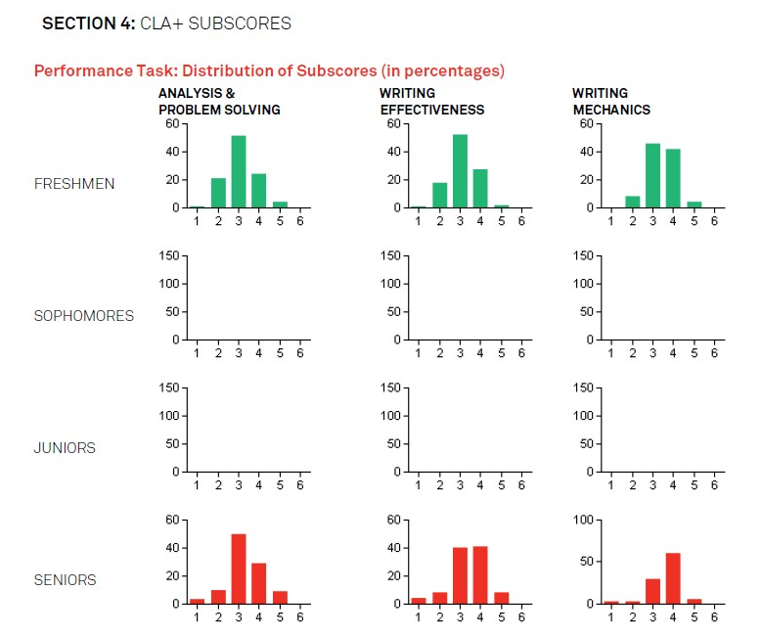

Several faculty members also evaluated first-year students in ENL 111 sections using a paper assignments and the AAC&U Value rubric for writing. The Assessment Committee made decided to focus the data collection on first-year students to provide a baseline from which we can compare the achievement of more advanced students. Every student in the sample was given a score for each of five dimensions of writing: context and purpose for writing; content development, genre and disciplinary conventions; sources and evidence; and control of syntax and mechanics. The Assessment Committee set goals for each class of students and a percentage of each obtaining specific levels:
- 75% of first-year students will be at level 2 or higher,
- 50% of sophomores will be at level 3 or higher,
- 65% of juniors will be at level 3 or higher, and
- 85% of seniors will be at level 3 or higher.
The data collected by faculty indicate that first-year student scores exceed our goals in all areas except sources and evidence.

Indirect Assessment of Student Learning: Writing
The National Survey of Student Engagement (NSSE) provides indirect data related to writing. Data collected from students about writing reveals a couple of interesting trends:

1) First-year students report writing a significantly higher number of papers of 0-5 pages compared to first-year students at other institutions;
2) Augsburg College seniors reported writing significantly fewer papers between 6-10 pages, over 11 pages, and fewer assigned pages overall compared to our benchmark group; and
3) Augsburg College seniors also indicate that their experience at Augsburg College has had a smaller positive effect on their ability to write clearly and effectively compared to the benchmark.

