2019 URGO Summer Research Program
Program Dates: May 16th – July 31st
An on-campus summer research program for Augsburg University undergraduates

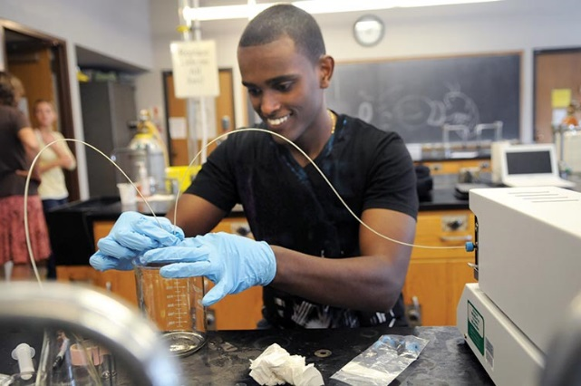

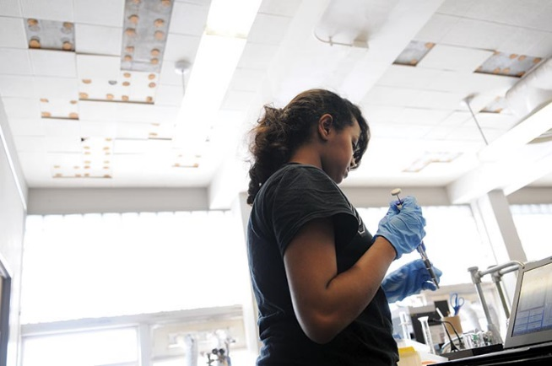
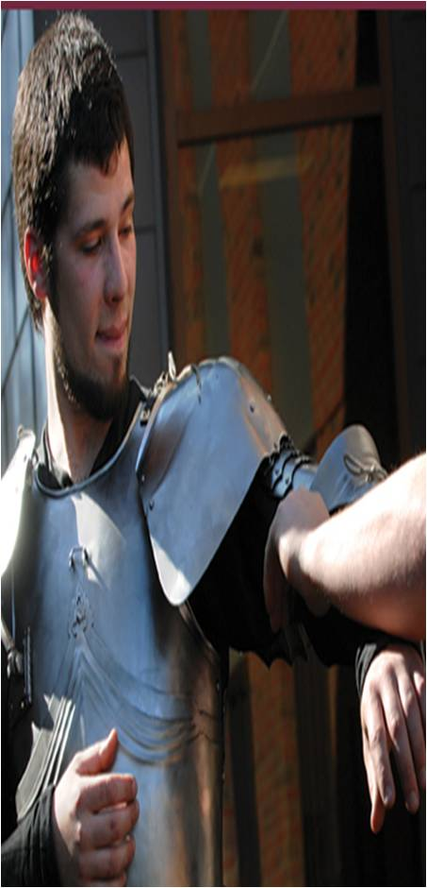

Application Deadline:
Phase 1: January 29th 11:59 p.m.
Phase 2: February 19th 11:59 p.m.

URGO: The Office of Undergraduate Research & Graduate Opportunity
Augsburg University, Minneapolis, MN
Overview of Application

- Getting Started page 3
  - Research/Scholarship/Creative Activity Defined
  - Selecting a Faculty Mentor
  - Selecting a Research/Creative Project

- Student Researcher Information page 4-7
  - Eligibility
  - Research Options
  - Time Commitment and Expectations
  - Compensation
  - Housing Stipend
  - Research Supply Funds
  - Jobs, Volunteer Activities, and Summer Coursework in Addition to Research

- Faculty Mentor Information page 8
  - Responsibilities
  - Compensation

- The Application Process page 9-10
  - Application Submission & Deadline
  - The Selection Process & Award Notification
  - Frequently Asked Questions

The 2019 URGO Summer Research Application is available at www.augsburg.edu/urgo.

Questions? Contact Kirsten O’Brien
Undergraduate Research and Graduate Opportunities Specialist
obrienk@augsburg.edu, 612-330-1446

- Getting Started

- Research/Scholarship/Creative Activity Defined

Student “scholarly research” may be disciplinary or interdisciplinary in nature. “Scholarly research” is defined as any type of scholarly investigation or work that is original in nature. It should produce knowledge, a product, or an outcome that makes an original contribution to its area. Research and scholarship may be conducted in all disciplines. Research may be qualitative or quantitative in nature, or may use any other methodology that is typical of the discipline in which the student is working.

Creative Activity
Research conducted as part of a creative project should be integral either to the process of artistic creation or necessary to the end product itself, as well as contribute to aesthetic or practical knowledge of the artistic field or medium in which the student is working. Students proposing a creative project should take care to show how their project depends on research, and explain how the research will enhance and deepen the creative activity.

- Selecting a Faculty Mentor

In order to apply to the URGO Summer Research Program, students must have the support of a faculty mentor. Most often, the faculty mentor will be someone in the student’s discipline. Students should make appointments to talk to faculty members about what research is currently going on in the department to determine faculty availability over the summer. Please be mindful that faculty members can only mentor a limited number of students and not all faculty members are available to serve as mentors. It may be of benefit to talk to multiple faculty members when seeking a mentor.

- Selecting a Research/Creative Project

Four hundred hours over 11 weeks (or 200 hours) is—surprisingly—not much time to conduct research; therefore, students are expected to join a faculty member’s existing project or develop a proposal within the faculty’s area of research expertise. Often you can work on an offshoot of the faculty member’s ongoing or past research/creative line. Students can also do a parallel project to one that a faculty member is working on. Please set up an appointment with the URGO office if you are having trouble thinking of how to design a project that aligns with your faculty’s area of interest.

- Student Researcher Information

- Eligibility

Applicant must:
- Be a full-time Augsburg student (currently taking ≥ 12 credits per semester) in the undergraduate program
- Have completed at least one year of undergraduate study by the start of research, and have at least one semester of full-time study (≥ 12 credits) remaining after the completion of summer research
- Have a minimum GPA of 3.0 (lower GPAs are considered on a case-by-case basis; note that the average GPA of last year’s research participants was 3.7)
- Not have previously participated in the URGO Summer Research Program* (including Sundquist, Lindstrom, Thompson, or Larson Scholars) or the McNair Scholars Program

*Note: The 100-hour Research Assistants remain eligible for URGO summer research in the future. However, once you have done the URGO Summer Research Program at 200 or 400 hours, you cannot do it again.

- Research Options

Students applying for the URGO Summer Research Program must choose 400, 200, or 100 hours at the time of application.

Option 1: URGO Summer Research Program (400 or 200 hours)

Students are expected to join a faculty member’s existing project or develop a project within the faculty’s area of expertise. Students and faculty mentors may collaborate on the development of a proposal that describes the student’s role within a professor’s ongoing research or creative activity, or may develop a new project within the faculty member’s area of expertise in which the professor helps to shape the research question, develop the proposal, and guide the subsequent research. We highly encourage projects that support faculty lines of research.

Option 2: Research Assistantship (100 hours)

A professor with an ongoing line of research or creative activity determines what tasks to assign to the student. Students most likely will not see a project from start to finish, but rather will contribute to a particular aspect of a professor’s ongoing research. To maximize time spent on the project, these students will not participate in URGO summer programming. The faculty mentor and student together decide how to allocate the 100 hours. Research must be completed by August 31st. Students who complete this option may apply for the URGO Summer Research Program in the future.

- Time Commitment and Expectations

  - Expectations for URGO Summer Research Program

400-hour researcher requirements:

- Participate in at least 400 hours of research and programming over the course of 11 weeks (May 16th – July 31st), taking no more than 5 days off (and must be present for the dates listed below)
- Participate fully in all URGO-related functions and programs throughout the summer
- Attend the full-day URGO Summer Research orientation session May 16th
- Meet once weekly (and in some cases daily) with research mentor and complete tasks as required
- Attend all weekly Speaker Series (1 excused absence)
- Social Sciences, Humanities and the Arts students only: attend weekly seminars (1 excused absence)
- STEM students only: attend Court Agre Research Symposium June 17th
- Meet as needed with assigned library mentor
- Present research findings orally at URGO Summer Research Conference the week of July 29th
- Be present for all sessions of URGO Summer Research Conference the week of July 29th
- Submit a final product by noon on Wednesday, July 31st
- Attend final luncheon and complete program evaluation on Wednesday, July 31st
- Present projects at Zyzzogeton, Augsburg’s annual poster session in April 2020

Note: As is true with any job, failure to meet requirements of the program will result in reduced payment and potential removal from the program.

200-hour researcher requirements:

Mentor-mentee teams who choose this option are free to determine the number of hours worked each week as long as the overall total of hours reaches 200 by the end of the program. For example, some teams might decide to work half-time (20 hours per week) for ten weeks to arrive at 200 hours and a final product; others might decide to work full time (40 hours per week) for five weeks; still others might choose another combination of days and times that fit individual schedules and the nature of the project.

200-hour researchers must:
- Conduct 200 hours of research between May 16th – July 31st
- Attend SSHA Seminar every week you are doing research
- Encouraged to attend weekly Speaker Series
- Attend the full-day URGO Summer Research orientation session May 16th
- STEM students only: attend Court Agre Research Symposium June 17th if this falls within your weeks of research
- Meet with research mentor at least once per 20 hours of work
- Meet as needed with assigned library mentor
- Present research findings orally at URGO Summer Research Conference the week of July 29th. Only under extenuating circumstances, if your research schedule ends before July 29th, an alternative date for the presentation will be arranged
- Be present for sessions of URGO Summer Research Conference the week of July 29th in accordance to your timeline for that week
- Submit a final product by noon on Wednesday, July 31st
- Attend final luncheon on Wednesday, July 31st if research schedule extends to this date or are able to return to campus for the celebration
- Complete program evaluation
- Present projects at Zyzzogeton, Augsburg’s annual poster session in April 2020

  - Expectations for 100-hour Researchers

Mentor-mentee teams who choose this option are free to determine the number of hours worked each week as long as the overall total of hours reaches 100. For example, some teams might decide to work 10 hours per week for ten weeks to arrive at 100 hours; others might choose another combination of days and times that fit individual schedules and the nature of the project.

100-hour researcher requirements:
- Conduct 100 hours of research between end of spring semester and August 31st
- Meet with research mentor as necessary
- Submit a progress report to mentor and URGO after 50 hours of research
- Submit a final research report to mentor and URGO by August 31st

- Compensation

Payments are made periodically throughout the summer. Payment is dependent on sufficient progress towards research objectives and meeting the participation expectations above.

400 hours: $4,000 research stipend
200 hours: $2,000 research stipend

Five paychecks are distributed throughout the 11-week program. Paychecks may be held until program requirements are met, or reduced if program or mentor requirements are not met. For full or half-time researchers, seven hundred dollars (or $350 for half-time researchers) is contingent upon the submission and approval of the final product; the final $100 (or $50 for half-time researchers) is contingent upon participation in Zyzzogeton, Augsburg’s annual poster session in April of 2020.

100 hour Research Assistants: $1,000

Research Assistants will receive $500 at the completion of 50 hours and the mid-project progress report, and $500 after 100 hours and the completion of the final research report.
- Housing Stipend (200 and 400 hour researchers living on campus only)

Students choosing to live on campus during the summer should contact the residence life office to secure housing. The University will provide a housing credit to students conducting 200 and 400 hours of research. Because of a generous housing stipend offered by residence life, 400-hour researchers pay $400 total to live on campus during the summer, and 200-hour researchers pay a total of $800 total to live on campus during the summer. There is no housing stipend provided for student researchers living off-campus.

- Research Supply Funds

Each 400-hour researcher may request up to $500 in research supplies (200-hour researchers can request up to $250) using the budget request form. URGO will review budget requests and notify researchers of what supply costs are approved.

- Jobs, Volunteer Activities and Summer Coursework in Addition to Research

400-hour researchers: summer research is a full-time job and must be the student’s first priority; all outside commitments and/or vacations during the 11 weeks should not interfere with your ability to complete 400 hours of research and the required URGO programming. Outside employment or volunteer activities should be kept to no more than 10 hours a week. Students are not permitted to take summer courses. See URGO before turning in the application and beginning summer research if you have extenuating circumstances.

200-hour researchers: all outside jobs, summer coursework, vacations, and volunteer commitments during the ten weeks should not interfere with your ability to complete 200 hours of research and the required URGO programming.

Research Assistants: all outside jobs, summer coursework, or volunteer commitments should not interfere with your ability to complete 100 hours of research and adhere to the timeline established with your faculty mentor.

- URGO Summer Research Program Faculty Mentor Information

- Responsibilities

Thank you for considering being a mentor. The URGO summer program cannot be successful without the care and expertise of faculty mentors. Listed below are URGO mentor responsibilities.

- Provide close supervision and support (no less than one meeting per week); most mentors report spending considerably more time in person per week with students
- Be available to meet in person 10 of the 11 weeks if you are mentoring a 400-hour student (please talk to URGO Director, Dixie Shafer, before beginning the application and summer research if this is not possible) We have found that students whose mentors are gone for more than a week struggle with their projects noticeably more than others. If you will be out of town for more than two of the eleven weeks, we ask that you co-mentor with another faculty member who can work with the student while you are gone.
- If IRB (Institutional Review Board) approval is required (typically if study involves human subjects), walk mentee through the IRB approval process prior to the start of summer research
- Educate and develop novice researchers
- Ensure that students are making adequate daily and weekly progress
- Provide ongoing coaching and clear feedback on student performance
- Complete program and student evaluations
- Communicate to the URGO office if your student is not meeting your expectations or is experiencing other difficulties
- Provide feedback on, and approve mentee’s final product and presentation
- Attend mentee’s oral presentation (the week of July 29th) and ideally additional presentations

- Faculty Mentor Compensation

Faculty mentors for 400-hour projects receive a stipend of $1,000 per mentee, paid at the end of the program. If a student has two mentors, each mentor receives $500, unless a different arrangement is requested by the co-mentors based on division of workload.

Faculty mentors for 200-hour projects receive a stipend of $500 per mentee, paid at the end of the program.

Research Assistant faculty mentors (supervising those working 100) receive a $250 stipend, paid once the project completion report is submitted to URGO and approved by the mentor.

- The Application Process

A. Application Submission & Deadline

Phase 1: Mentors must sign (or type their name in the electronic form) the Phase 1 application. Students or mentors may submit the completed Phase 1 application to Hagfors 101 by 5:00 p.m. on January 29th OR email it to urgo@augsburg.edu by 11:59 p.m. on January 29th. The Phase 1 application is not evaluated, and ALL who submit on-time Phase 1 applications (late submissions are not accepted) are eligible to turn in a Phase 2 application.

Phase 2: Mentors must forward the phase 2 application to urgo@augsburg.edu by 11:59 p.m. on February 19th. This is a strict deadline. Proposals turned in past the deadline will not be considered. Be sure to select the application for phase 2 that corresponds with the research option you choose.

B. The Selection Process & Award Notification

Proposals will be reviewed by the Director of URGO and the URGO Summer Research Selection Committee which is comprised of faculty members from a variety of disciplines. Applicants will be notified via email about the decision by mid-March.

2019 URGO Summer Research Selection Committee Members: David Crowe (biology), Stella Hofrenning (economics), Merilee Klemp (music), Ben Denkinger (psychology), Eileen Uzarek (health and physical education), Pavel Belik (mathematics), Bob Cowgill (English), Amanda Case (chemistry), Melissa Hensley (social work), Kristen Chamberlain (communications), Maheen Zaman (history), Kirsten O’Brien (URGO), and Dixie Shafer (URGO).

C. Frequently Asked Questions
- Does URGO summer research fulfill the Honors Program research requirement?
200 hours of research or more fulfills the Honors Program requirement.
- Does URGO fund research done with a non-Augsburg faculty member?
No. Students are funded to conduct research with Augsburg faculty.
- Are there funds to pay for supplies?
Yes and no. Supply funds are available for 200 and 400 hour researchers. Supply funds are allocated at the start of the research season and the amount varies by project, need, and budget. Due to limited funds, however, there are no supply funds available for the 100-hour research assistantships.
- How do I think of a research question?
See section 1C: “Selecting a Research/Creative Project.”
- Can I apply if I am a first-year student? Or a graduating senior?
Applicants must have completed at least one year of undergraduate study by the start of summer research and have at least one semester of full-time study remaining after the completion of summer research.
- Does URGO fund research in the creative arts?
Yes. URGO supports research and scholarship in all academic disciplines, including the areas of the visual, studio, performing arts and creative writing. Students proposing a creative project should take care to show how their project depends on research, and explain how the research will enhance and deepen the creative activity.
- I was an URGO summer researcher last summer, can I apply again?
Students who worked as 100-hour Research Assistants in past summers are eligible. However, students who have been funded as 400 hour or 200 hour researchers are ineligible. McNair Scholars are also ineligible.
- I had an URGO Academic Year Research Grant, can I apply in the summer?
Yes. Students who have conducted research during the academic year are eligible for summer research.
- Can I take a summer course during URGO summer research?
400 hour summer researchers are not permitted to take coursework during the program (see section 2G). 200 hour researchers may take courses as long as they do not interfere with your ability to complete your contracted hours.
- Can I submit more than one application?
No. Students can submit only one application.
- As a faculty member, if all of my students are working on the same project, can they turn in just one application?
No. Each student must submit their own application.
- Can students apply to work on the same project together?
Yes. However, students who would like to work on a project together need to each submit their own application. Each student’s application needs to stand alone as a project, as the applications will be reviewed independently and it is not guaranteed that both will receive the grant (so one person’s project can’t depend on another person’s project).
- Can I do research outside of my major?
Yes, if you provide evidence that you are sufficiently prepared and have the knowledge and skills needed to contribute original findings to that field.
- Can I have two mentors?
Yes. Sometimes it can be helpful to have mentors from two different fields or with two different areas of specialty. The two mentors then split the mentor stipend.
- I will be gone for 2 weeks (or more) for a vacation or study abroad. Can I participate in URGO?
Yes, but you can only apply for a 200 hour grant. 400 hour researchers must be physically present for 10 of the 11 weeks.

The 2019 URGO Summer Research Application is available at www.augsburg.edu/urgo.

Questions? Contact URGO at urgo@augsburg.edu or 612-330-1446

