How to filter responses to Qualtrics Evaluations
Log into Qualtrics at http://survey.augsburg.edu/ -- you’ll need to log in using your Augnet username and password.
Home screen looks like this:
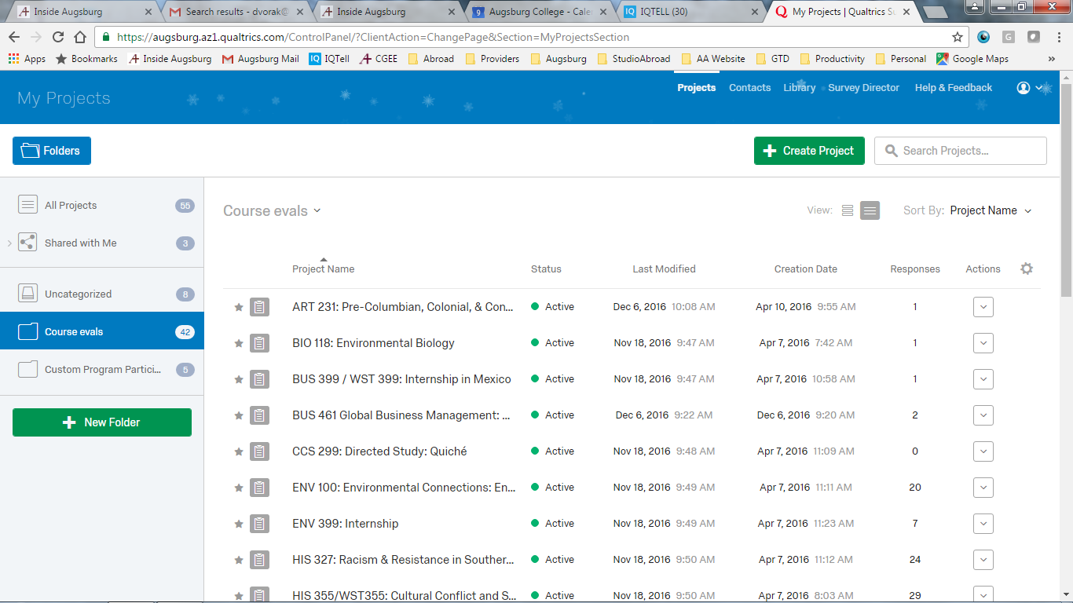
Choose your course eval from the list and click on the name to open it.
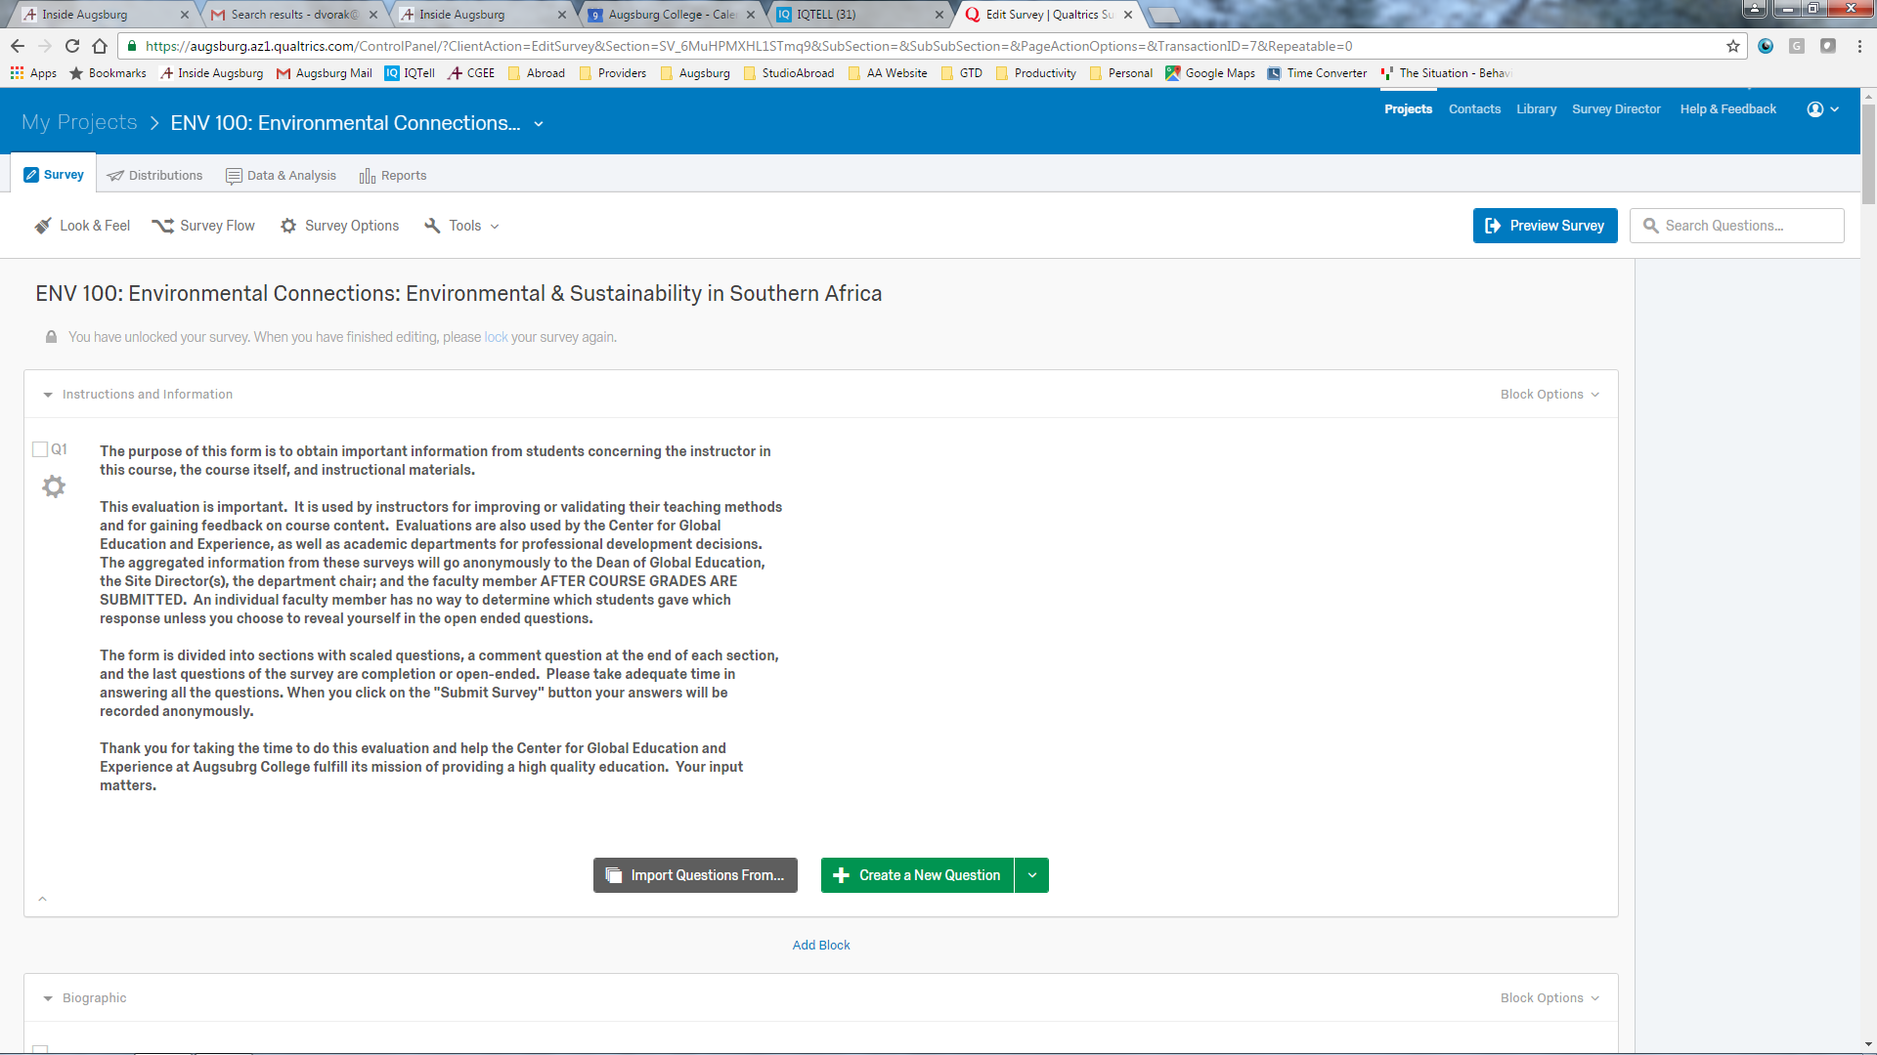
In the top left are tabs to navigate this course evaluation. Choose the REPORTS tab, the last one on the list.
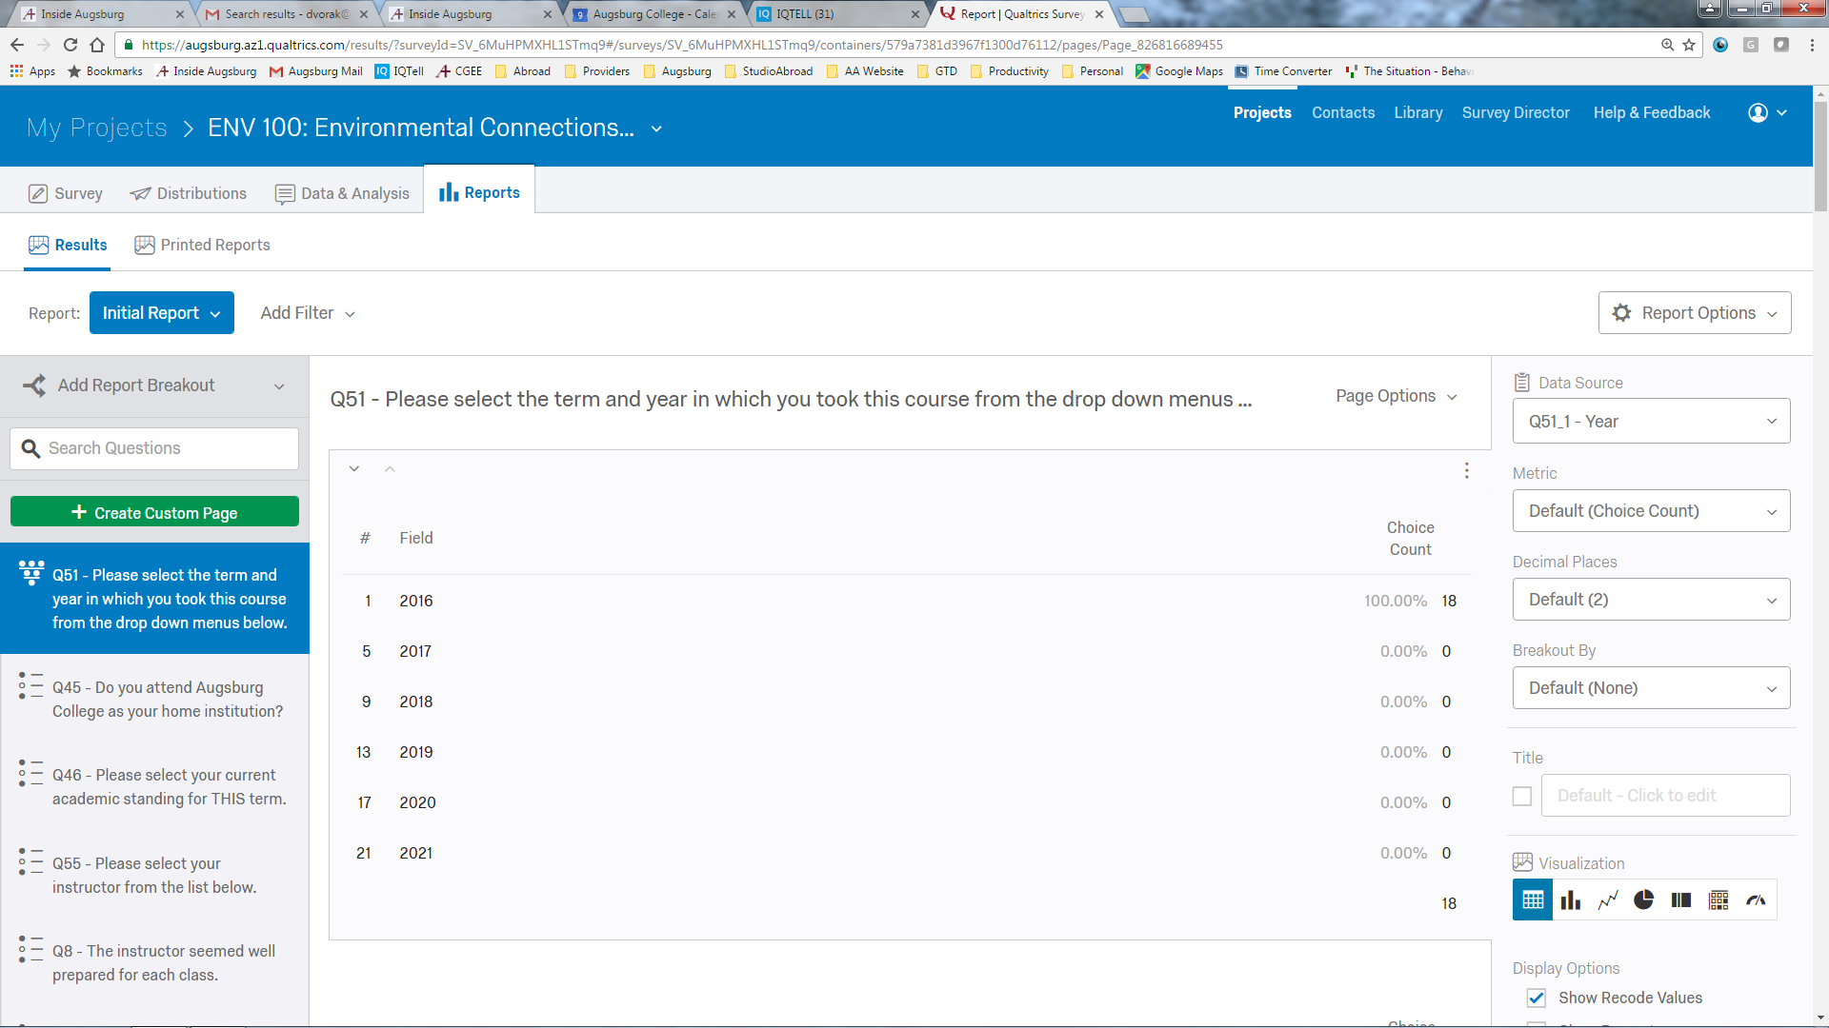
From the report, you can filter responses by any of the questions. To see only the evaluations for a particular term and year, click the ADD FILTER dropdown list and choose the question “Please select the term and year….” It should be the first one on the list – You’ll then need to choose YEAR. (since both year and term are part of that question.)
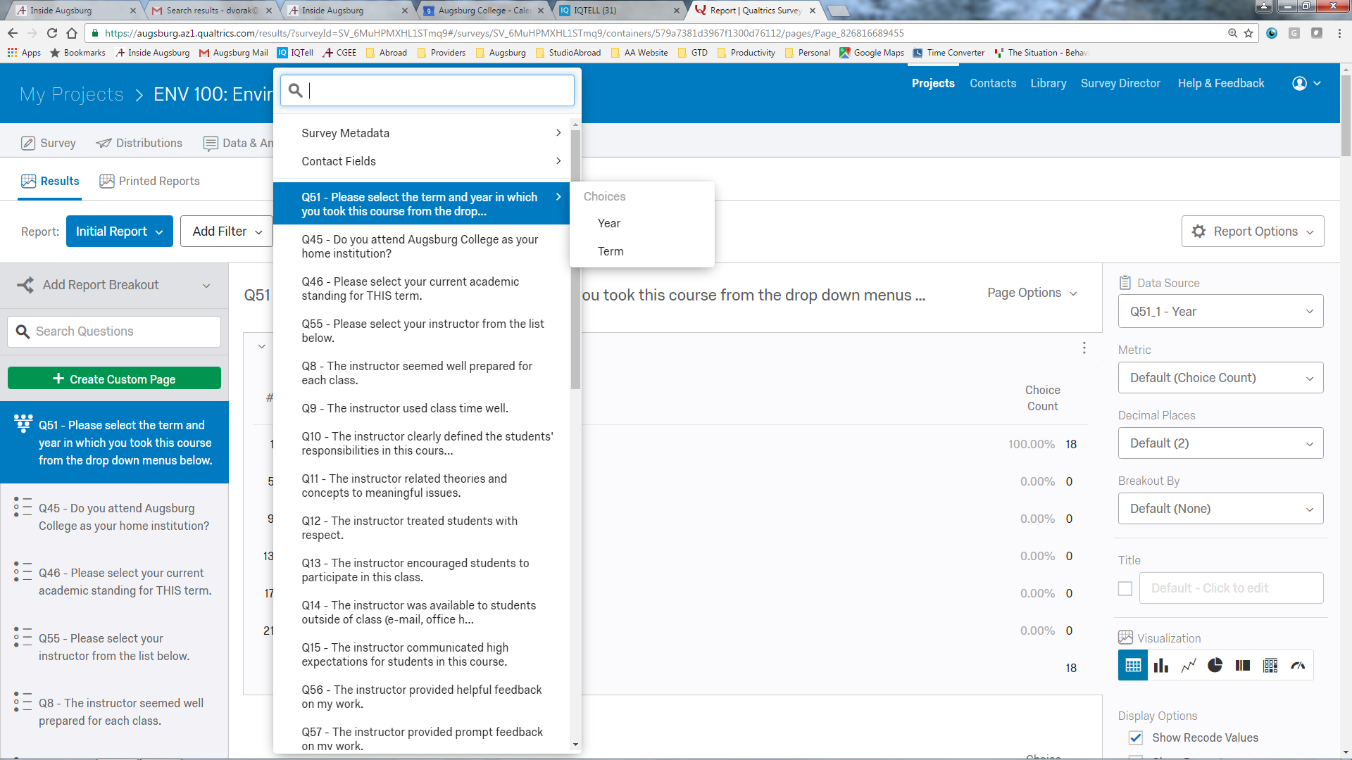
Then you’ll say that you want the year to be whichever one you want. First operator should be IS…
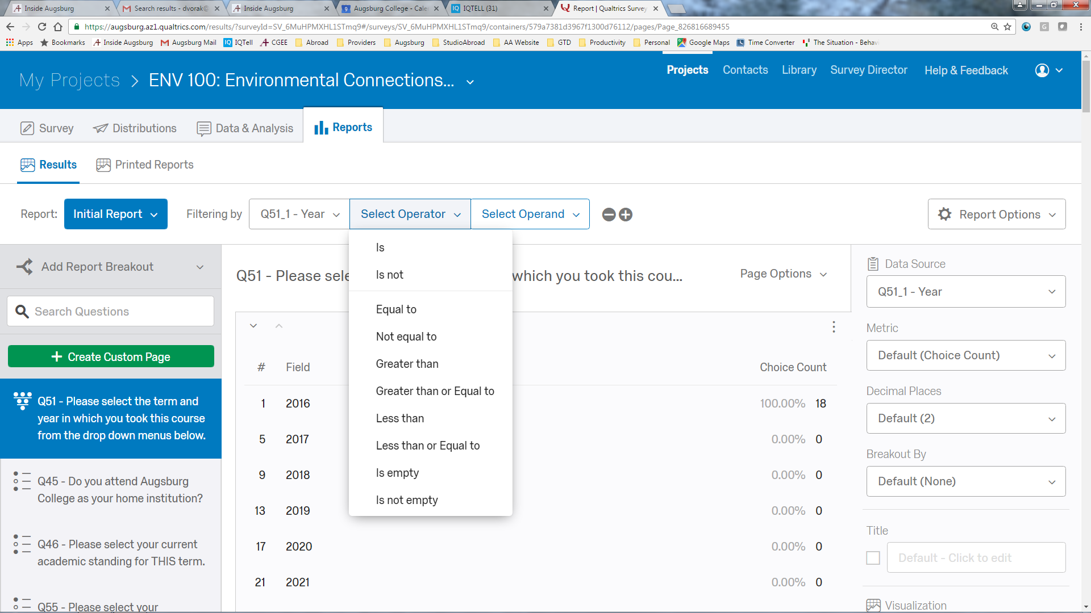
And the second one you choose the year
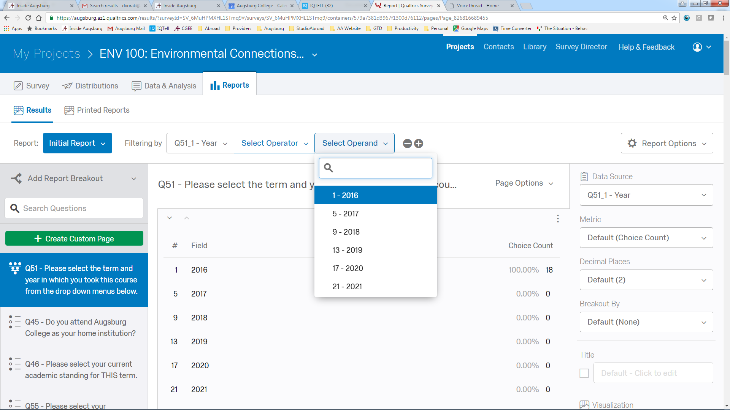

If you want to filter by more things (like also term) choose the + sign – I circled it in RED below
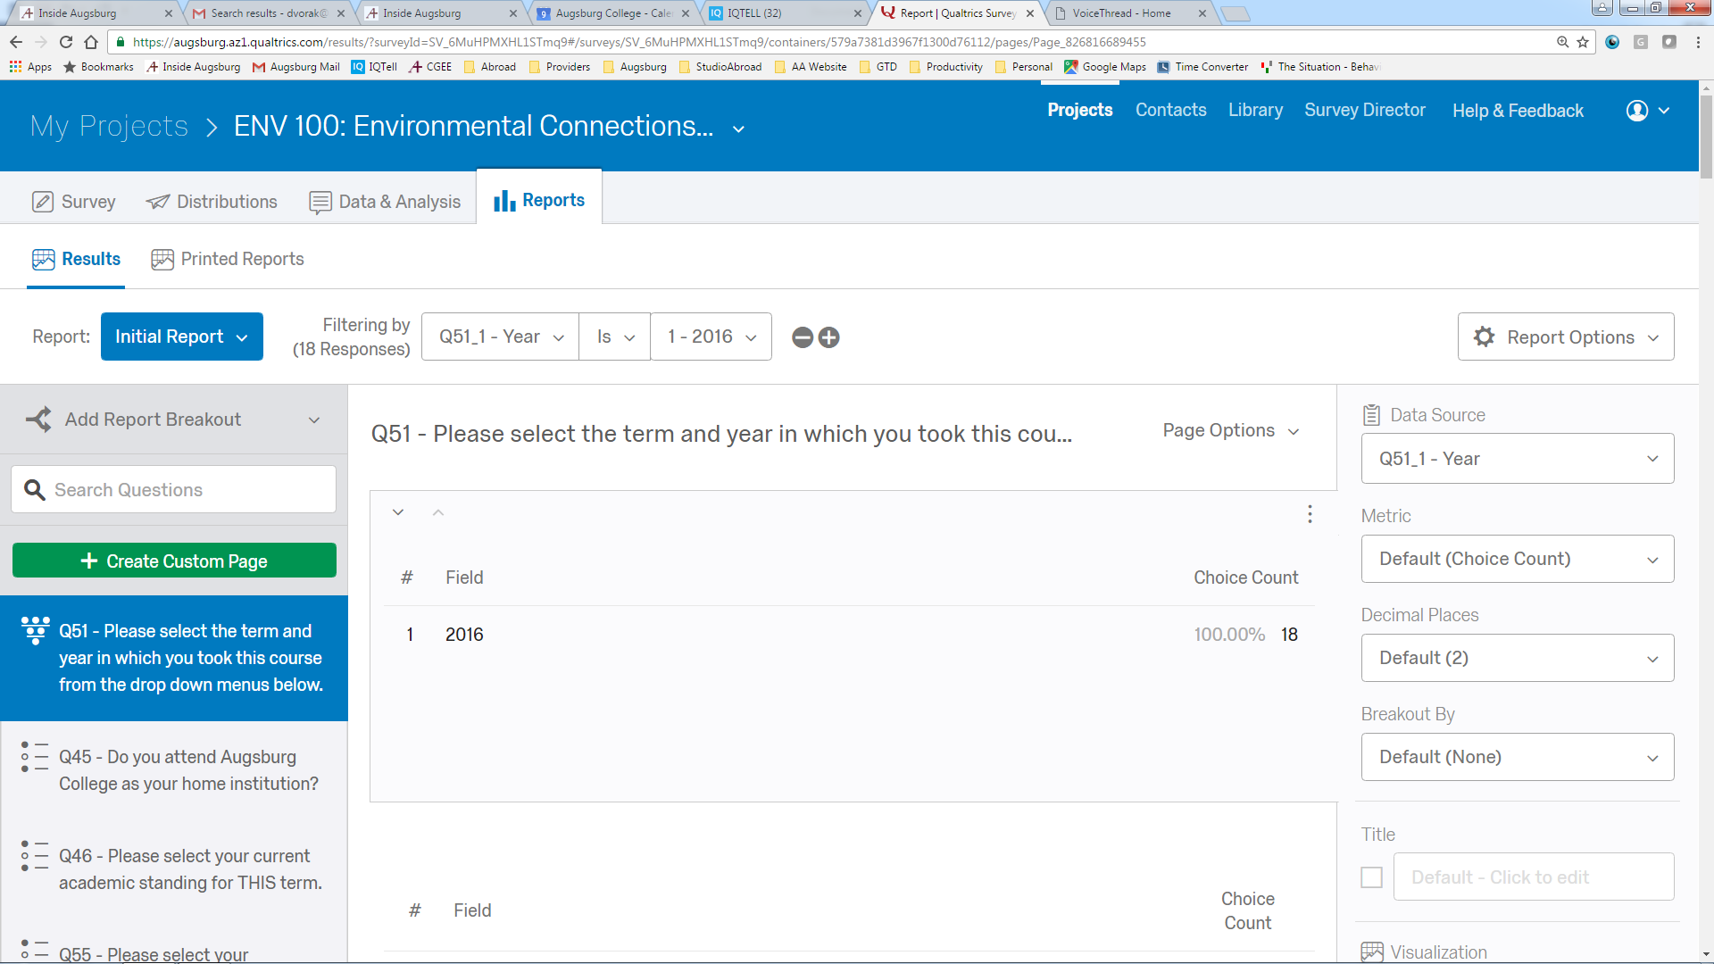
Here you can add more filters.
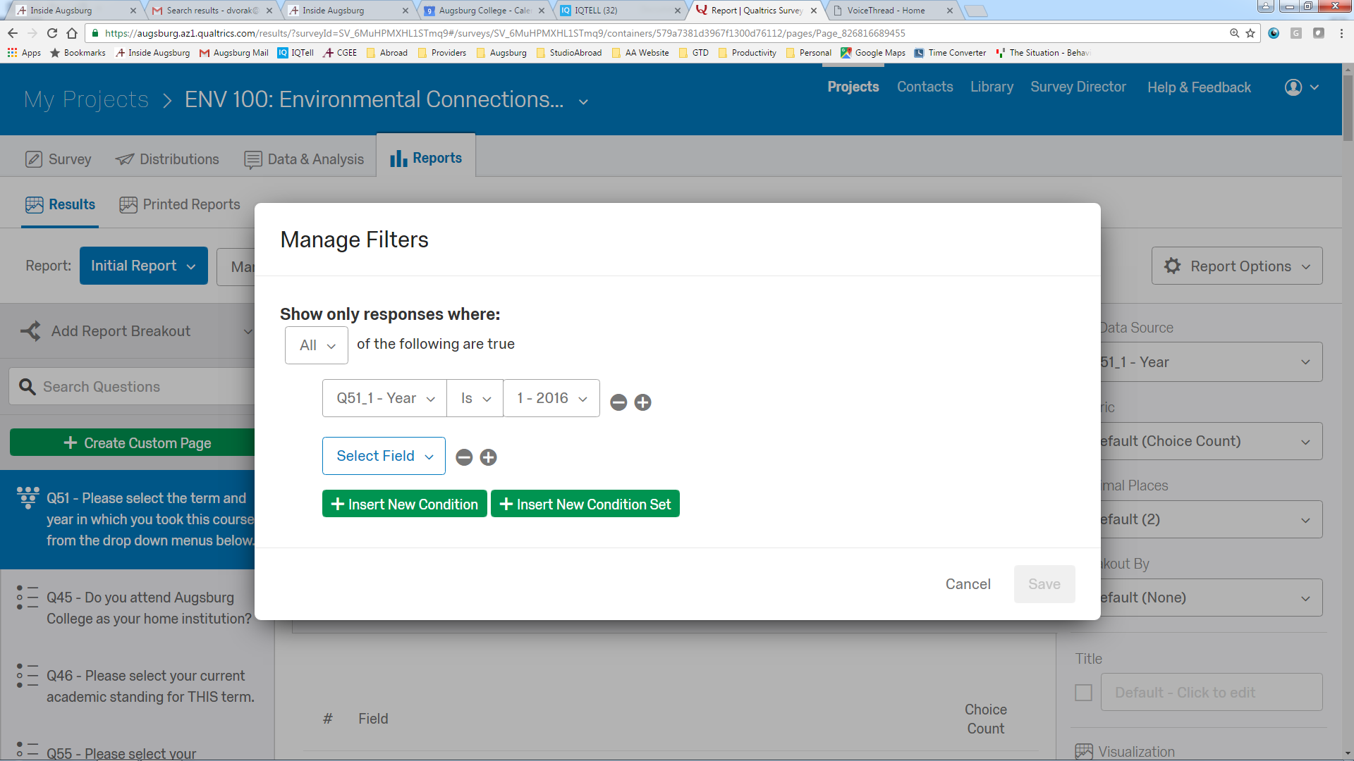
The filters apply as soon as you set them up and limit the responses you can see.

Now you can create a report of just this filtered information. Click the Report Options Gear icon and choose export report. You can choose PDF, Word or a CSV file (which can be used in a spreadsheet format)
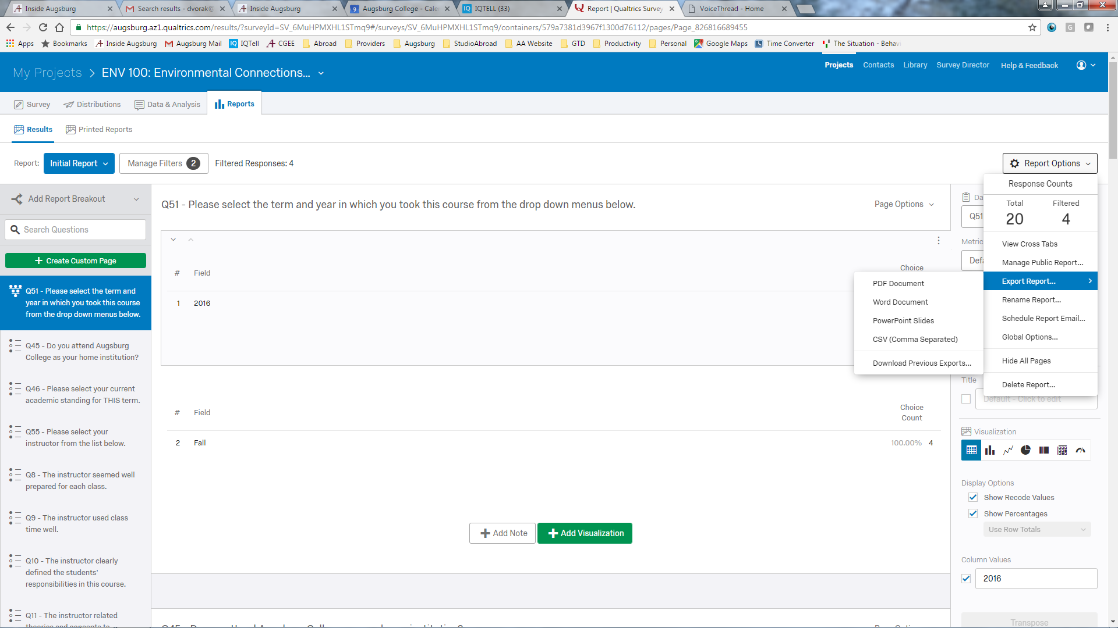
The export report wizard allows you to choose which questions to report on. I leave all the questions there, but you might like to only include some. You can also change the format here. Then click export pages
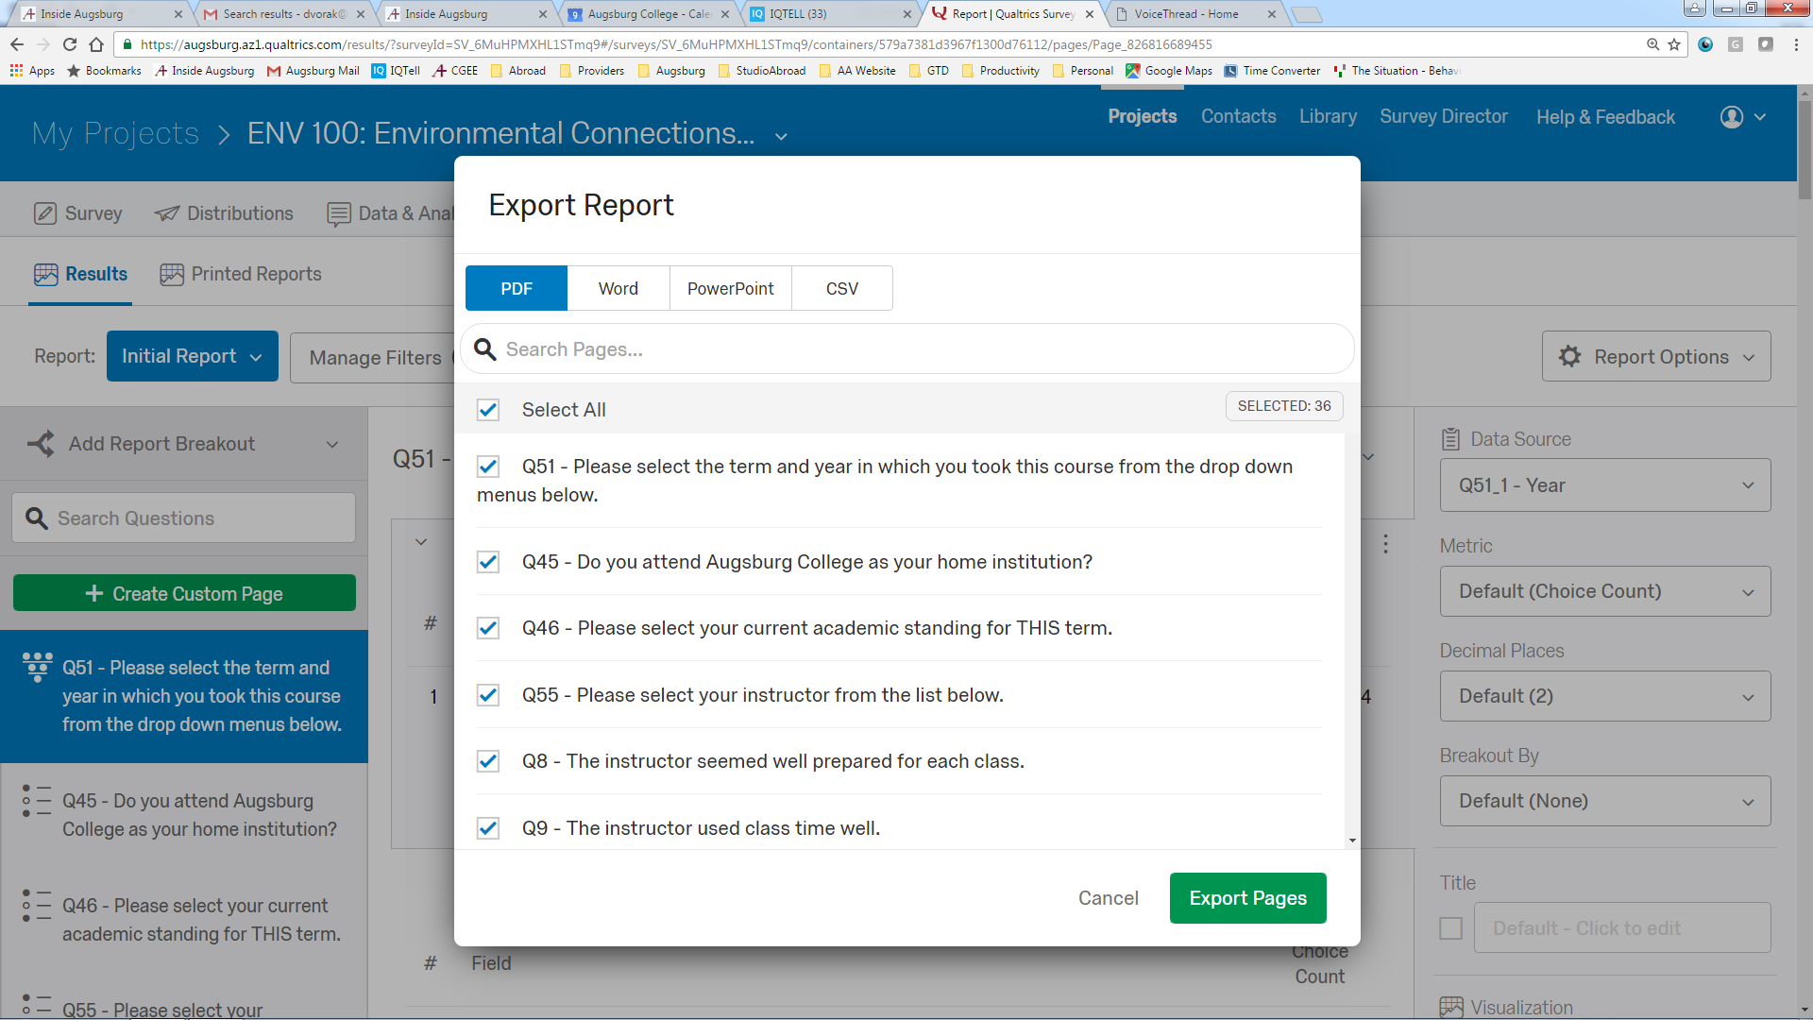
It takes a few seconds to generate the report – you can see any previous reports that have been exported.
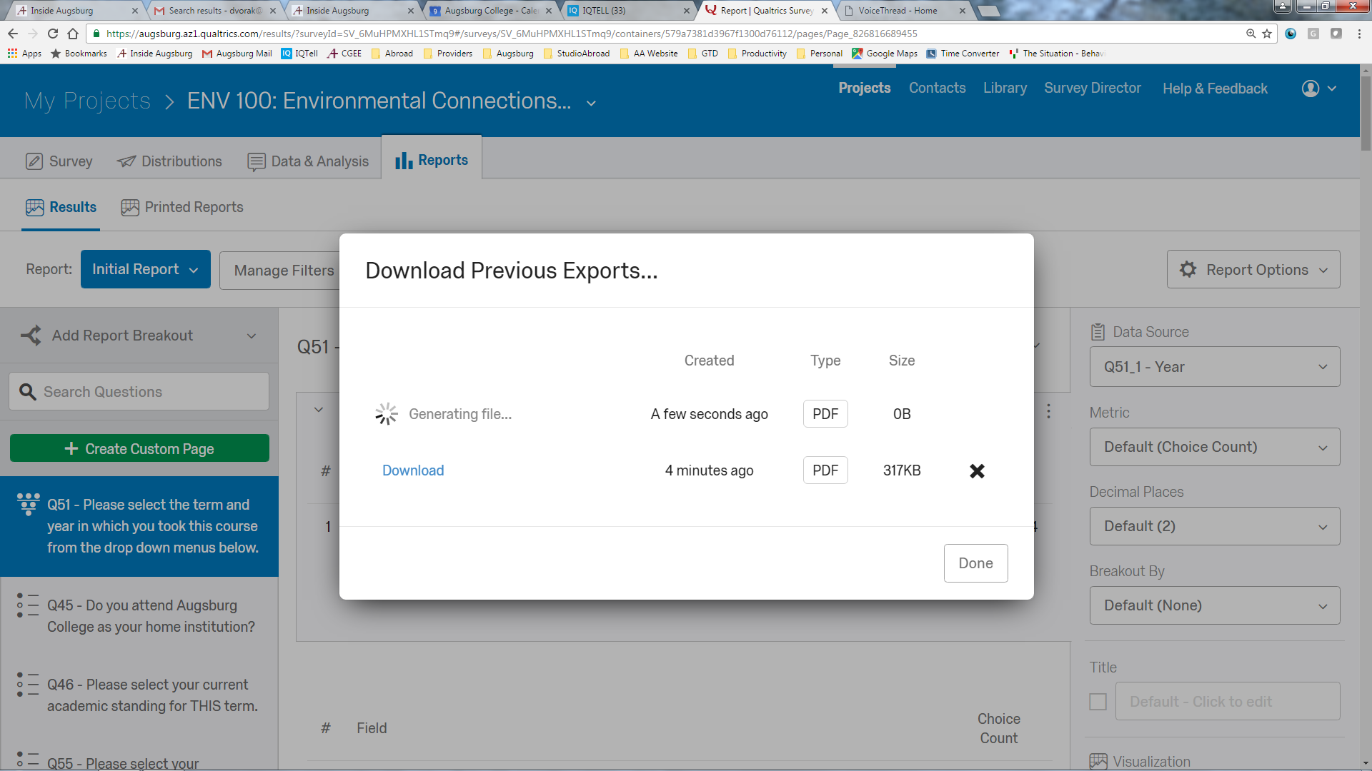

Click the download link and save the file.

