How to use Flickr albums for publications photos
Last updated April 4, 2017 LH

Table of Contents
- How to Log in
- How to deposit photos from the semester into an album
- How to choose photos for publications
- Addendum: other helpful information regarding photos

- How to Log In

Go to www.flickr.com
Sign in username: email Lucy for username and password
password: email Lucy for username and password

If you are having trouble logging in (get a note that says “we’ve sent a security code to your backup email/or phone”) email Lucy. Flickr often gives us error messages, due to the fact that multiple countries attempt to use the same log-in. It automatically assumes our password was stolen.

Return to table of contents

II. How to deposit photos from the semester into an album

Through the academic year, you may take some photos of the programs that you would like to save for possible future use for CGEE publications. Each academic year, we will have created specific albums for each site to store all of their photos into.

Please log in to flickr when you have photos to share, and upload them all into your site’s current album.

To do this:
- Choose the “upload” button in the upper right hand corner of the screen
  - Looks like this:
- Choose the photo(s) to upload (either drag and drop or use the file select option)
- Click each photo and add a title and description
  - You can type in the given boxes below the thumbnail of the photo, like this: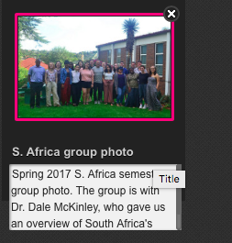
- Once you have uploaded all your photos and added descriptions, be sure to add to the appropriate album!
  - Click “Add to albums” on the left hand side of the screen
  - A pop-up will appear, giving you multiple choices for album. Choose the correct one, and then select “done”
  - IMPORTANT: If you are uploading multiple photos, make sure each photo is selected so you can add all to one album at once (instead of adding individually). You know a photo is selected if it has a pink border around it.
- Once your photos are in the correct album, choose the blue “upload # photo” button in the upper right hand corner
  - Looks like this:
- You will get another pop-up that says, “Upload item with the following changes?” with the private button and the album button selected. This is correct. Choose upload.

Once you have completed the upload, it will bring you back to our main photo stream. You may or may not see your uploaded photos here. If you want to check that you did indeed upload them in the correct spot, you will navigate to the album itself. To do this:
- Choose “albums”
  - 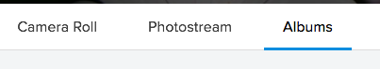
- Find your album
- Your photo(s) should now be in here.

Other notes: occasionally students, interns, or staff will simply email their photos to me and I will ensure they are uploaded into the correct album. If you cannot get into the Flickr account, or if your bandwidth is not high enough to upload photos, please email them to me as attachments instead.

Return to table of contents

III. How to Choose Photos for Publications

Once you're signed in, go to the top left corner where you will see a black bar with different options (You - Explore - Create) Mouse over to the "You" tab, and a drop-down menu will appear. Click on "Albums"

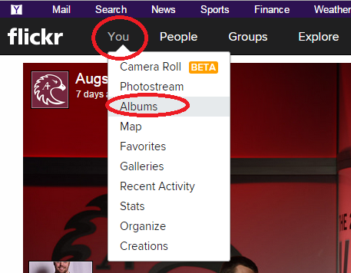

You will see a lot of albums. You want to find your location with the current year:
- Mexico 2016-17
- Southern Africa 2016-17
- Central America 2016-2017

This is where we store all photos from the academic year into. From there, you will be able to see all of the photos we have already collected from the year. We want you to choose from that large album, your top choices to go onto the new brochures.

To select your favorites and add to the promo album:

Click on a photo you like.
The photo will open for you to view
Scroll down the page
You will see an option "Add to album" in the lower right hand of the screen
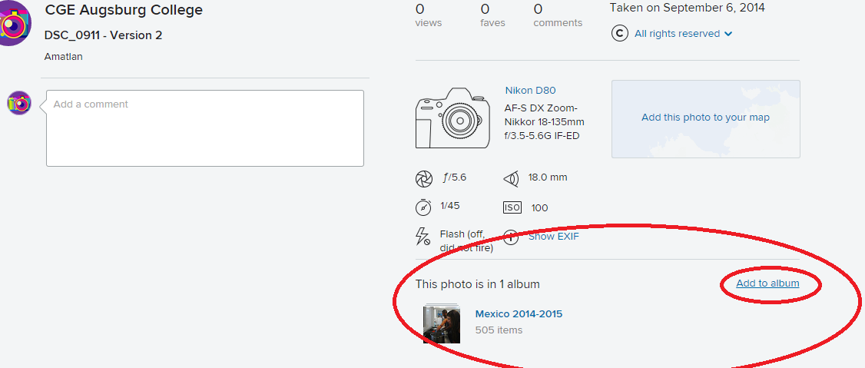

Choose "Add to Album"
A list of possible albums will appear
Scroll down until you find your publications album "Mexico Pubs 2017"/”Southern Africa Pubs 2017”/”Central America Pubs 2017”
Click on that album
Then choose the blue "Add to album" button

Choose the correct ‘pubs’ album and add it

Return to table of contents

Addendum: other helpful information regarding photos

Ideally, we would like about 10-15 photos per site as our “top favorites” (Mexico you need more since you have more programs, please give me at least 20 photos). Not all photos will be used, but is good to have a variety to choose from.

What types of photos work best? I usually put good marketing photos into one of these categories:

- Visually stunning, the “wow factor” photos - these can be landscape photos that show off natural beauty of the country, or local architecture/cityscape photos, among others. These photos are must-haves in study abroad advertising, and get students to come over to our table at the fairs to look at our materials and talk to us.
- Group shots/students posing - helps students “picture themselves there” by showing them others’ having fun on site.
- Candid shots of the community and activity photos - since CGEE is so experiential, we really want to showcase this in our materials. Photos of visits to local organizations, guest speakers, excursions, etc. However, these photos are the hardest to get because we typically don’t think to take photos at these times!

We do also screen for appropriate images. For example, even though we do have internships that work with children, I tend to avoid using those images due to the unfortunate connotation of the “white savior” complex that can accompany those types of photos. Even though WE KNOW that is not what is happening in the photo, it is difficult to explain that when we simply use the photo on a publication that may not have any caption or explanation to it.

We try to have photos which include a diverse array of participants, but again, the unfortunate reality is that I am forced to work with what I am given. This is why it is so important to gather photos from all the students we can, so we can get a broad range of viewpoints. When we are unable to gather photos, we have to fall back on old photos and landscape photos we can purchase online.

Other types of photos I typically avoid…
- Students in bathing suits
- Anything with alcohol
- Anything that might depict a power imbalance between students and community members; we want those photos to be shown with all parties in equal positions, or with community members teaching the students as we believe in learning from the community (again, no “white savior complex” type photos)
- Photos with children - parents might object knowing their child is on a website somewhere without their permission. IF I use any of these, I mostly use them on the Education publications because how else do you show that without showing a school, basically. But the photo needs to be very tastefully done.
- Anything that might perpetuate a stereotype of the country/area/people of the region (such as students all wearing sombreros and fake mustaches in Mexico)

Return to table of contents

