Wellness Plan for Off-Campus Study
This is your plan. You are encouraged to develop it to anticipate, reflect on, and prepare for your medical and mental health needs while studying off-campus. Please keep a copy of this wellness plan in an accessible place (e.g., email or a cloud account like Dropbox, in addition to having a paper copy with you). We also encourage you to leave a copy with family/loved ones. If you feel comfortable doing so, consider sharing this form with program faculty and staff if you think it would help them support you while studying off-campus. If you do share this information with them, they will keep it strictly confidential. Otherwise, this form can be kept exclusively for your own use and planning.

Date
Name

Program & Term Abroad/Away

My health/mental health condition(s):

1. Off-campus Disability Accommodation Request
If you receive accommodations through the Disability Services office on your campus, have you completed your Off-campus Study Accommodations Request Form? (This may prove helpful in completing your Wellness Plan.)
Yes |  | No |  | N/A

2. Early warning signs
What are the first signs or “red flags” that I notice, that indicate that the symptoms of my health/mental health condition are starting to come back, or are becoming more problematic?
Are there any signs that the program faculty/staff should be alert for? What kind of support would you like from the program leader(s)?

3. Support Resources
I will use these support resources for my health and/or mental health while studying abroad. We encourage you to start by talking with your study abroad/away advisor, who can help you contact with the appropriate support staff/faculty/ program directors/resources at home and off-campus. Please fill in the contact information for any support people you could contact

Who/What | Name | Phone/Skype/  WhatsApp | Email
Physician(s)
Therapist (if accessible by email, phone, Zoom)
Sponsor if in recovery
Family member(s)
Close friend
US Based Health Insurance | Policy/group #:
Telephone Counseling | Augsburg’s Center for Wellness & Counseling contracts with an after-hours phone counseling service. This service is for Augsburg students only. | +1-612-330-1707,  Option 1 | n/a
Augsburg University  24/7 International Health and Travel Insurance | EIIA/Generali Global Assistance  (Reference Group  ID C2EII) | For Emergency Assistance call collect worldwide at +1-240-330-1551  From US: 1855-901-6712 | ops@gga-usa.com  www.eiia.org/internationaltravel/
Augsburg CGEE 24/7 Emergency line | Staffed by Augsburg CGEE in Minneapolis | +1 612-817-2830
Study Abroad/Away Advisor

Online counseling is available for all students on Augsburg CGEE programs. See: LifeWorks Student Support Program. This is not only for use in an emergency, or once you are abroad. You can take advantage of the services if you have any issues prior to departure, set up ongoing sessions if you think you will need the services of a therapist while you are abroad, and at any time you just need to talk to someone before, during or after the semester. In fact, we are told that predeparture counseling is one of the most common points of contact.

We highly recommend that you download the MySSP app on your phone, become familiar with the services and delivery options, and create an account. This last step is vital to easy access in the future.
· For MAC
· For PC

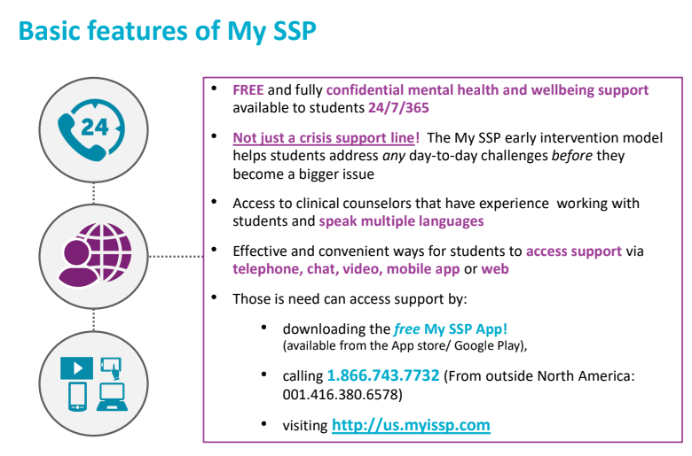

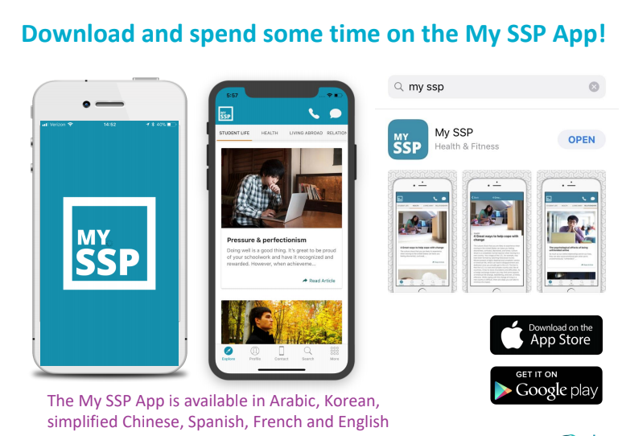

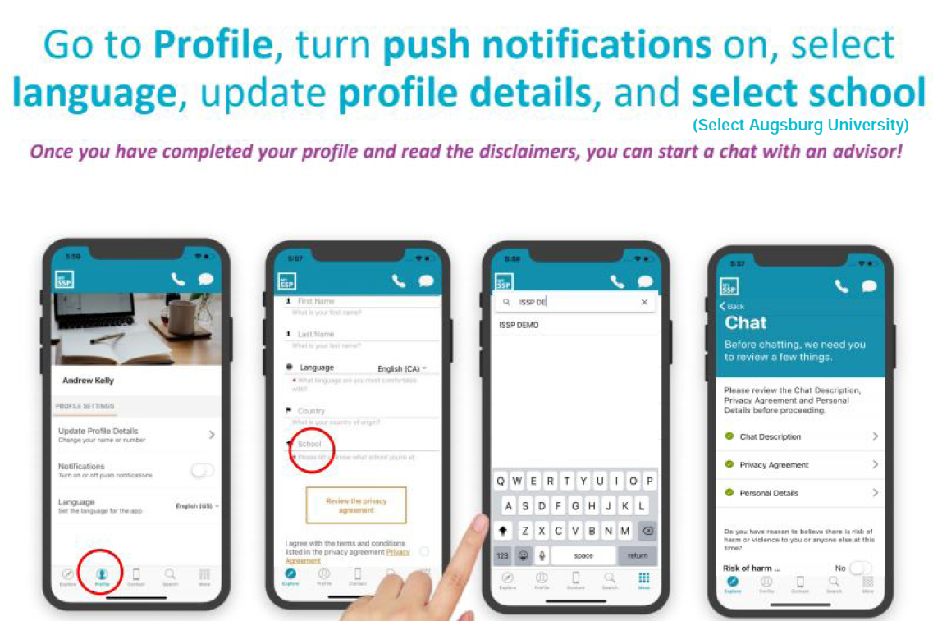

4. Coping Plan
What can I do to cope if symptoms of my health or mental health condition are showing up? Please list coping activities or supports that have helped you in the past and that will be available to you in your host country. See Center for Wellness & Counseling “Anxiety Support” and “Depression Support” resources (Blue Buttons on www.augsburg.edu/cwc)

5. Plan for preventive, daily stress management practices
Please identify practices that help you to stay healthy.

6. Exit Plan
Emergency Evacuation for Medical Reasons: Augsburg’s insurance provides coverage for up to $100,000. Generali Global Assistance must coordinate evacuation.

What to do in case of a Medical Emergency
We recommend making your phone calls in the following order:
- Call the emergency number of the international director provided by your campus or call the host country equivalent of 911 for a serious and/or life threatening medical emergency.
- Call Generali for all emergency travel, accident and emergency sickness assistance at +1 (240) 330 1551.
- Call the international office at your host institution or your institution's professor traveling with your group and give them the claim number.
- Call your Institution's Study Abroad Coordinator and give them the claim number.
- Call your family and give them the claim number

6. Medications
If on prescription medication(s) for health/mental health concern, please be aware of the following:
- your medication may go by a different name in the host country;
- some medications are illegal to import into certain countries;
- when bringing a medication in your luggage, it is best to bring it in the original prescription bottle;
- contact Generali Global Assistance for information on medications in your host country (see contact information on page 2)

Please complete the following for each medication you may be taking while in your host country:

MEDICATION #1
Name in U.S. |  |  |  | Name in host country
Is medication legal in host country? |  |  |  |  |  |  | Yes |  | No
Dosage |  |  | Drug classification schedule
Side effects I may experience:
Plan to ensure I’ll have access to this medication during study abroad (for example, “have full supply with for duration of trip”; “bring copy of prescription”).

MEDICATION #2
Name in U.S. |  |  |  | Name in host country
Is medication legal in host country? |  |  |  |  |  |  | Yes |  | No
Dosage |  |  | Drug classification schedule
Side effects I may experience:
Plan to ensure I’ll have access to this medication during study abroad (for example, “have full supply with for duration of trip”; “bring copy of prescription”).
MEDICATION #3
Name in U.S. |  |  |  | Name in host country
Is medication legal in host country? |  |  |  |  |  |  | Yes |  | No
Dosage |  |  | Drug classification schedule
Side effects I may experience:
Plan to ensure I’ll have access to this medication during study abroad (for example, “have full supply with for duration of trip”; “bring copy of prescription”).

If you have any additional prescriptions, please note in the “Additional Notes” box below.

Additional notes

