TO ACCESS STUDENT RECORDS IN STUDIO ABROAD

Go to http://studyabroad.augsburg.edu/

In the upper right hand corner there should be this link: LOGIN/REGISTER
Click on this. If you are not already logged into Augnet you will be asked to do so.

You should then be directed to a page that looks like this:

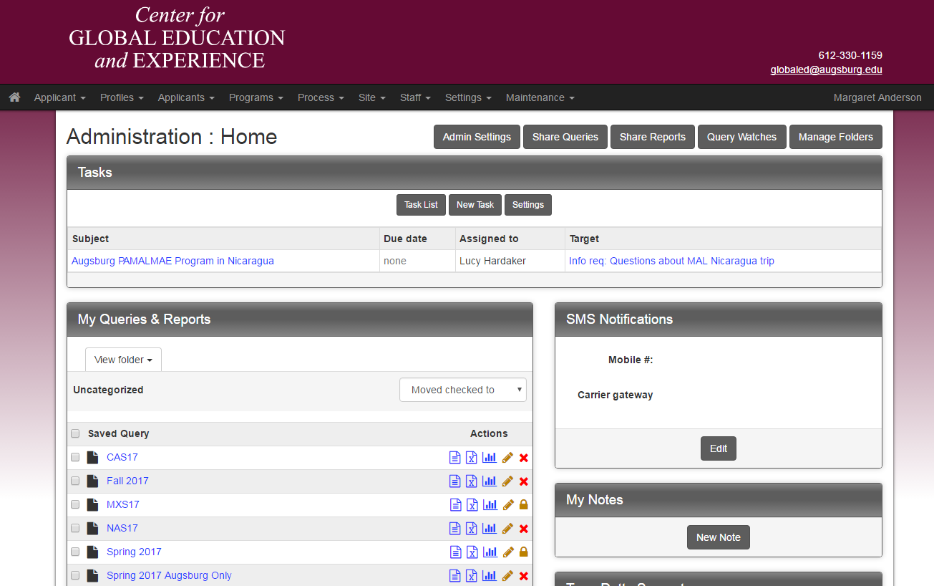

If not, you can click on this icon at the top left of the page:

Select "Admin" and you should get the above screen.

You won’t see all of the queries as on that screen, but click on this link and you will see your program queries:

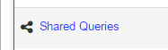
VIEW/PRINT APPLICATIONS
To view and/or print students’ applications, click on:

NAS17

It will show you this screen:
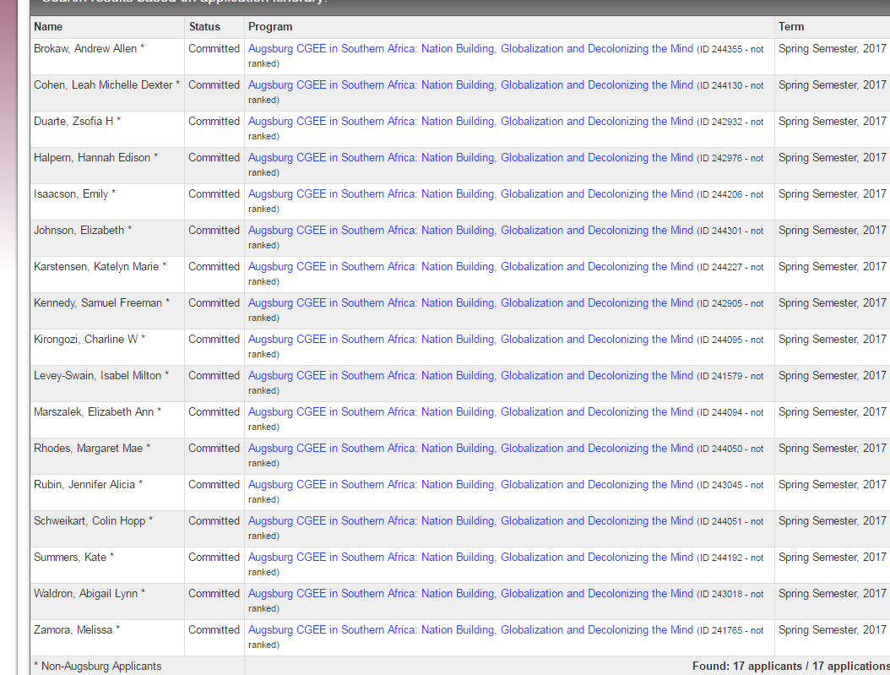

You can select any student by clicking on the hyperlinked program title next to their name.

Then you will get this screen:

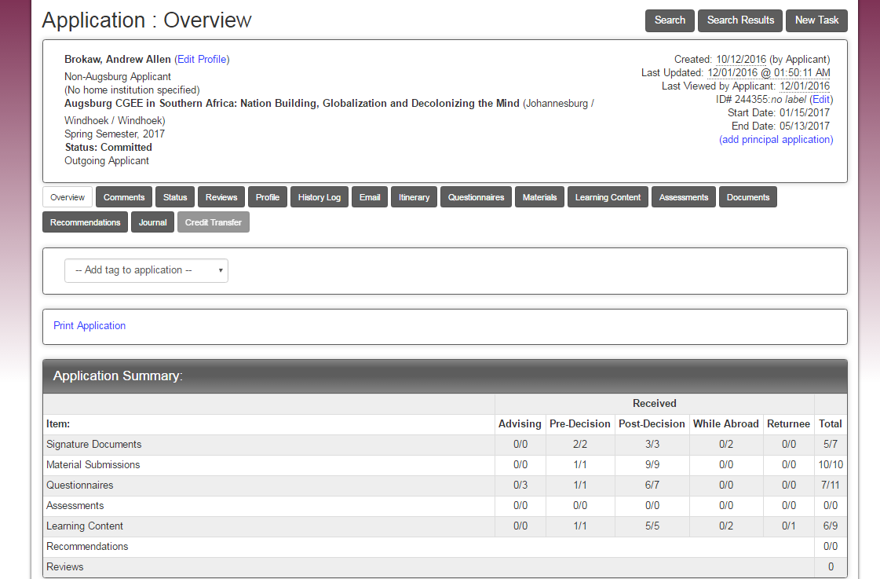

This is a summary of all the information in their application file.

If you click on the “Print Application” link you will get a read-out of any information included in their questionnaires.

You can either print a paper copy, or if you wish, a PDF copy by changing “Printer Destination” to “Save as PDF.”

VIEWING REPORTS

To view registrations, medical forms and internship/fieldwork applications, scroll down on this page, and you will see:

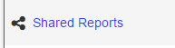

- VIEW REGISTRATIONS
You should see:

Clicking on this should show you all the students' registrations. Then you will not have to wait for me to send this information to you! It will create a real-time report so any additions since the last time you looked at it will be there.

It looks like all the students have filed their course selections already.

- VIEW HEALTH/MEDICAL REPORTS
Click on in the following report in the Shared Reports.

- VIEW INTERNSHIP APPLICATIONS
Click on in the following report in the Shared Reports.

- VIEW EMERGENCY CONTACTS
Click on in the following report in the Shared Reports

About tripcodes:
Each semester I will create the same reports and share them with you. You can tell which semester by the final three digits of the tripcode: NAS17 = Namibia Spring 17
Next fall it will be NAF17, then NAS18, etc.

