TO ACCESS STUDENT RECORDS IN STUDIO ABROAD

Go to http://studyabroad.augsburg.edu/

In the upper right hand corner there should be this link: LOGIN/REGISTER
Click on this. If you are not already logged into Augnet you will be asked to do so.

You should then be directed to a page that looks like this:

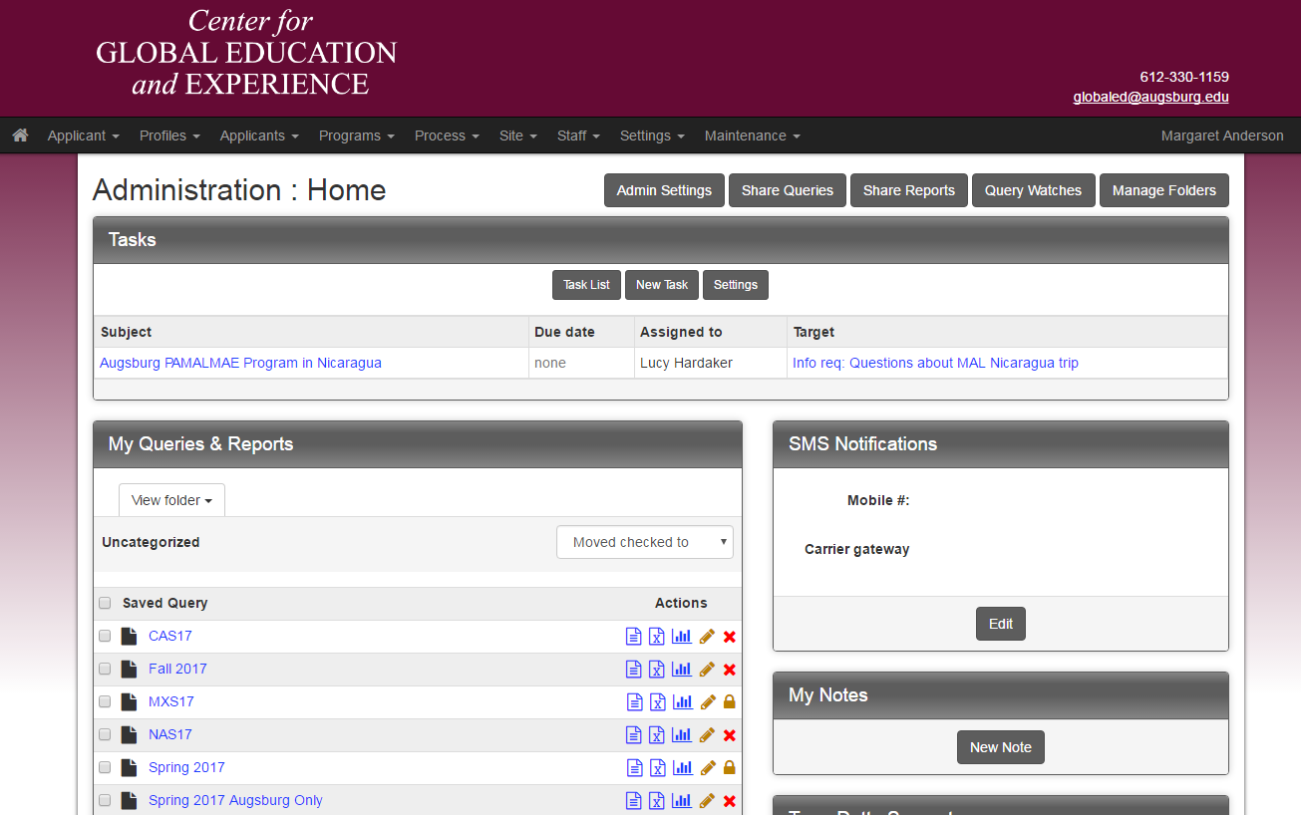

If not, you can click on this icon at the top left of the page:

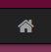

Select "Admin" and you should get the above screen.

You won’t see all the queries as on this screen, but should see this option:
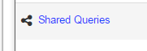

Click on this and you should see:

VIEW/PRINT APPLICATIONS
To view and/or print students’ applications, click on:

It will show you this screen:
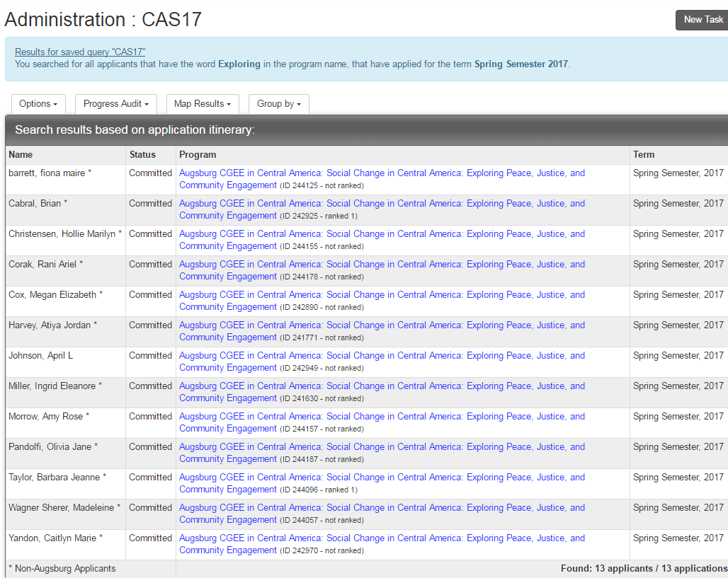

You can select any student by clicking on the hyperlinked program title next to their name.

Then you will get this screen:

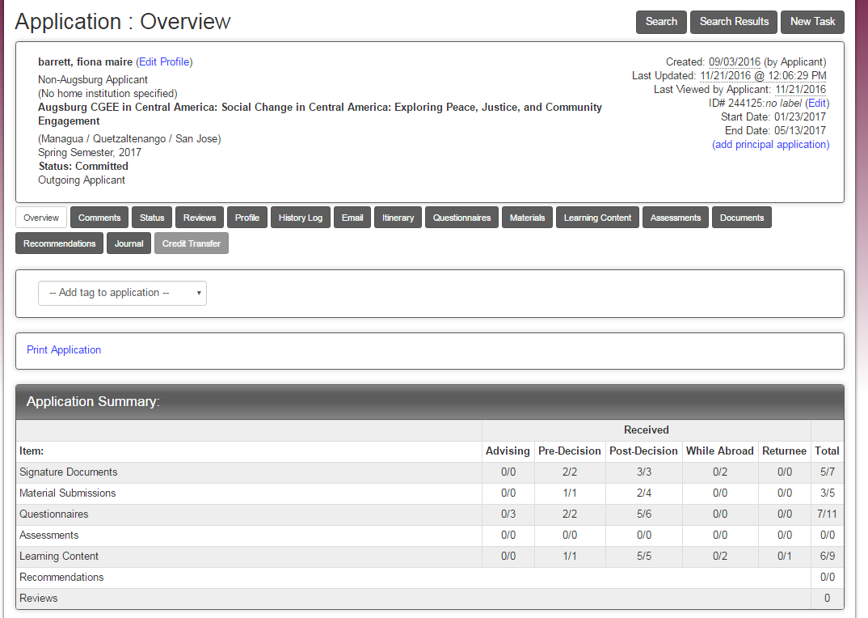

This is a summary of all the information in their application file.

If you click on the “Print Application” link you will get a read-out of any information included in their questionnaires.

You can either print a paper copy, or if you wish, a PDF copy by changing “Printer Destination” to “Save as PDF.”

VIEWING REPORTS

To view registrations, medical forms and internship/fieldwork applications, scroll down on this page, and you will see:

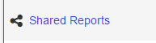

VIEW REGISTRATIONS
You should see:

Clicking on this should show you all the students' registrations. Then you will not have to wait for me to send this information to you! It will create a real-time report so any additions since the last time you looked at it will be there.

VIEW HEALTH/MEDICAL REPORTS
Click on in the following report in the Shared Reports.

VIEW EMERGENCY CONTACTS

About tripcodes:
Each semester I will create the same reports and share them with you. You can tell which semester by the final three digits of the tripcode: CAS17 = Central America Spring 17
Next fall it will be CAF17, then CAS18, etc.

