Chicago ORD
$1,684.15

Chicago to Johannesburg
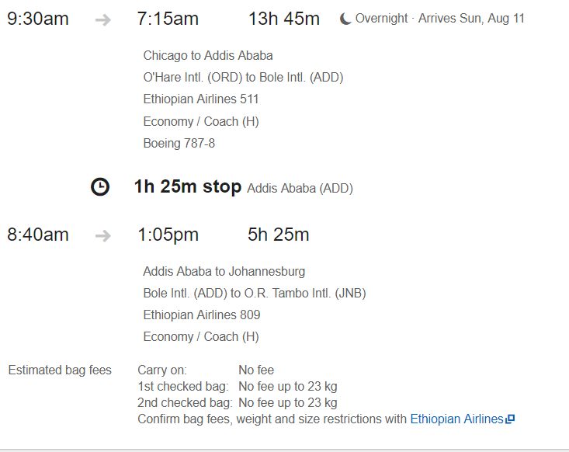

Windhoek to Chicago
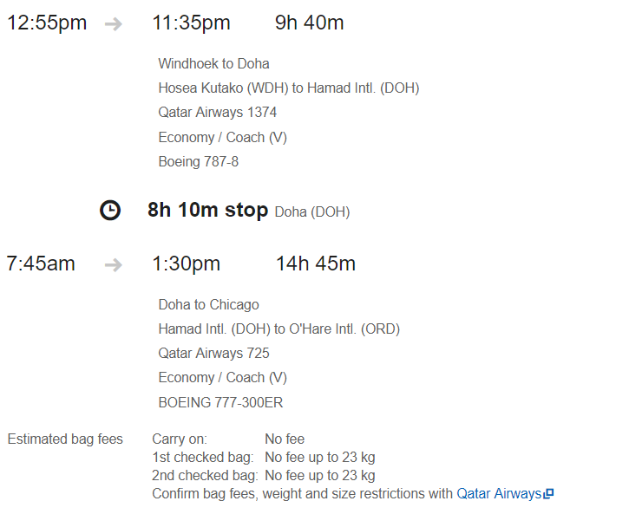

Detroit DTW
$2,116.71

Detroit to Johannesburg
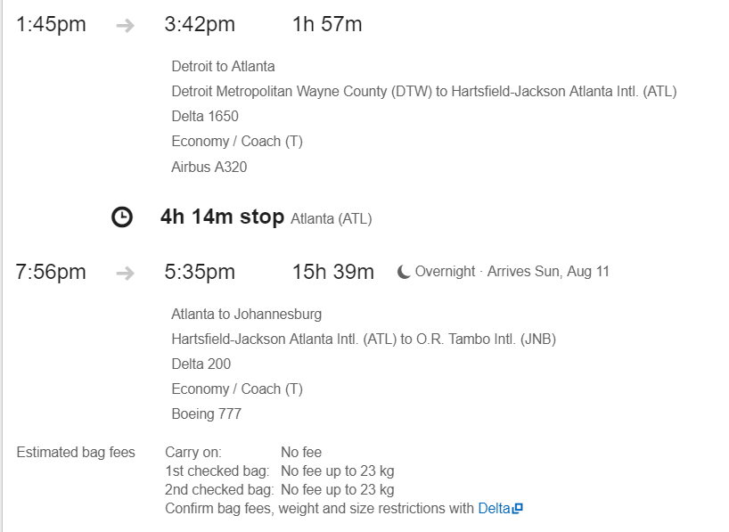

Windhoek to Detroit
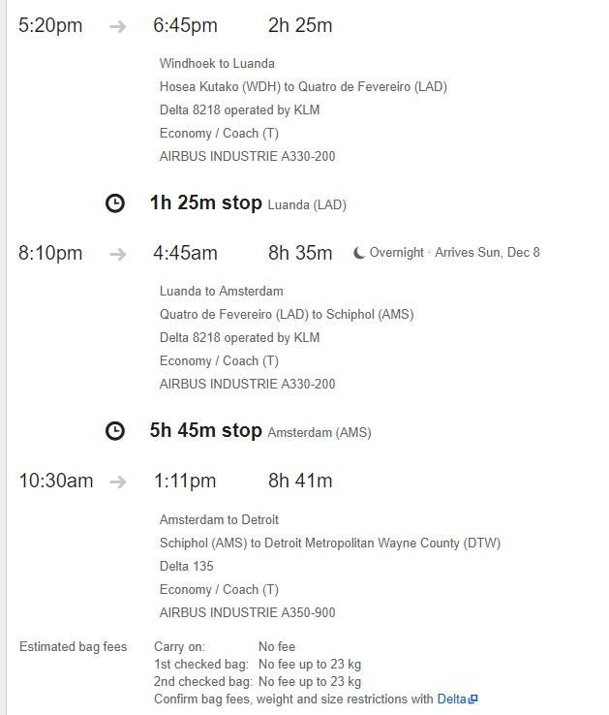
Los Angeles LAX
$1,9215.65

Los Angeles to Johannesburg
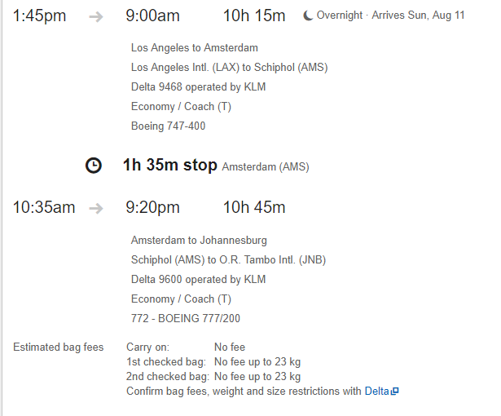

Windhoek to Los Angeles
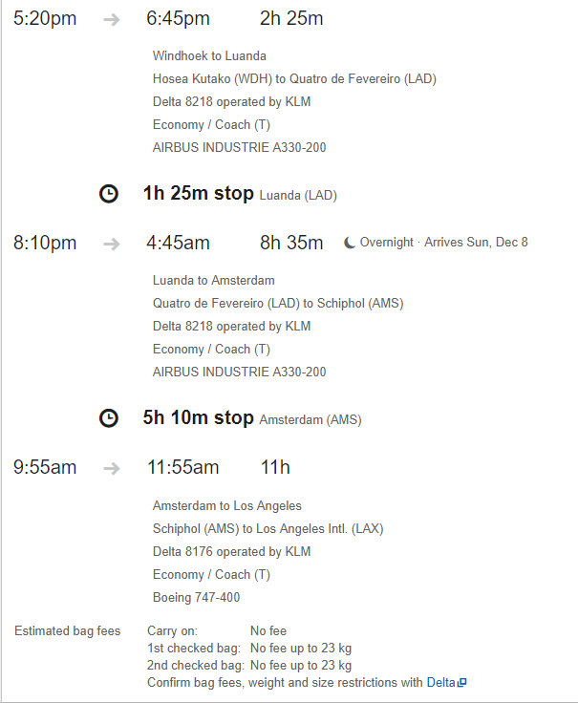
Minneapolis MSP
$2,162.00

Minneapolis to Johannesburg
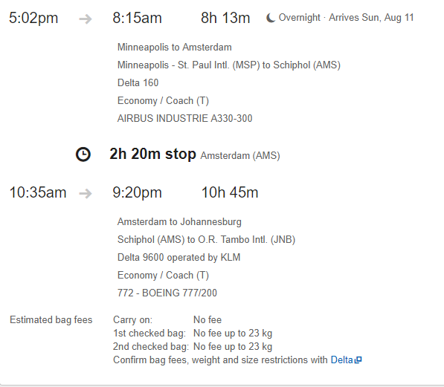

Windhoek to Minneapolis
