How to Access Your Course Moodle Site

After you have activated your account, Go to Inside Augsburg and log in

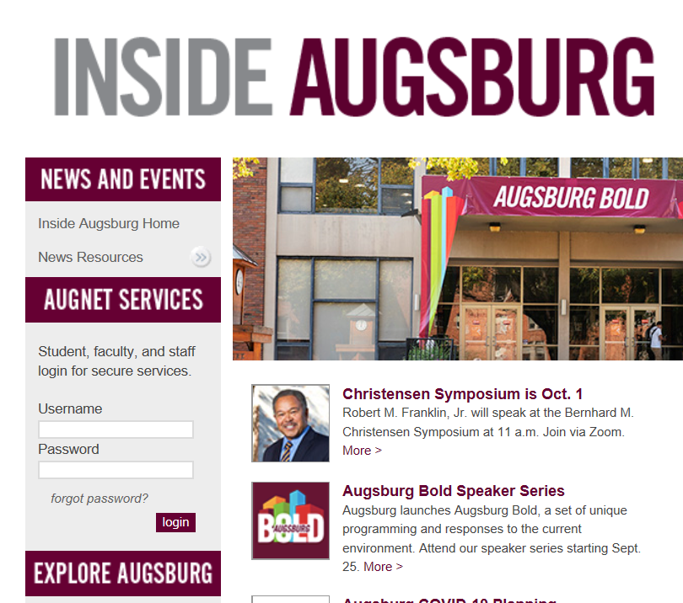
Note: when you log in here, you do not need to use your entire Augsburg email address, only your user name.

When you have done so, click on the Moodle 2020-21 link on the left sidebar.

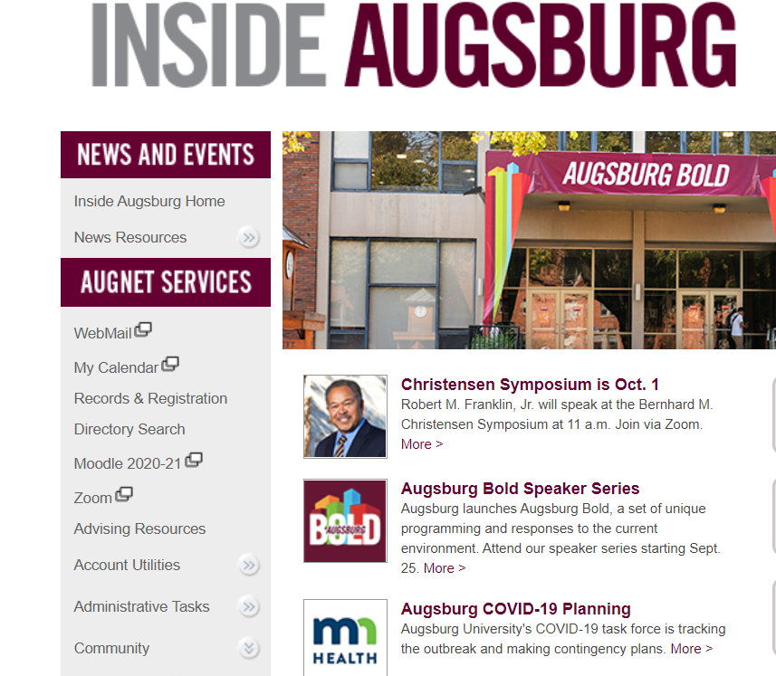

On the Augsburg Bold page, click on MOODLE

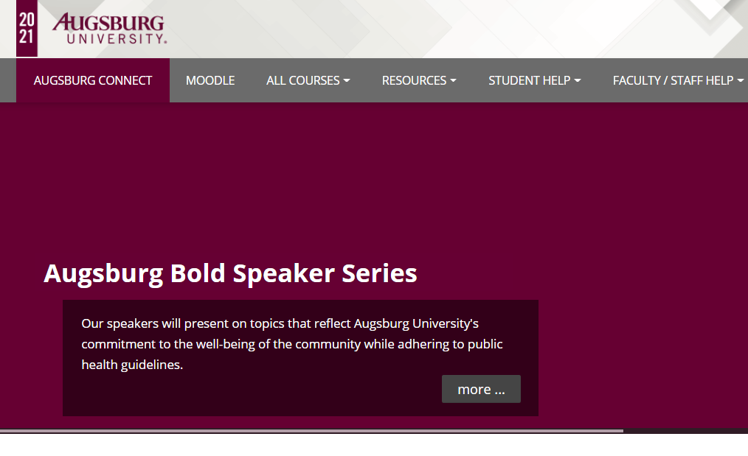

You should then see the Moodle site for any course(s) you are registered for. Click on this link to access your course’s Moodle site.

