Creating a non-Augsburg “Global” CGE student

- Make sure the student is not already in the database.
Using Student Inquiry, enter your information in the darker grey row. You must use the asterisk * (wildcards) to search using any part of the name. The Search name field always starts with last name, so you might want to type Anders* or Anderson, Mar* - but a more thorough search could be done by using *Anderson* (with wildcard in front and back of the name), which tells the system that you are want any students who have ‘Anderson” as any part of their name, which would search maiden names as well..
You can also search by social security number by moving your cursor to the first white row (row 2) and clicking on Tools, Display Hidden Fields.
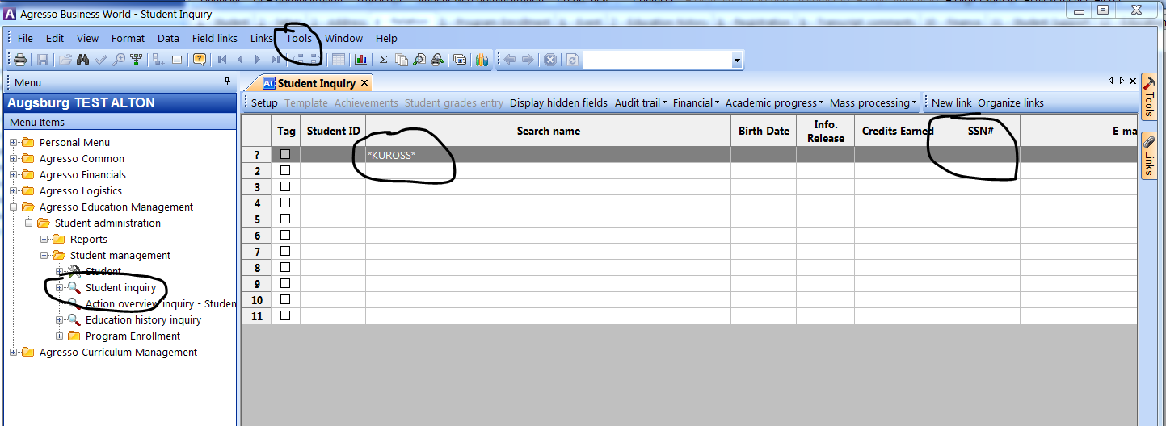

After you have entered your search criteria, click on either the binoculars icon, or the F7 key.
If you find the student you are looking for contact Kathy Kuross #1365 to see if it is ok to update that student’s record. She will look to see if it is a current or historical student and whether you can proceed to step 3 and create a program record.

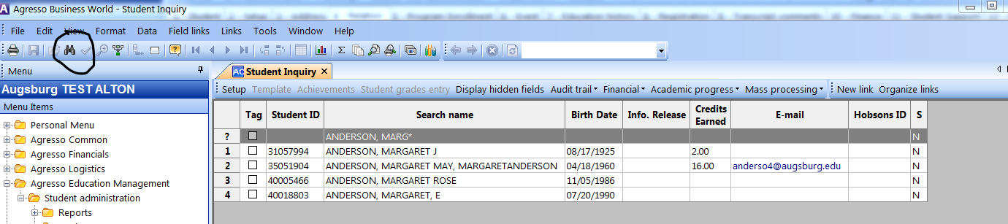

If the student does not exist in the system, you will begin to create the student record.

- Creating a student record
Use the menu item Student
Enter the minimal data as seen below on the first student page
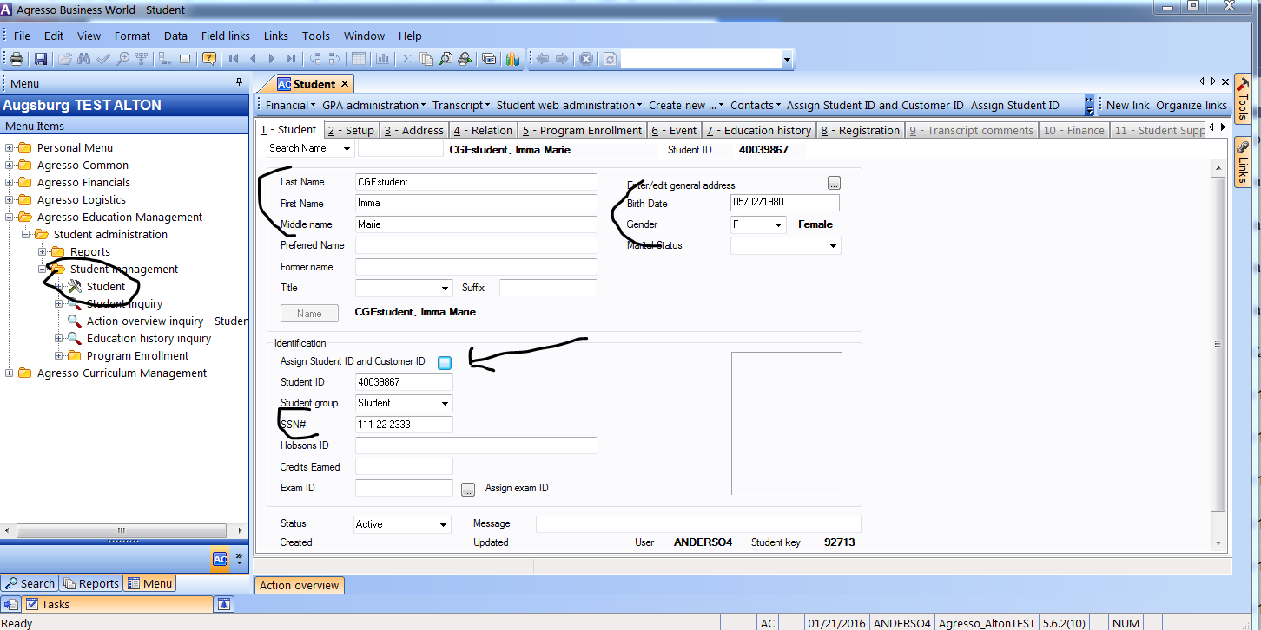

Setup Tab
On the Setup tab, change the Fee Group to ‘Global Program Students’
And enter the ‘Province of residence’ = the state they currently live in.
Or if International, you can enter the Country of Citizenship.
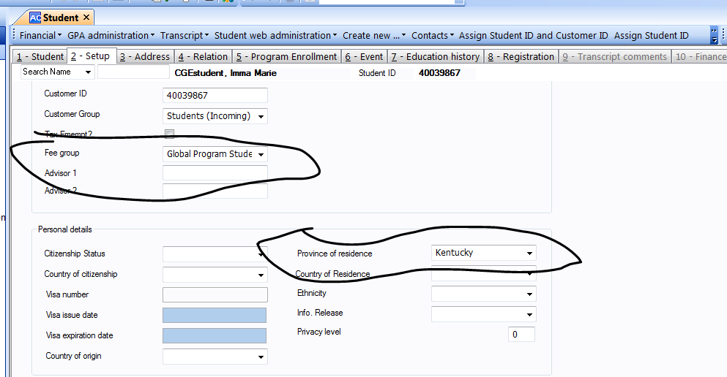

Address Tab
Select ‘General’ in the Type column and hit your tab key

If you need to enter a second line of address, move to the last entry in the first line of address and hold the Ctrl key and click the Enter key.
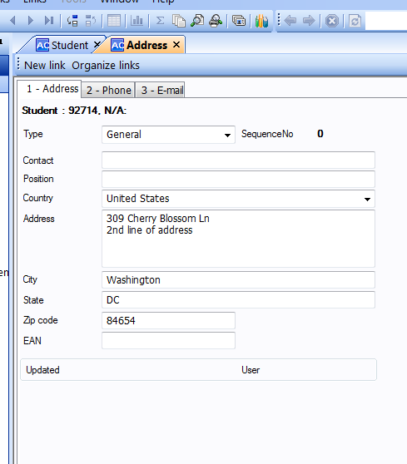

When you have completed entering the address, click on the Keep icon or F11.
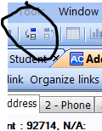

Now you can save the record using the Save icon or F12

After you save the record your screen will look like the image below, but if you hit your tab key, the student’s data will repopulate on the screen.
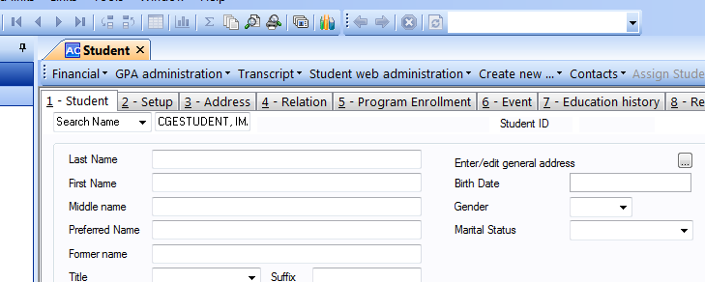

Repopulated data on the screen:

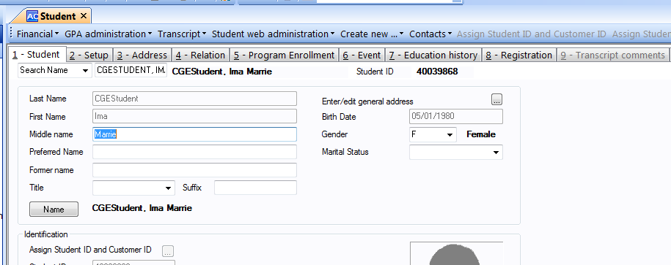

- Creating the Program Enrollment Record

Within the student’s record, click on the Program Enrollment tab and click on the Insert row icon

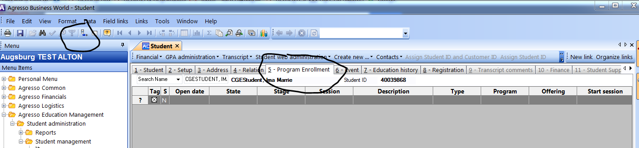
The first tab it will bring you to, is the Setup tab.
Leave the ‘Open date’ as today’s date, unless the term of entry has already started, then enter the first date of the entry term.
Enter the rest of the information as shown below, on the bottom half of the page, under the “ACTUAL” section:
Program = UG
Offering = GLOBAL
Start session = pick appropriate start session
Examples of terms shown below. The beginning year of the academic year is always entered first. Summer is a trailing term
2016SEM1 – Fall 2016
2016SEM2 – Spring 2016-2017 (2017 Actual year)
2016SEM3 – Summer 2016-2017 (2017 Actual year)
2017SEM1 – Fall 2017

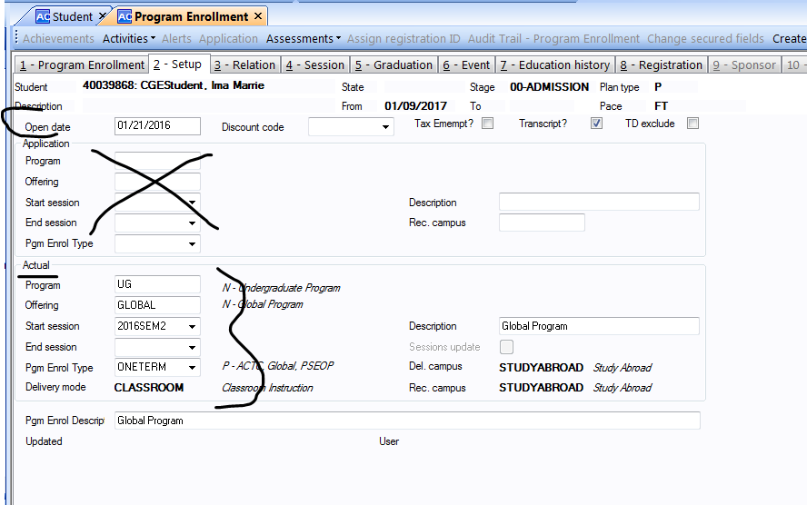

Now move to the first tab – Program Enrollment
Enter the information as below:
State = ACCEPTED
Stage = 09-GLOBAL

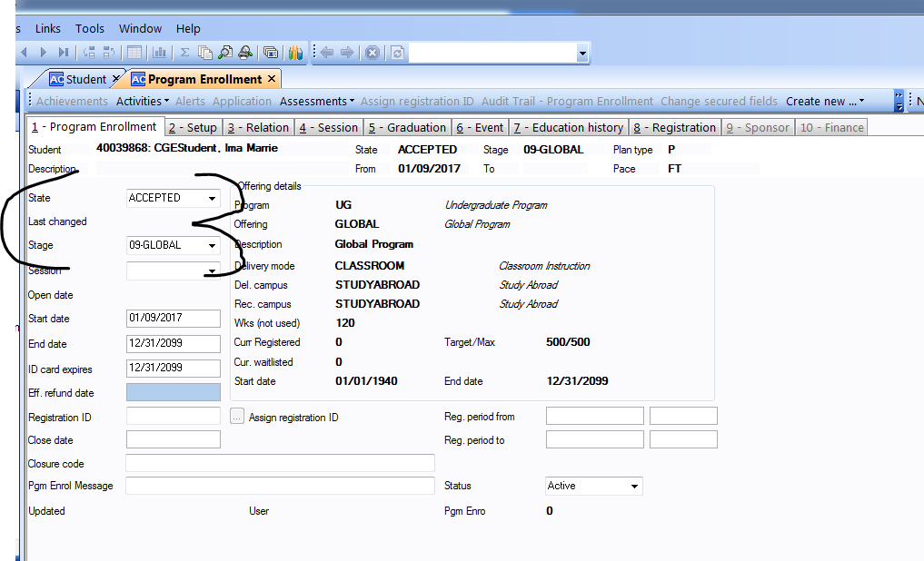

Now hit the Save Icon or F12

You will get this ‘Multiple Registrations’ screen. Just click on the x to close the tab
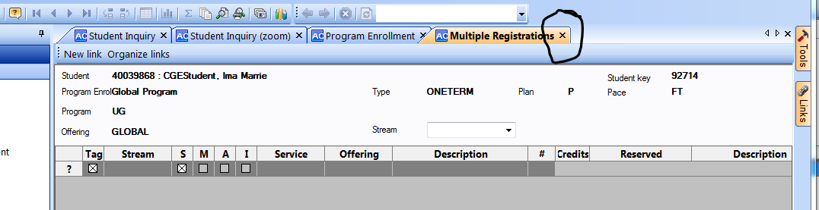

It should look now like this:

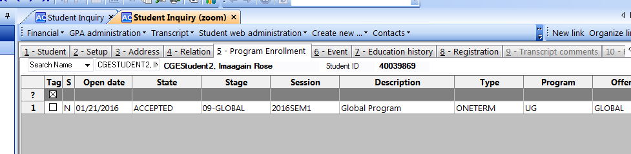

Click on the x’s on each tab to close each record.

